CF01
Suzuki DR 750 BIG

Fitting kit:
ID | Description | Cat.n | Qt
1 | Crash bars | CF01 | -
2 | UP bracket | X55 | 1
3 | Down bracket | X56 | 1
4 | UP special U bolt M10 stirrup | X51 | 1
5 | Washer M8 | 988 | 2
6 | Bolt M8x25 | 833 | 2
7 | Bolt M8x80 | 843 | 1
8 | Nut M8 lock nut | 809 | 1
9 | Nut M10 lock nut | 810 | 2
10 | Washer M10 | 804 | 4
11 | 3M tape | 3M | 1
12 | Plastic cover M10x35 | X35 | 2
13 | Bolt M10x20 | 819 | 2
14 | Stickers | - | 2

Instruction:
- Installation of the left and right cash frame make according to the attached photos below.
- Remove the original bolt M8 on the frame in front of the engine.
- Give the steel adapter to this place and use the bolt M8x80mm together with nut M8 for mounting (don’t tighten, leave the nut free).
- Remove the original bolt M8 on the right side of the frame of the motorcycle (rear gripping, above driver’s foot pegs).
- Take crash frame for the right side and give it into the steel adapter before the engine. Use the bolt M8x25mm for tightening of crash frame in the rear. Use the spring pad M8 under the bolt.
- Take the steel adapter and by stirrup (...mm) mount it on the frame of the motorbike, under the stirrup stick 3M tape.
- Do not tighten the stirrup, put it in the position to upper right handle on the crash frame and use the bolt M10x30mm and lightly tighten it. Under the screw use the spring pad M10.
- Now you have lightly mounted the right crash frame.
- Give the crash frame for the left side into the bottom steel adapter. Use the bolt M8x25mm for tightening of crash frame in the rear. Use the spring pad M8 under the bolt.
- Use the bolt M10x30mm for gripping to upside steel adapter. Use the spring pad M10 under the bolt.
- Now you have crash frames mounted on the motorcycle, you can tighten everything.
- Give the plastic covers on bolts M10x30mm, which connect the crash frames together with upside steel adapter.
- Warning – we recommend to use safety glue on threads of all bolts (moderate strong – blue colour).
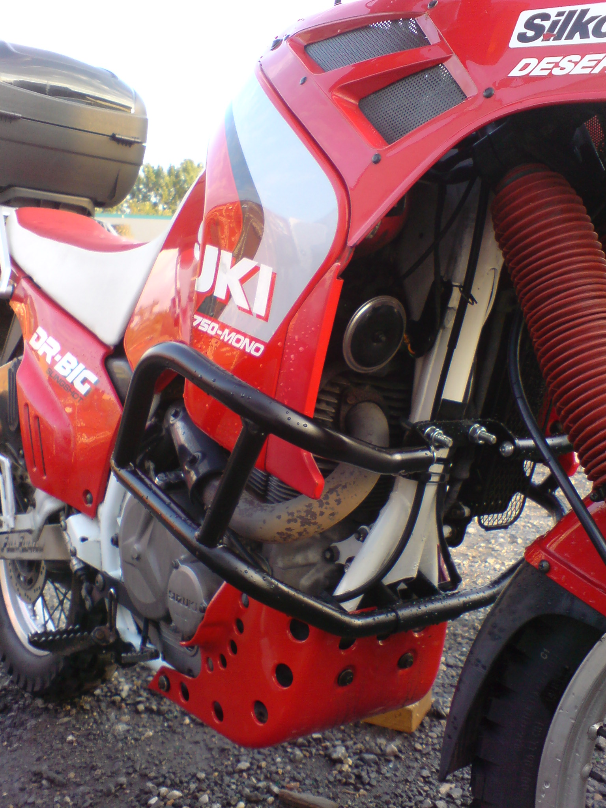
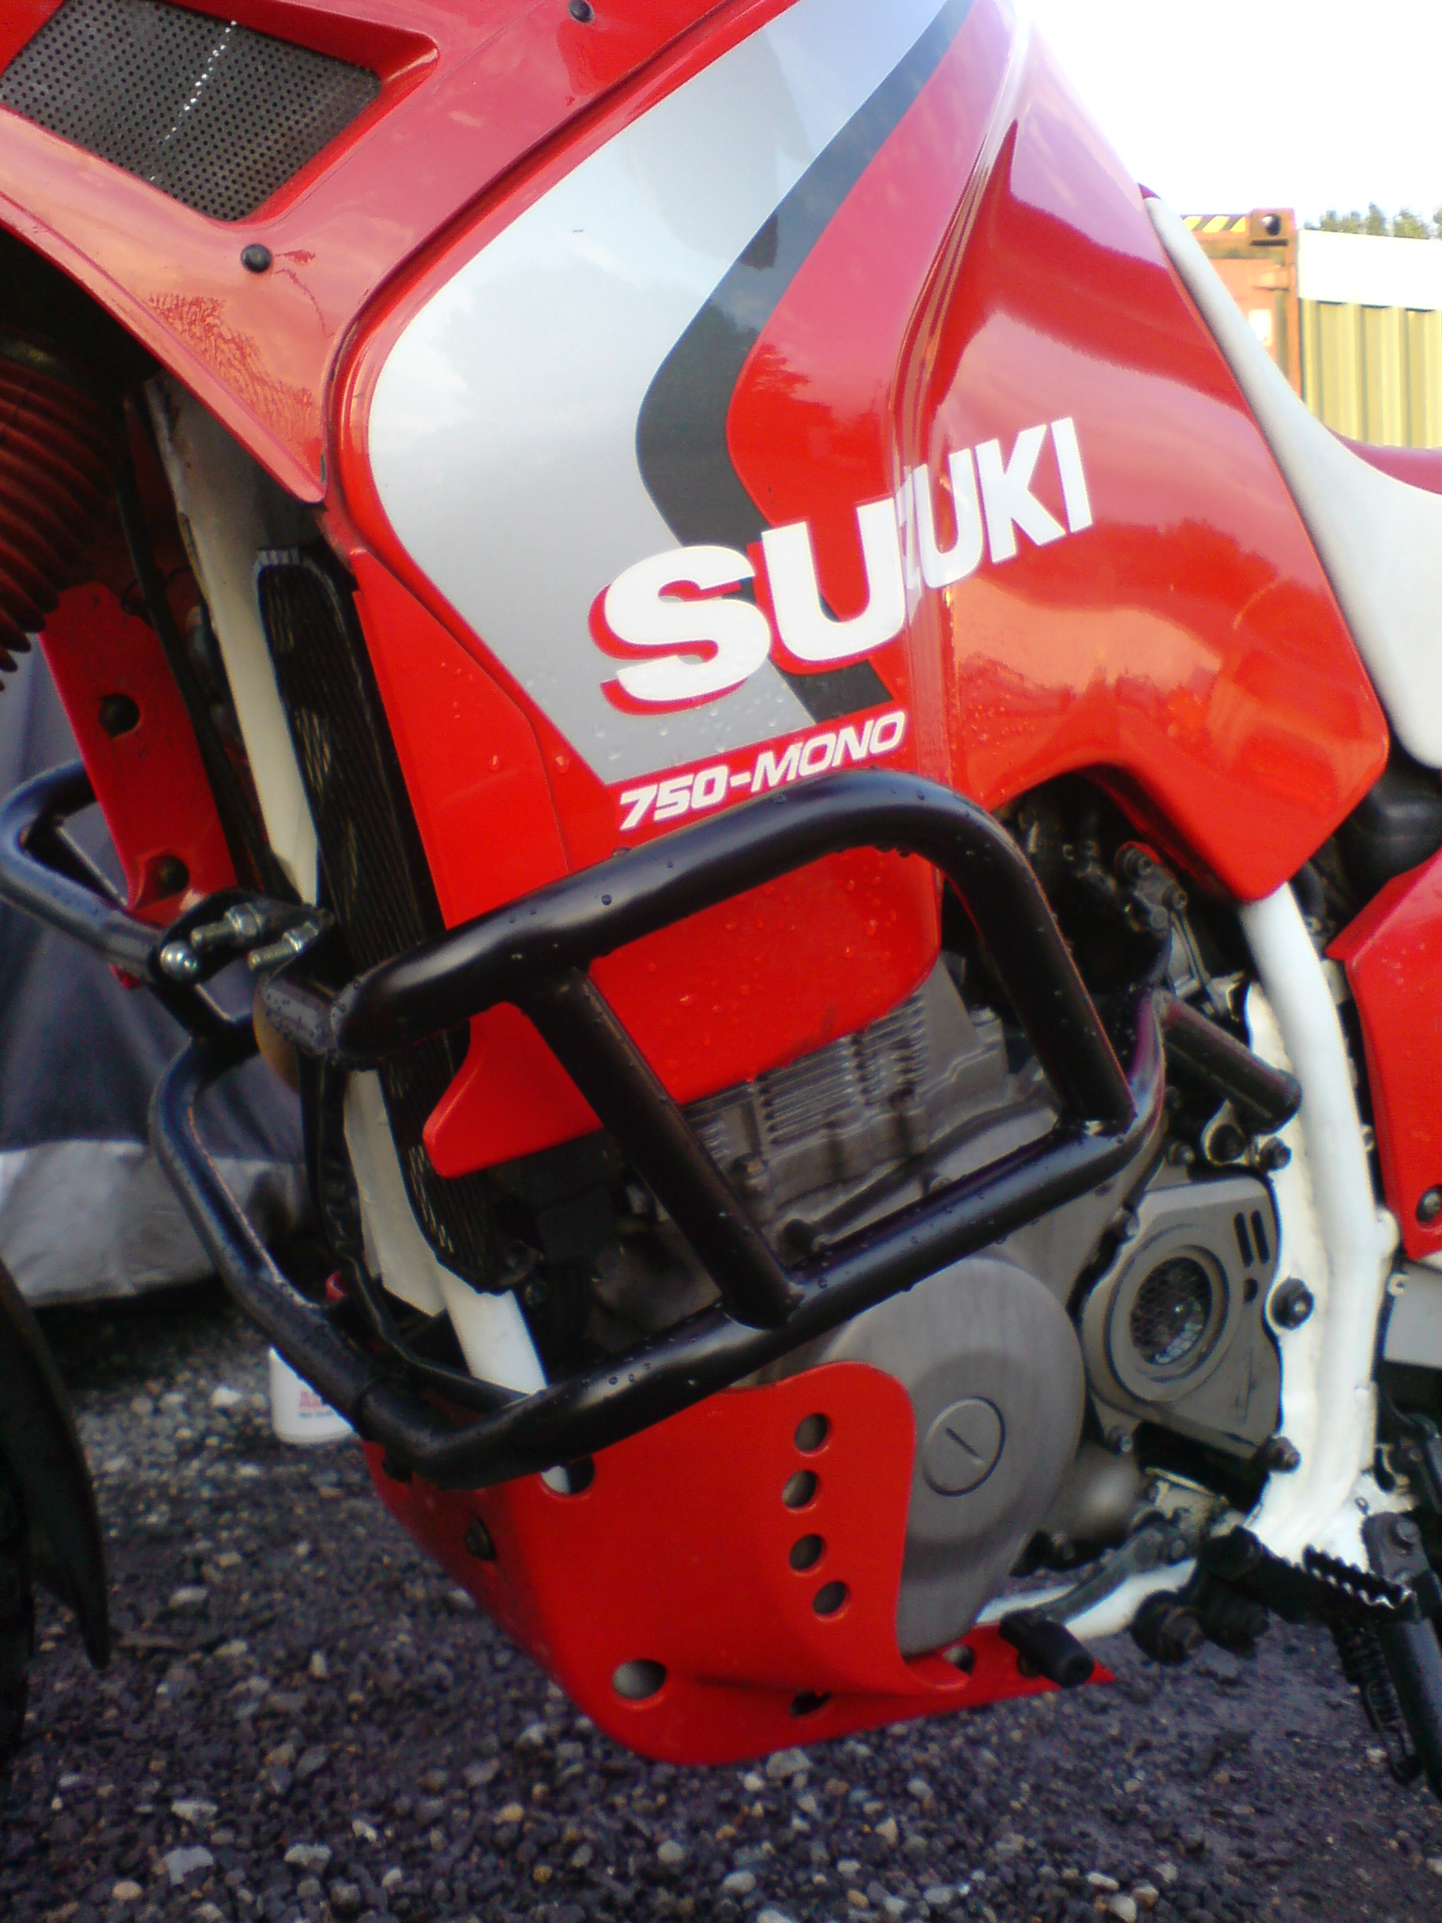
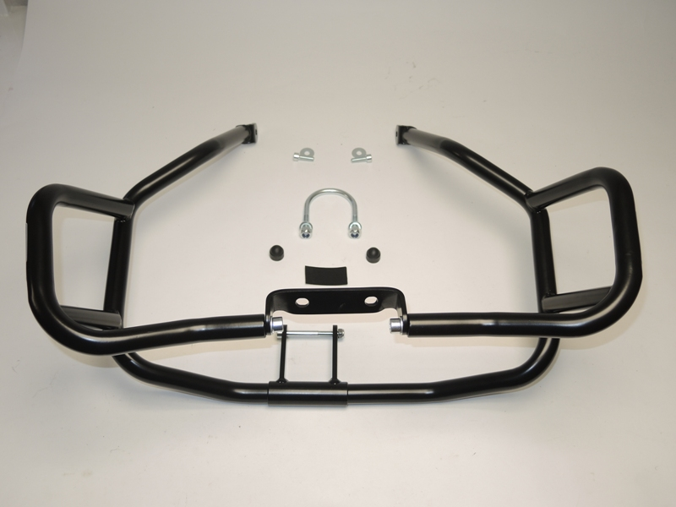
4
3
2
1
1
12
12
9,10
7,8
5,6
13,10

