CF03
Ducati Multistrada 1200 (10-14)

Kit for the left side |  |  |  |  | Kit for the right side
ID | Description | Cat.no. | pcs |  |  | ID | Description | Cat.no. | pcs
1 | Crash frame |  | 1 |  |  | 1 | Crash frame |  | 1
2 | Dural roller 28mm | 1206 | 1 |  |  | 2 | Dural roller 28mm | 1206 | 1
3 | Dural roller 37mm | 1207 | 1 |  |  | 3 | Dural roller 37mm | 1207 | 1
4 | Dural roller 40mm | 1205 | 1 |  |  | 4 | Dural roller 40mm | 1205 | 1
5 | Screw M10x60 | 850 | 1 |  |  | 5 | Screw M10x60 | 850 | 1
6 | Screw M10x70 | 851 | 1 |  |  | 6 | Screw M10x70 | 851 | 1
7 | Washer M10 – plochá | 804 | 2 |  |  | 7 | Washer M10 – plochá | 804 | 2
8 | Washer M12 – plochá | 803 | 1 |  |  | 8 | Washer M12 – plochá | 803 | 1
9 | Nut M12 – pojistná | 811 | 1 |  |  | 9 | Nut M12 – pojistná | 811 | 1
10 | Steel rod 12x355x30x30 |  | 1
Installation
(we recommend to use medium strong glue on all threads)
dural roller 28mm (ID2) + screw M10x60 (ID5) +
washer M10 (ID7)
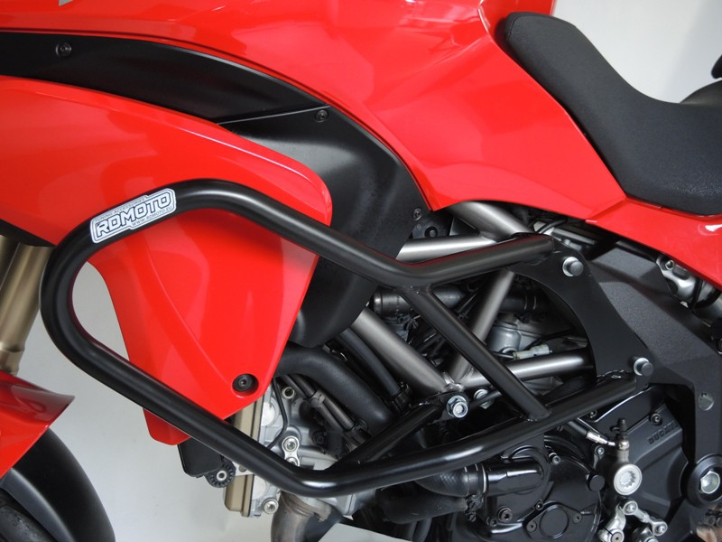
dural roller 37mm (ID3) + screw M10x70 (ID6) +
washer M10 (ID7)
Steel rod (ID10) +
dural roller 40mm (ID4) + nut M12 (ID9) +
washer M12 (ID8)

