CF04
Suzuki GSF600 Bandit
1995-2004
Suzuki GSX750 Inazuma

Kit for the left side |  |  |  |  | Kit for the right side
No. | Description | Cat.no. | Pcs |  |  | No. | Description | Cat.no. | Pcs
1 | Crash bar |  | 1 |  |  | 1 | Crash bar |  | 1
2 | Bolt M8x70mm | 841 | 1 |  |  | 2 | Bolt M8x70mm | 841 | 1
3 | Bolt M8x60mm | 838 | 1 |  |  | 3 | Bolt M8x60mm | 838 | 1
4 | Bolt M10x60x1,25mm | 896 | 1 |  |  | 4 | Bolt M10x60x1,25mm | 896 | 1
5 | Pad M8-spring | 800 | 2 |  |  | 5 | Pad M8-spring | 800 | 2
6 | Pad M10-spring | 801 | 1 |  |  | 6 | Pad M10-spring | 801 | 1
7 | Advertising sticker RDmoto |  | 1 |  |  | 7 | Advertising sticker RDmoto |  | 1

Installation:

Make the installation of the crash bar according to the instruction on the below attached photos.

The installation of the crash bar for the left and right side is the same.

The crash protectors with the logo RDmoto is not included in this type of crash bar.

Warning – we recommend to use safety glue on threads of all bolts (moderate strong – blue colour).

The right side:

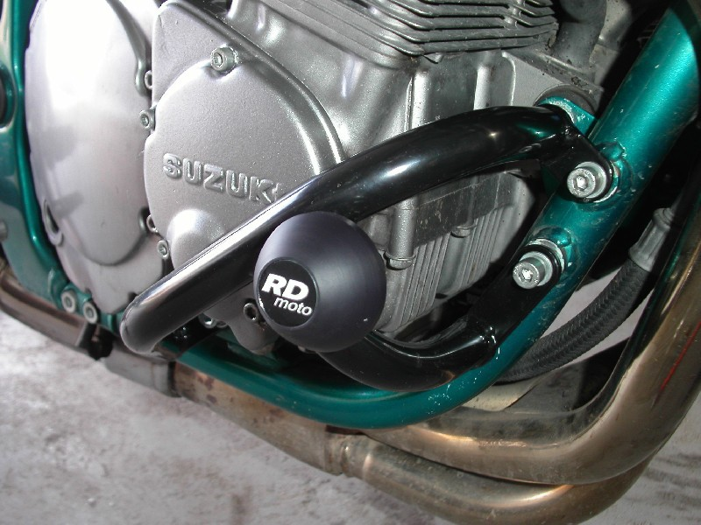

bolt M10x60x1,25mm + pad M10 (spring)
crash protectors with the logo RDmoto is not included in this type of crash bar
bolt M8x70mm + pad M8 (spring)
bolt M8x60mm + pad M8 (spring)

The left side:

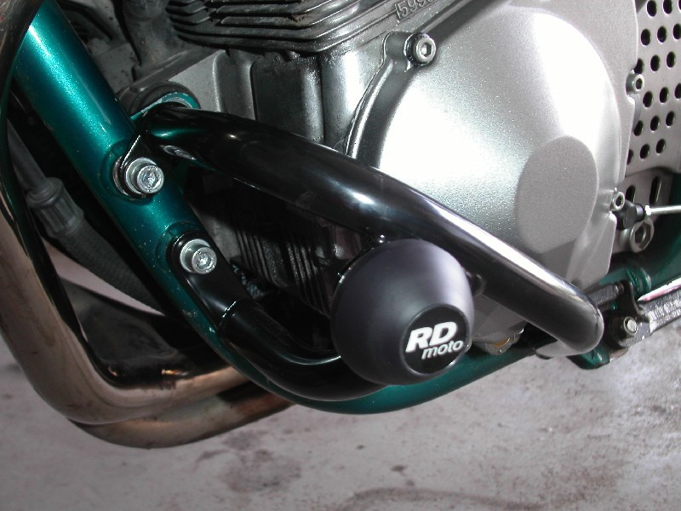

bolt M8x60mm + pad M8 (spring)

bolt M8x70mm + pad M8 (spring)
crash protectors with the logo RDmoto is not included in this type of crash bar
bolt M10x60x1,25mm + pad M10 (spring)

