CF05
Suzuki GSF600 Bandit
1995-2004
Suzuki GSX750 Inazuma

Kit for the left side |  |  |  |  | Kit for the right side
No. | Description | Cat.no. | Pcs |  |  | No. | Description | Cat.no. | Pcs
1 | Crash bar |  | 1 |  |  | 1 | Crash bar |  | 1
2 | Bolt M10x60x1,25mm | 896 | 2 |  |  | 2 | Bolt M10x60x1,25mm | 896 | 2
3 | Pad M10-spring | 801 | 2 |  |  | 3 | Pad M10-spring | 801 | 2
4 | Advertising sticker RDmoto |  | 1 |  |  | 4 | Advertising sticker RDmoto |  | 1

Installation:

Make the installation of the crash bar according to the instruction on the below attached photos.

The installation of the crash bar for the left and right side is the same.

Warning – we recommend to use safety glue on threads of all bolts (moderate strong – blue colour).

The right side:

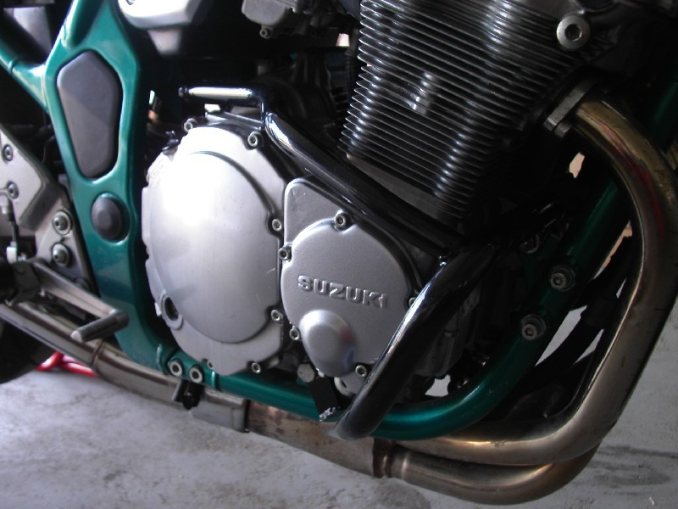

bolt M10x60x1,25mm + pad M10 (spring)
original bolt
bolt M10x60x1,25mm + pad M10 (spring)

The left side:

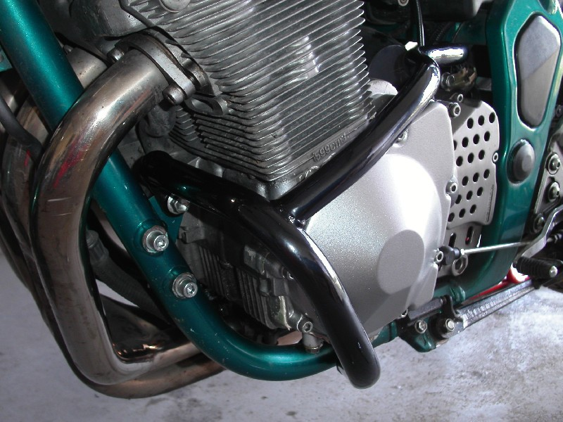

original bolt
bolt M10x60x1,25mm + pad M10 (spring)
bolt M10x60x1,25mm + pad M10 (spring)

