CF06
Suzuki GSF650 Bandit
2007-

Kit for the left side |  |  |  |  | Kit for the right side
No. | Description | Cat.no. | Pcs |  |  | No. | Description | Cat.no. | Pcs
1 | Crash bar |  | 1 |  |  | 1 | Crash bar |  | 1
2 | Bolt M10x50mm | 849 | 2 |  |  | 2 | Bolt M8x30mm | 834 | 1
3 | Dural. cylinder d=10mm | 436 | 2 |  |  | 3 | Steel bolt 10x240x30x30 |  | 1
4 | Advertising sticker RDmoto |  | 1 |  |  | 4 | Pad M10 | 804 | 2
 |  |  |  |  |  | 5 | Nut M10-safety | 810 | 2
 |  |  |  |  |  | 6 | Advertising sticker RDmoto |  | 1
Installation:

Make the installation of the crash bar according to the instruction on the below attached photos.

The installation of the crash bar for the left and right side is the same.

Warning – we recommend to use safety glue on threads of all bolts (moderate strong – blue colour).

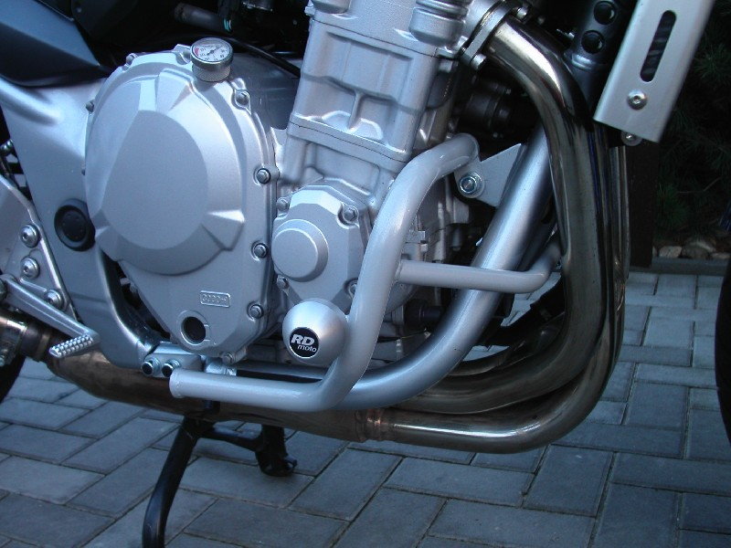
bolt M8x30mm to connect the left and the right crash bar
steel bolt M10x240mm + two pads M10 + two nuts M10
two bolts M10x50mm + two duralumin cylinders d=10mm
the crash protector is not included in this fitting kit

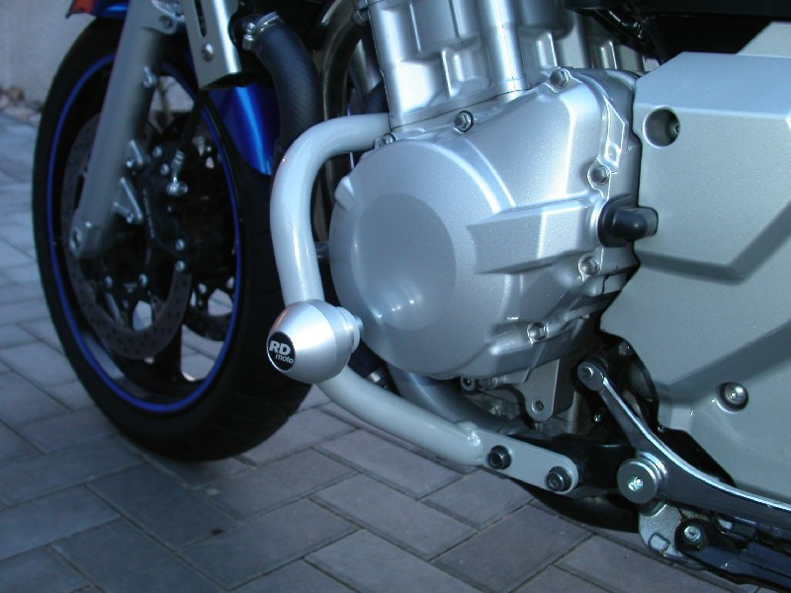
the crash protector is not included in this fitting kit

original bolts

