CF08
BMW R1150GS / Adventure

Kit for the left side |  |  |  |  | Kit for the right side
No. | Description | Cat.no. | Pcs |  |  | No. | Description | Cat.no. | Pcs
1 | Crash bar |  | 1 |  |  | 1 | Crash bar |  | 1
2 | Steel strut between bars | X22 | 1 |  |  | 2 | Silenblok | X21 | 1
3 | Silenblok | X21 | 1 |  |  | 3 | Nut M8 – safety | 809 | 1
4 | Nut M8 – safety | 809 | 1 |  |  | 4 | Pad M8 – plane | 802 | 1
5 | Pad M8 – plane | 802 | 1 |  |  | 5 | Bolt M8x25mm | 831 | 1
6 | Bolt M8x25mm | 831 | 1 |  |  | 6 | Pad M8-spring | 800 | 1
7 | Pad M8-spring | 800 | 1 |  |  | 7 | Bolt M10x100mm | 885 | 1
8 | Bolt M10x100mm | 885 | 1 |  |  | 8 | Pad M10-spring | 801 | 2
9 | Pad M10-spring | 801 | 2 |  |  | 9 | Dural. cylinder d=55mm | 439 | 1
10 | Dural. cylinder d=55mm | 439 | 1 |  |  | 10 | Screw M10x70mm | 851 | 1
11 | Screw M10x70mm | 851 | 1 |  |  | 11 | Dural. cylinder 15mm | 1170 | 1
12 | Dural.cylinder 15mm | 1170 | 1 |  |  | 12 | Advertising sticker RDmoto |  | 1
13 | Advertising sticker RDmoto |  | 1

Installation:

Make the installation of the crash bar according to the instruction on the below attached photos.

The installation of the crash bar for the left and right side is the same.

Warning – we recommend to use safety glue on threads of all bolts (moderate strong – blue colour).

The right side:

bolt M10x100mm + duralumin cylinder 55mm + pad M10 (spring)

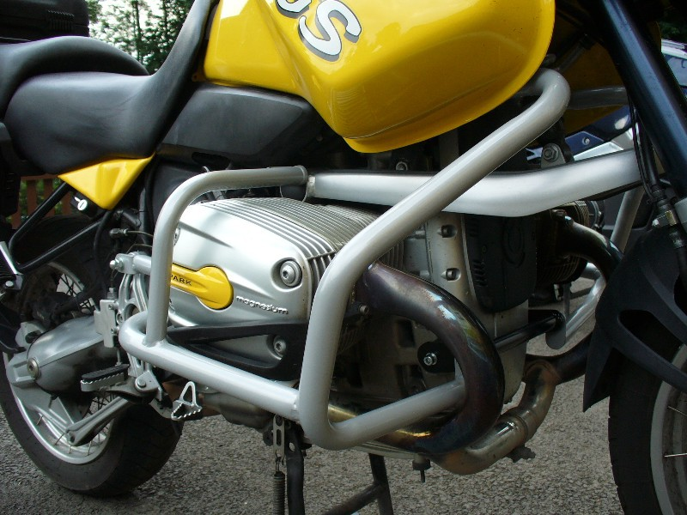
original bolt
bolt M8x25mm + pad M8 (spring)

nut M8 (safety) + pad M8 (plane) + silenblock
Screw M10x70mm, dural. cylinder l=15mm and spring washer

The left side:

bolt M10x100mm + duralumin cylinder 55mm + pad M10 (spring)
original bolt

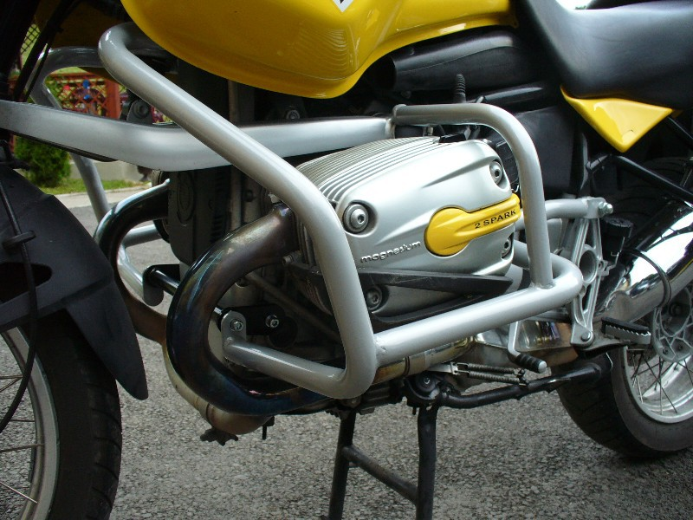
Screw M10x70mm, dural. cylinder l=15mm and spring washer

nut M8 (safety) + pad M8 (plane) + silenblock
bolt M8x25mm + pad M8 (spring)

