CF09
Yamaha XV1700 Warrior

Kit for the left side |  |  |  |  | Kit for the right side
ID | Description | Cat.no. | Pcs |  | ID | Description | Cat.no. | pcs
1 | Dural. Cylinder | 106 | 1 |  | 1 | Dural. Cylinder | 106 | 1
2 | Bolt M10x85 | 981 | 1 |  | 2 | Bolt M10x85 | 981 | 1
3 | Washer M10 | 804 | 2 |  | 3 | Washer M10 | 804 | 2
4 | Nut M10 (safety) | 810 | 1 |  | 4 | Nut M10 (safety) | 810 | 1
5.1 | Bolt M6x30 | 864 | 1 |  | 5.2 | Bolt M6x40 | 865 | 1
6 | Washer M6 | 987 | 1 |  | 6 | Washer M6 | 987 | 1
- | - | - | - |  | 7 | Cylinder | 115 | 1
8 | Bolt M8x25 | 831 | 1 |  | - | - | - | -
9 | Washer M8 | 802 | 1 |  | - | - | - | -
10 | Poly cylinder | X9 | 1 |  | - | - | - | -

Instructions

- We recommend to use the glue on all threads (medium strong).
- First slightly fit crash frame at the bottom using bolt (ID2).
- Insert cylinder (ID1) between frame and motorcycle.
- Tighten it slightly using safety nut (ID4).
- Do not forget to place washer (ID3) under bolt and nut.
- Now fit upper part of frame using bolt (ID8). Do not forget to place washer (ID9).
- Insert poly cylinder (ID10) between frame and motorcycle.
- Now fit upper part of frame on both sides.
  - On the left side is only bolt(ID5.1) and washer (ID6).
  - On the right is bolt (ID5.2), washer (ID6) and cylinder (ID7).
- In the end tighten all bolts and nuts.
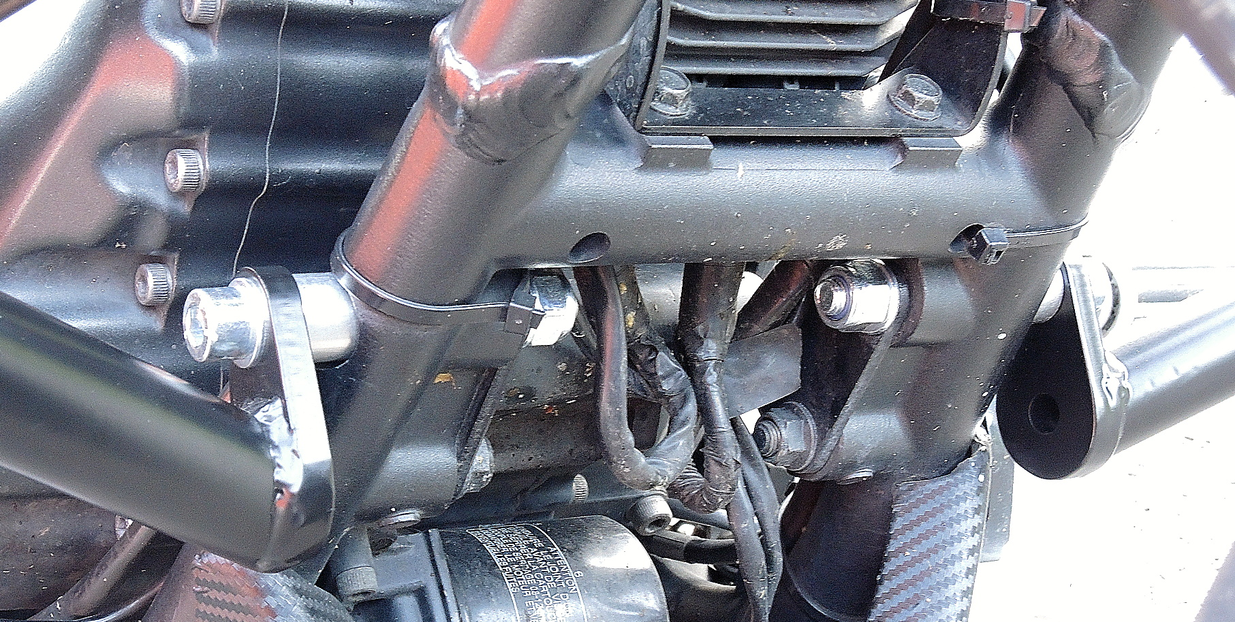

ID1 + ID2 + ID3 + ID4

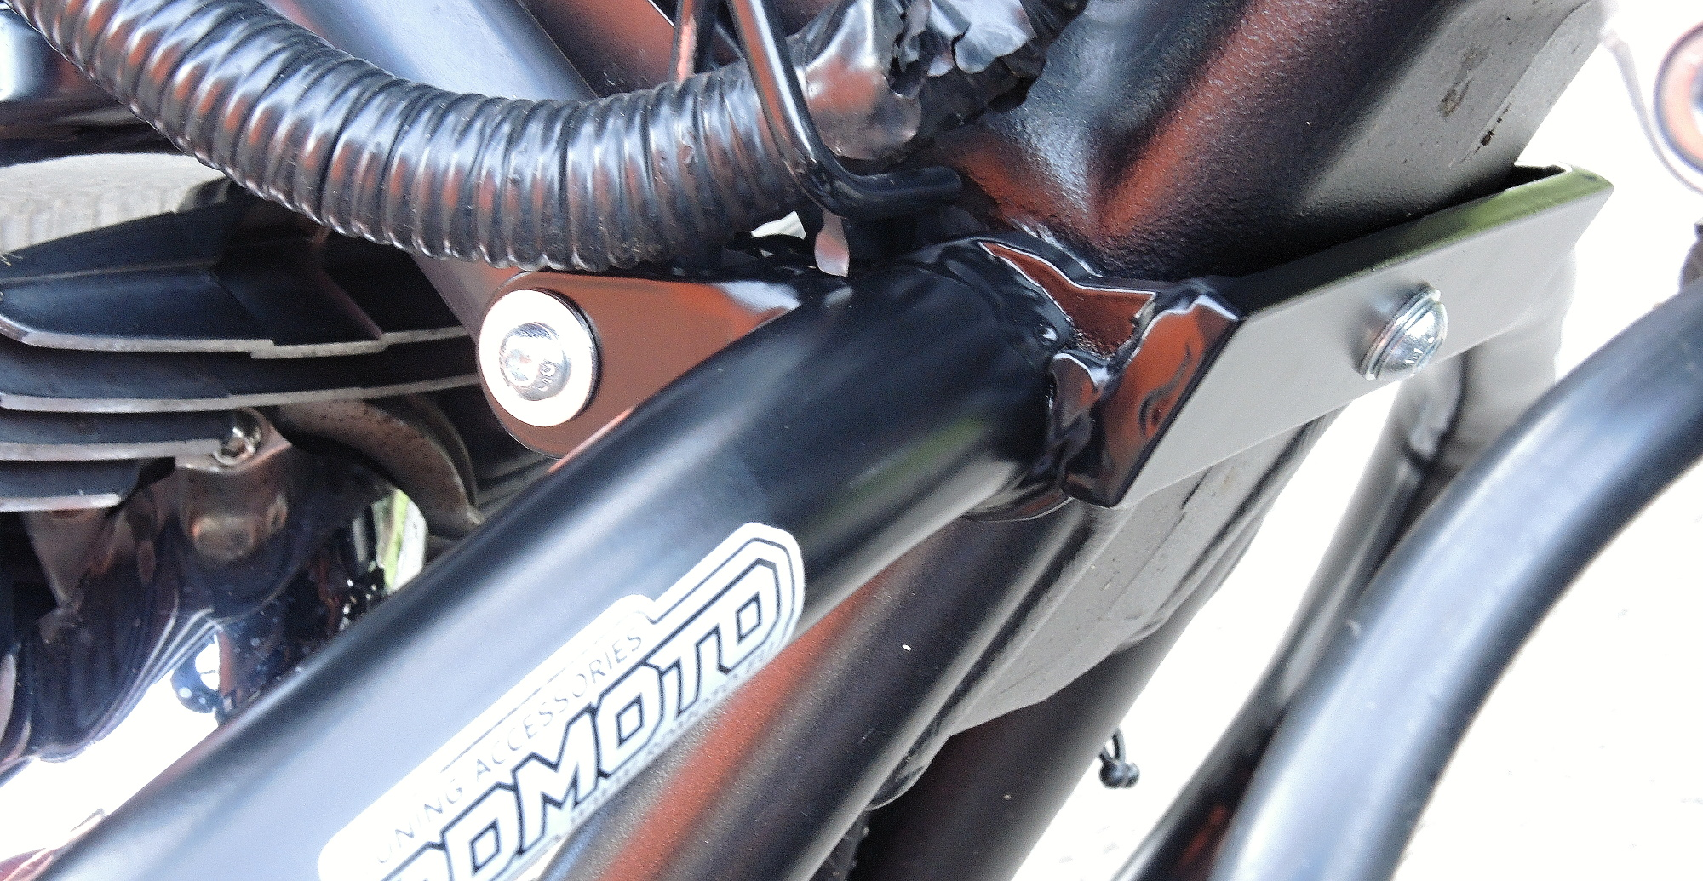
ID8 + ID9 + ID10
Left side: ID5.1 + ID6
Right side: ID5.2 + ID6 + ID7

