CF100
Lower
Honda CRF 1000 Africa Twin ´18-

Mounting kit:
ID | Description | Cat.N | Pcs
1 | Roller d=25, hole diam 8,5 | 1257 | 2
2 | Bolt M8x70 | 841 | 2
3 | Washer M8 flat | 802 | 2
4 | Silentblock | X34 | 1
5 | Nut M8 | 813 | 1
6 | Sticker RD moto |  | 2

Proceed with installation as shown on the photos below.
Attention: We recommend using thread glue (blue color) during installation.

First, take off the botom engine cover. Then, unscrew the original M8 bolt from the frame. Finally, attach the washer with crash frame onto the ID.2 bolt from the right side of the motorcycle.
Place ID.1 roller and ID.4 silentblock under right side of the frame. Then, loosen bolt in the back part and fit the frame – slightly tighten the screws yet. Now do the same on the left side.
Finally, fit the engine cover to its original place again and you are done!

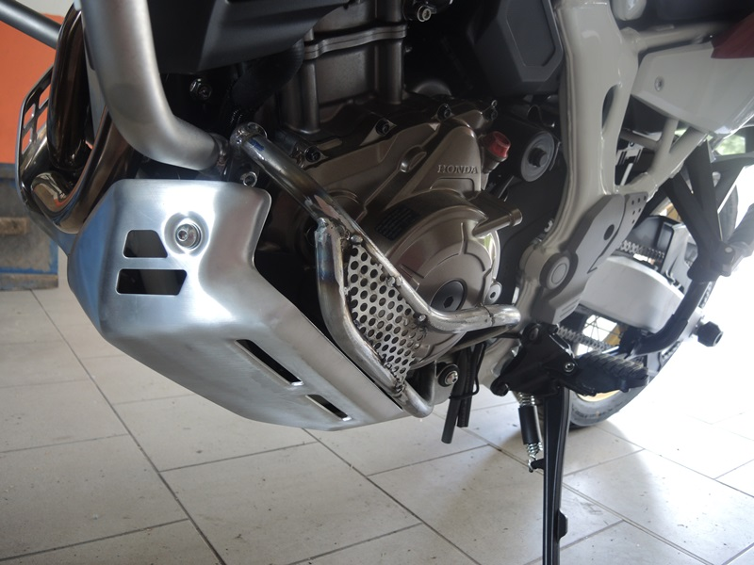
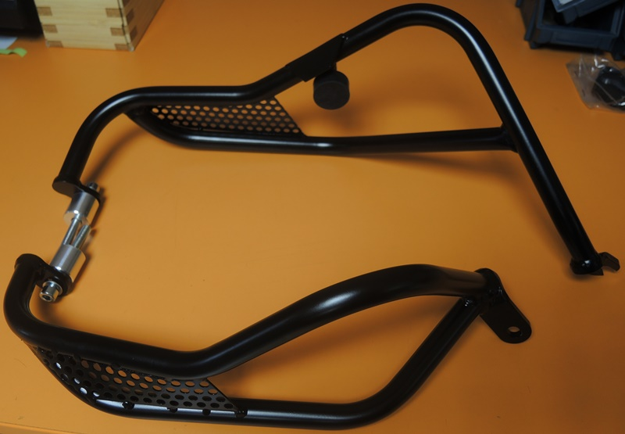
Silentblock ID.4 + nut M8 ID.5

Bolt M8 ID.2 + Roller ID.1
origináll
Original

ID.2 + ID.1
ID.2 + ID.1

4,5
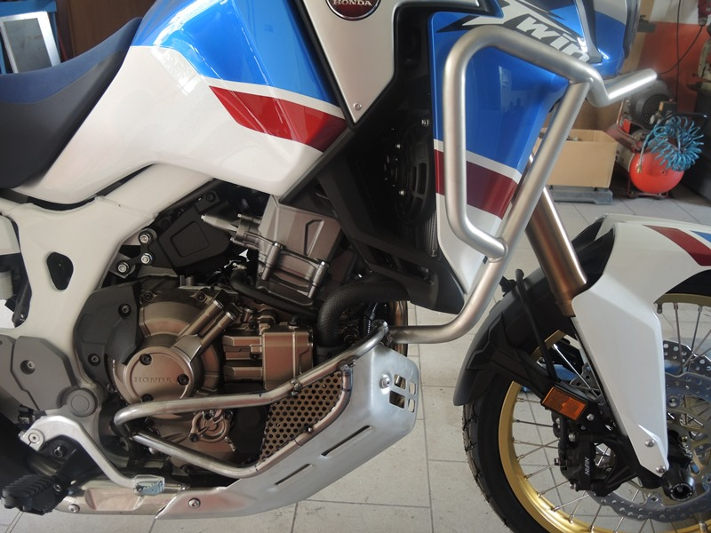
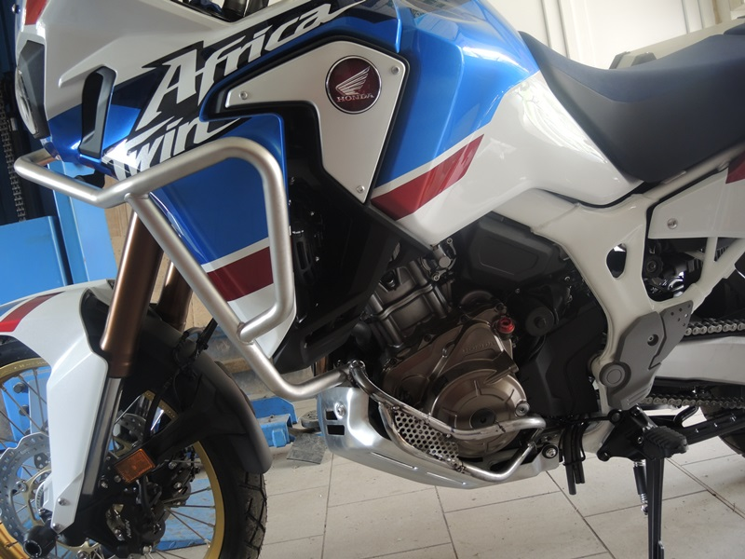
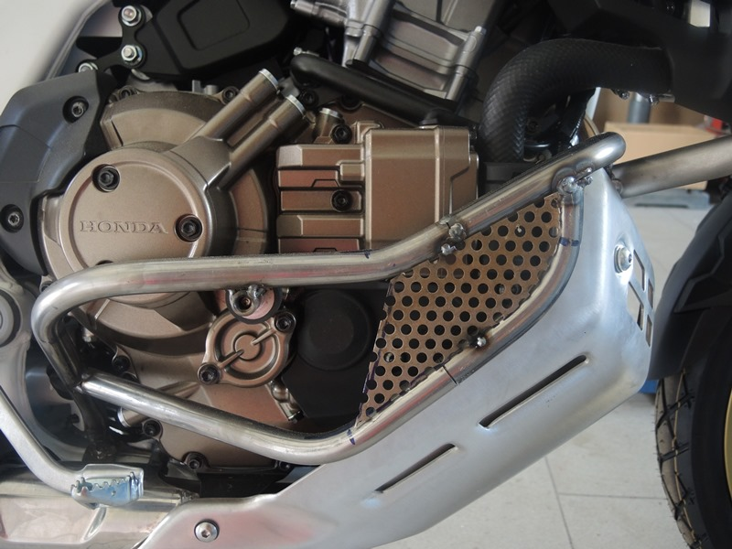
Original šrouby
Original bolts

