CF101
KTM 390 Duke_2018-

Kit for Left Side |  |  |  |  | Kit for Right Side
ID | Description | Cat. No. | Pcs. |  | ID | Description | Cat. No. | Pcs.
1 | Frame | CF101 | 1 |  | 1 | Frame | CF101 | 1
2 | Dural. roller d=30mm | 1252 | 1 |  | 2 | Dural. roller d=30mm | 1252 | 1
3 | Safety Nut M10 | 810 | 1 |  | 3 | Safety nut M10 | 810 | 1
4 | Washer M10 flat | 804 | 1 |  | 4 | Washer M10 flat | 804 | 1
5 | RDmoto stickers |  | 1 |  | 5 | RDmoto Stickers |  | 1
6 | Bolt M8x45 | 964 | 2 |  | 6 | Bolt M8x45 | 964 | 2
7 | Dural. roller d=13mm | 464 | 2 |  | 7 | Dural. roller d=13mm | 464 | 2
8 | Washer Flat M8 | 802 | 2 |  | 8 | Washer M8 Flat | 802 | 3
9 | Dural. roller d=5,6mm | 214 | 1 |  | 9 | Bolt M8x40 | 828 | 1
10 | Rod 10x240x30x30 |  | 1 |  | 10 | Dural. roller d=16mm | 252 | 1

We recommend using medium strenght thread glue.

Mouting Instructions (same for both sides):

- Unscrew the original bolt on bottom left side and replace it with ID.10 Rod, onto which you should put the ID.2 roller, then frame and finally ID.4 M10 washer with ID.3 M10 nut.
- Then, remove two bolts in top part and one in rear part as shown on attached pictures.
- Instead of the two bolts in top part, put the ID.7 rollers between motorcycle frame and crash frame and attach it using M8 ID.8 washers and M8 ID.6 bolts.
- At the rear part, replace original roller with ID.9 roller and frame, then tighten this assembly with the original bolt.
- Use the same steps for mounting the right side, only now at the rear part replace original bolt with ID.10 roller and M8 ID.9 bolt.
- As a last step, equally tighten and check all nuts and bolts at both sides.

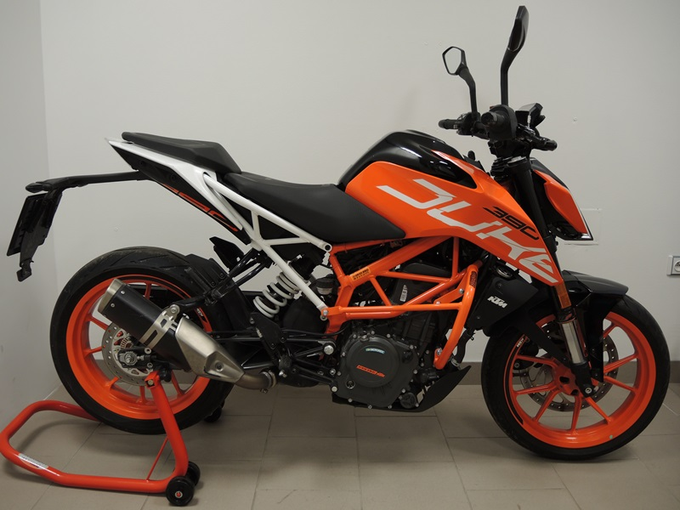

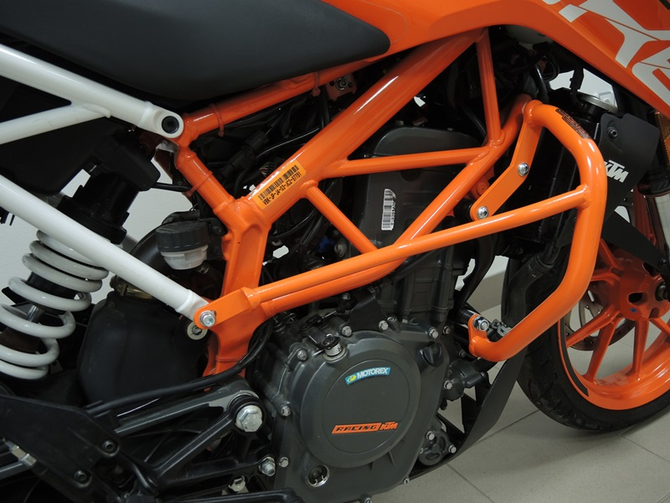
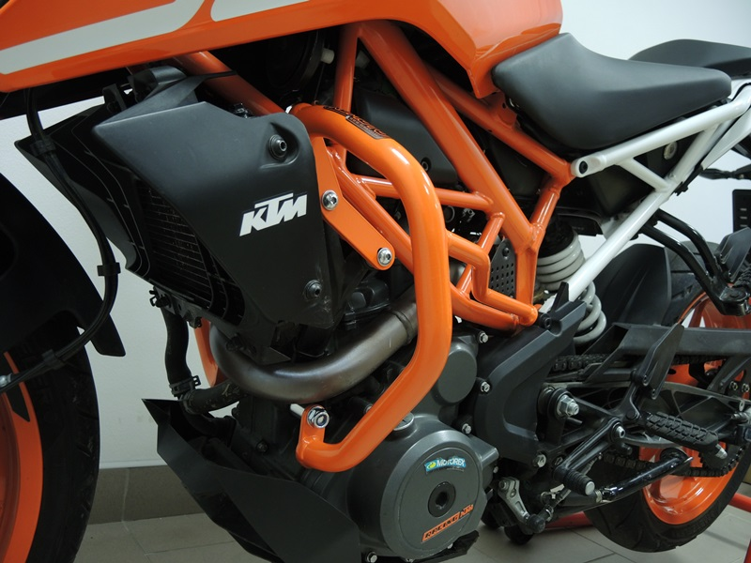
Rod 10x240 ID.10 + Dural.roller ID.2 + Washer M10 ID.4

Original bolt + Dural.roller ID.9
Rod 10x240 ID.10 + Dural.Roller ID.2 + Washer M10 ID.4

Dural. Roller ID.10 + Washer M8 ID.8 + Bolt M8 ID.9

Bolt M8 ID.6 + Washer M8 ID.8 + Roller ID.7
Bolt M8 ID.6 + Washer M8 ID.8 + Roller ID.7

9
13,11,12
10
Origin.bolt
Original bolt. Rear place.

