CF102
Honda CB 300 R_2018-

Kit for Left Side |  |  |  |  | Kit for Right Side
ID | Description | Cat. No. | Pcs. |  | ID | Description | Cat. No. | Pcs.
1 | Frame | CF102 | 1 |  | 1 | Frame | CF102 | 1
2 | Dural. roller d=36mm | 1239 | 1 |  | 2 | Dural. roller d=36mm | 1239 | 1
3 | Safety nut M10 | 810 | 3 |  | 3 | Safety nut M10 | 810 | 3
4 | Washer M10 flat | 804 | 3 |  | 4 | Washer M10 flat | 804 | 3
5 | Rod 10x285x30x30 |  | 1 |  | 5 | Dural. roller d=47mm | 48 | 1
6 | Rod 10x120x30x30 |  | 1 |  | 6 | RDmoto Stickers | L+P | 2
7 | Rod 10x230x30x30 |  | 1

We recommend using medium strenght thread glue during assembly.

Instructions (same for both sides):

- Take off the original bolts and replace them with rods, as shown on attached pictures.
- Take the ID.2 roller and fit it onto the rod in front part from both sides of the frame.
- Starting with left side, fit the ID.4 M10 washers and M10 ID.4 nuts onto all three rods in the frame.
- Then, fit the frame from right side and insert the ID.5 roller between the motorcycle and crash frame in the rear part.
- Then, take the M10 ID.4 washers, attach them using M10 ID.3 nuts and fit them onto the remaining three rods.
- Finally, tighten the nuts on both sides and make sure that all fits.
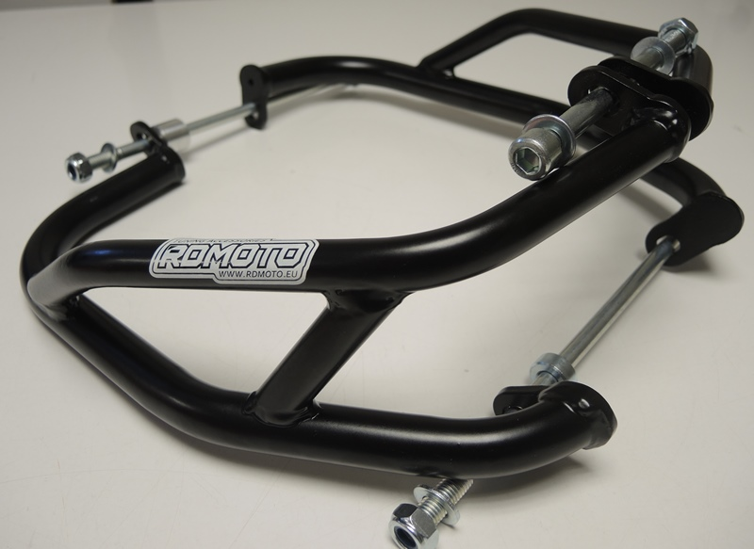

ID6 + ID2+ ID3,4
ID7 + ID3 + ID4

ID5
ID5 + ID3 + ID4
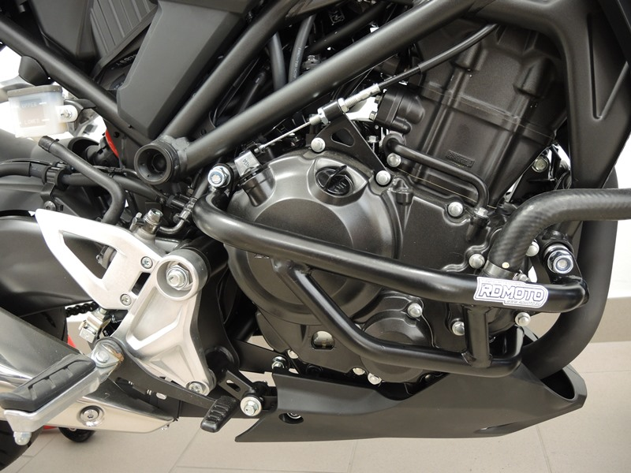
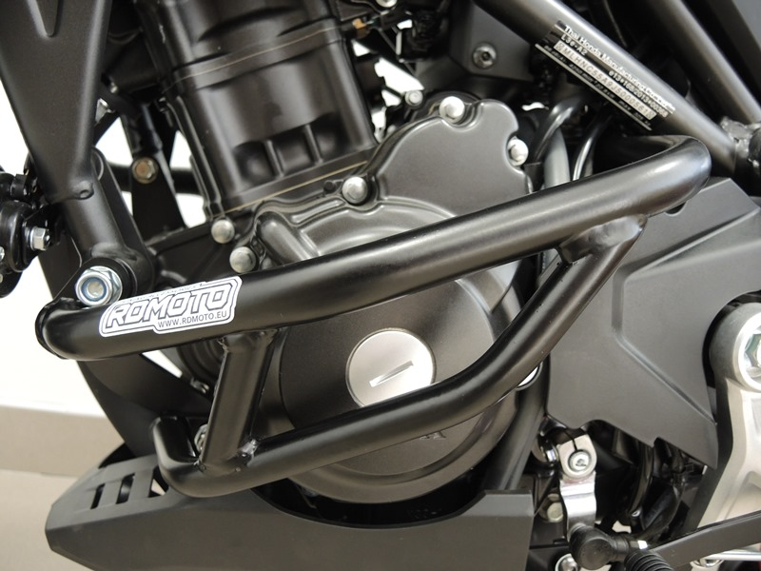
Rod 10x285 ID.5+ Dural.roller ID.2 + Washer M10 ID.4 + Nut M10 ID.3
Rod 10x120 ID.6 + Dural.roller ID.2 + Washer M10 ID.4
Rod 10x230 + ID.7 + Dural.roller ID.2 + Washer M10 ID.4
Dural.roller ID.2 + Washer M10 ID.4 + Nut M10 ID.3
Washer M10 ID.4 + Nut M10 ID.3
Dural. roller ID.5 + Washer M10 ID.4 + Nut M10 ID.3

9
13,11,12
10
Origin.bolt
Original bolt. Rear place.

