CF103KD
Honda CMX 500 Rebel 2017-

Kit for left side |  |  |  |  | Kit for right side
ID | Description | Cat. No. | Pcs. |  | ID | Description | Cat. No. | Pcs.
1 | Crash Frame |  | 1 |  | 1 | Crash Frame |  | 1
2 | Washer M10 flat | 804 | 1 |  | 2 | Washer M10 flat | 804 | 1
3 | Bolt M10x60 | 979 | 1 |  | 3 | Safety nut M10 | 810 | 1
4 | RD moto sticker |  | 1 |  | 4 | RD moto Sticker |  | 1
5 | Bolt M8x25 | 833 | 1 |  | 5

We recommend using medium strenght glue for threads of all bolts.

Mounting instructions:

- On the left side, take off the original bolt from lower part of frame (behind the radiator) and the long bolt from rear part going through the motorcycle (see photo).
- Take the original bolt and push it through the crash frame in the front part, attaching it with the original nut (do not tighten yet).
- Then, put the ID.2 Washer onto the M10 ID.3 Bolt and push it through the motorcycle frame.
- Unscrew the original bolt from right front side (behind the radiator) as well, then use it to push it through the frame and fit together with the left side in front of the radiator. Attach this assembly into the frame with original bolt and original nut and then, fit it onto the bolt sticking out in the back.
- Fit the ID.2 M10 washer and ID.3 M10 nut.
- As a last step, tighten the front part using M8 ID.5 bolt and finally, tighten all bolts and nuts.
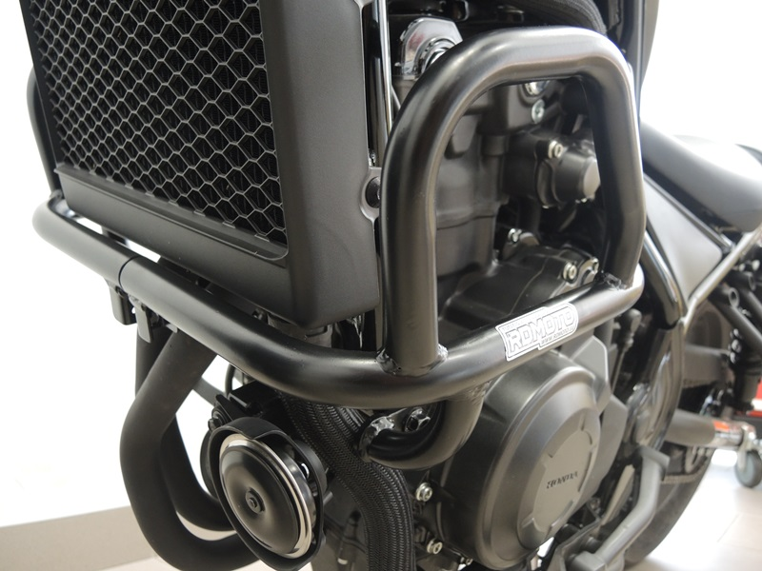

ID.5
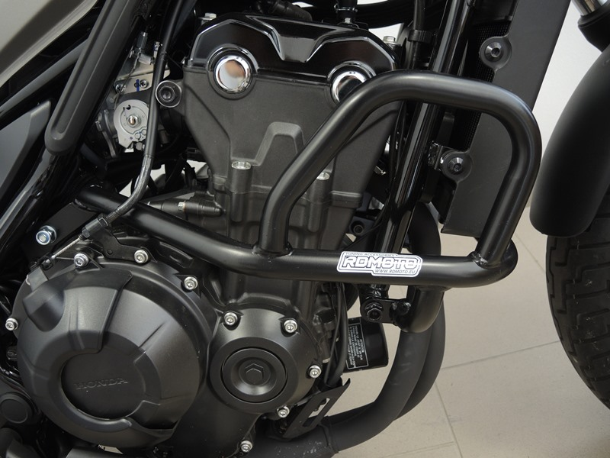
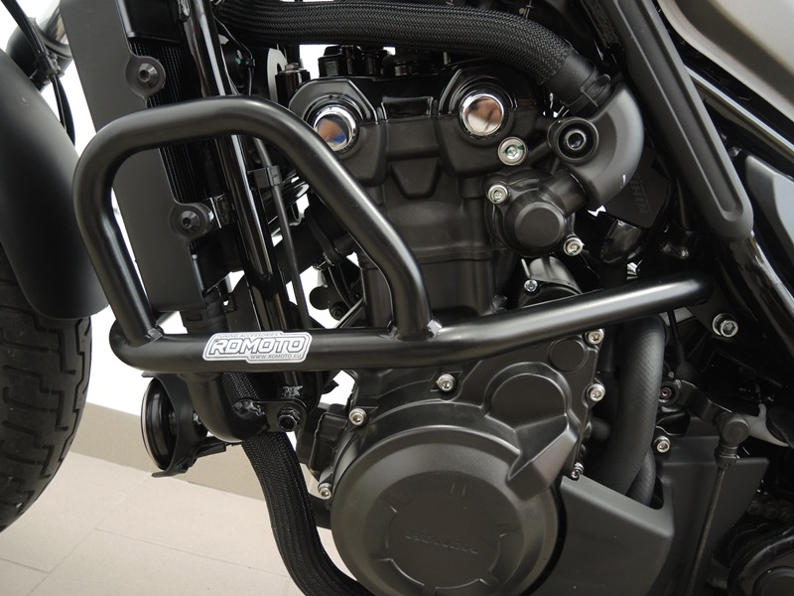
Washer M10 ID.2+ Nut M10 ID.3
Bolt M10 ID.3 + Washer M10 ID.2
Original Bolt M10
Original Bolt M10
9
13,11,12
10
Origin.bolt
Original bolt. Rear place.

