CF104
Honda X-ADV 750_2017-

Kit for left side |  |  |  |  | Kit for right side
ID | Description | Cat. No. | Pcs. |  | ID | Description | Cat. No. | Pcs.
1 | Frame | CF104 | 1 |  | 1 | Frame | CF104 | 1
2 | Bolt M8x60 | 838 | 1 |  | 2 | Bolt M8x60 | 838 | 1
3 | Bolt M8x50 | 837 | 1 |  | 3 | Bolt M8x50 | 837 | 1
4 | Dural. roller d=31mm | 1264 | 1 |  | 4 | Dural. roller d=31mm | 1264 | 1
5 | Dural. roller d=19mm | 1265 | 1 |  | 5 | Dural. roller d=19mm | 1265 | 1
6 | Bolt M8x40 | 828 | 1 |  | 6 | Bolt M8x40 | 828 | 1
7 | Washer M8 flat | 800 | 2 |  | 7 | Washer M8 flat | 800 | 2
8 | Plastic cover | X5 | 3 |  | 8 | Plastic cover | X5 | 3
9 | RDmoto Sticker |  | 1 |  | 9 | RDmoto Sticker |  | 1

We recommend using medium strenght thread glue.

Mounting Instructions (same for both sides):

- Unscrew the original bolts from your motorcycle.
- Prepare the new frame all necesarry bolts.
- Attach the top part with M8 ID.2 bolt, then do the same with bottom part and M8 ID3 bolt + M8 ID.7 washer (insert the ID.4 roller between crash frame and motorcycle frame) and then mount the rear part with M8 ID.6 bolt + ID.7 washer (here use the ID.5 roller to put between crash and motorcycle frame).
- Proceed on the other side using the same procedure
- Finally, tighten all screws and attach ID.8 plastic covers.
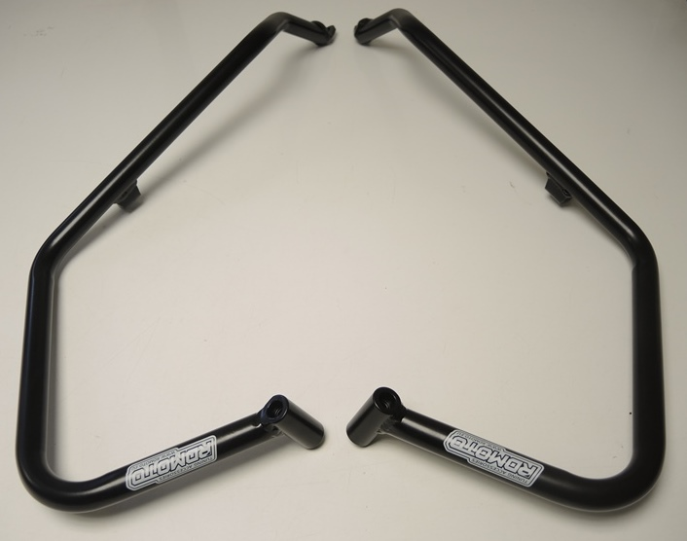

ID6

ID3
ID2
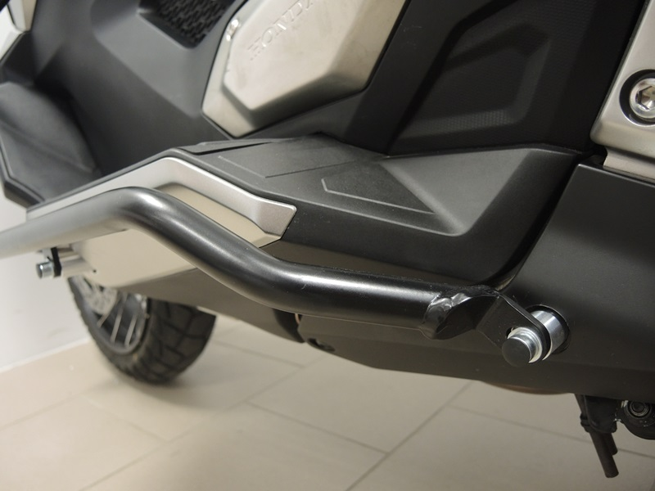
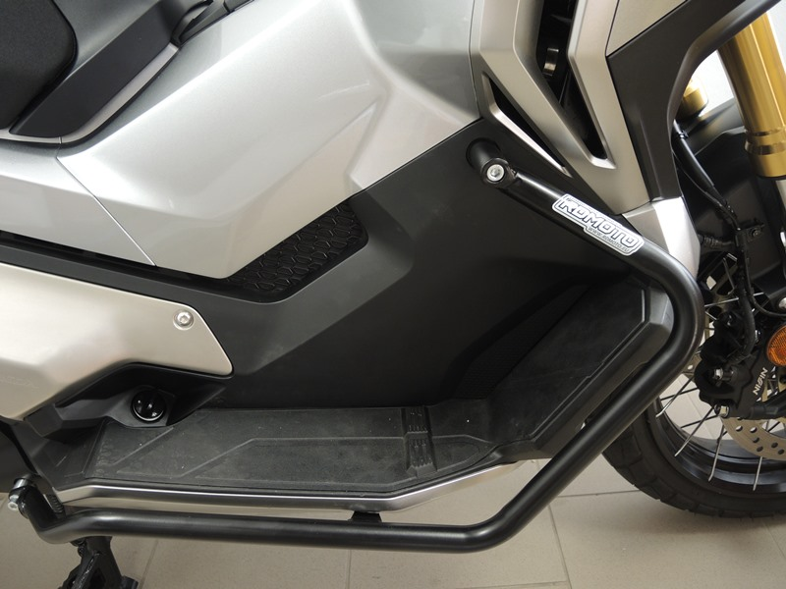
Bolt M8 ID3 + washer M8 ID7 + dural. roller ID 4 + ID8
Bolt M8 ID2 + ID8
Bolt M8 ID6 + Washer M8 ID7 + dural. roller ID5 + ID8
9
13,11,12
10
Origin.bolt
Original bolt. Rear place.

