CF106
Exhaust
Honda X-ADV 750 ´17-

Mounting Kit:
ID | Description | Cat. No. | Pcs.
1 | Dural. roller | 1263 | 1
2 | Bolt M6x30 | 863 | 1
3 | Bolt M8x60 | 838 | 1
4 | Washer M6 flat | 947 | 1
5 | Washer M8 flat | 800 | 1
6 | RD moto Sticker |  | 1

Mount the frame as shown on the attached pictures.
Note: We recommend using medium strenght glue (blue color) for threads of all screws.

First, take off the original bolts from the exhaust cover. Then, put the M6 ID.4 washer onto bolt ID.2 M6 and pus hit through the front part of the frame. Fit the ID.1 roller and mount this assembly onto front part of the exhaust (see pictures). Dont tighten yet!
Finally, take the ID.5 washer, put it onto the ID.3 M8 bolt and attach the frame in the rear part of the exhaust.

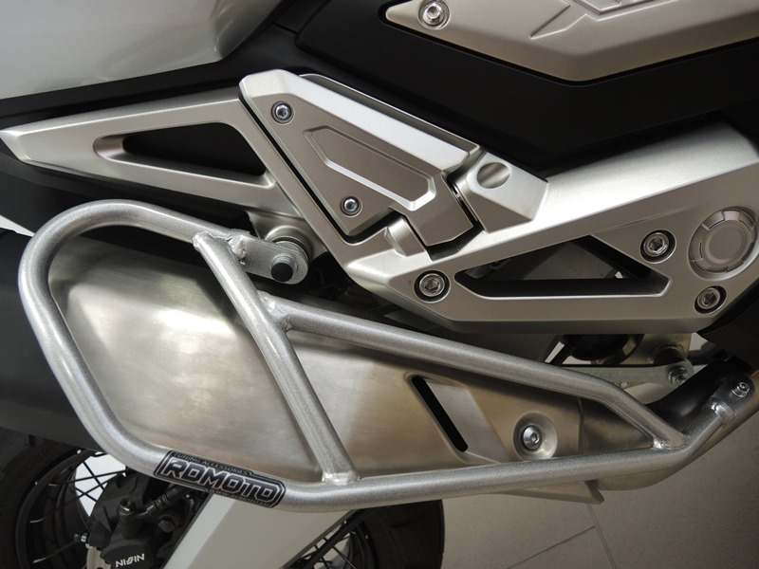
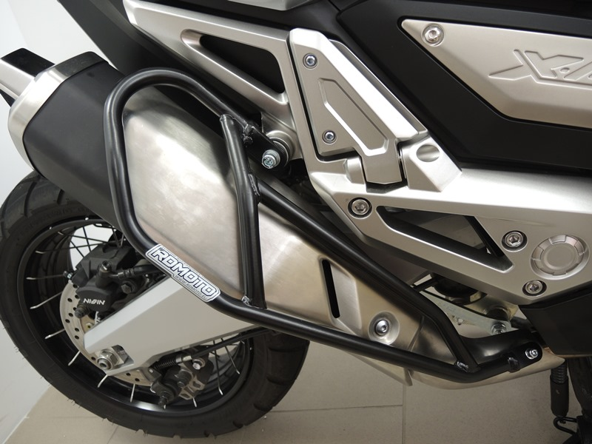

Bolt M8 ID.3 + Washer M8 ID.5

4,5
Bolt M6 ID2 + Washer M6 ID4 + dural. roller ID1

