CF108R
Yamaha MT-09

Kit for Left Side |  |  |  |  | Kit for Right Side
ID | Description | Cat. No. | Pcs. |  | ID | Description | Cat. No. | Pcs.
1 | Frame |  | 1 |  | 1 | Frame |  | 1
2 | Bolt M10x120x1.25mm | 895 | 1 |  | 2 | Bolt M10x110x1.25mm | 928 | 1
3 | Slider adapter d=40mm | 317 | 1 |  | 3 | Slider adapter d=40mm | 317 | 1
4 | Washer M10 flat | 804 | 1 |  | 4 | Washer M10 flat | 804 | 1
5 | Dural. roller d=13mm | 1127 | 1 |  | 5 | Dural. roller d=5mm | 168 | 1
6 | Safety nut M10 | 810 | 1 |  | 6 | Safety nut M10 | 810 | 1
7 | Bolt M6x25mm | 877 | 3 |  | 7 | Bolt M6x25mm | 877 | 3
8 | bolt M4x16mm | 876 | 2 |  | 8 | Bolt M4x16mm | 876 | 2
9 | SL01- K |  | 1 |  | 9 | SL01- K |  | 1
10 | CapSL-K |  | 1 |  | 10 | CapSL-K |  | 1
11 | RDmoto sticker |  | 1 |  | 11 | RDmoto sticker |  | 1
 |  |  |  |  | 12 | Rod 10x 300x30x30mm |  | 1

We recommend using medium strenght thread glue.

Mounting Instructions (same for both sides):

- Remove the original bolt from upper part of the frame.
- Prepare the Slider adapter (ID.3), Bolt (ID.2) and Dural. roller (ID.5) depending on which side of motorcycle you are installing at this point.
- Attach the upper part with M10 (ID.2) Bolt.
- Remove the original bolt from the bottom part of frame.
- Now push through the Rod (ID.12), fit the rear of the frame and attach it using M10 (ID.4) washers and nuts (ID.6).
- Finally, tighten all assembly. As a last step, mount the slider using ID.7 bolts and the Cap with ID.8 bolts.
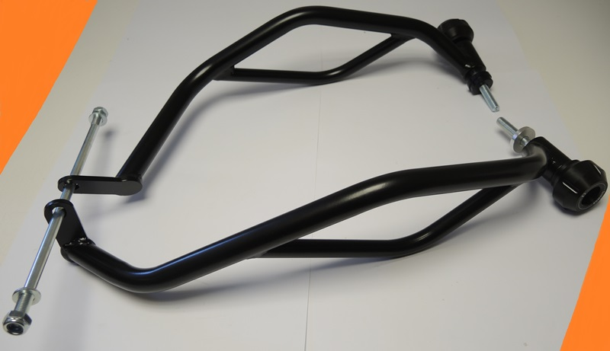
ID.5 - L

Rod ID.12 + Safety nut M10 ID.6 + Washer M10 ID.4
ID.5 - P

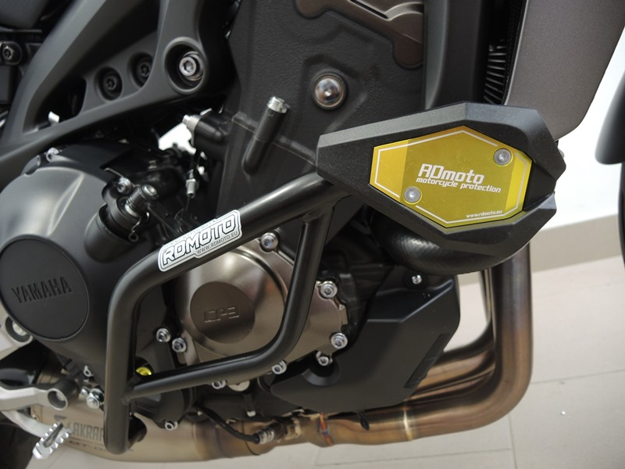

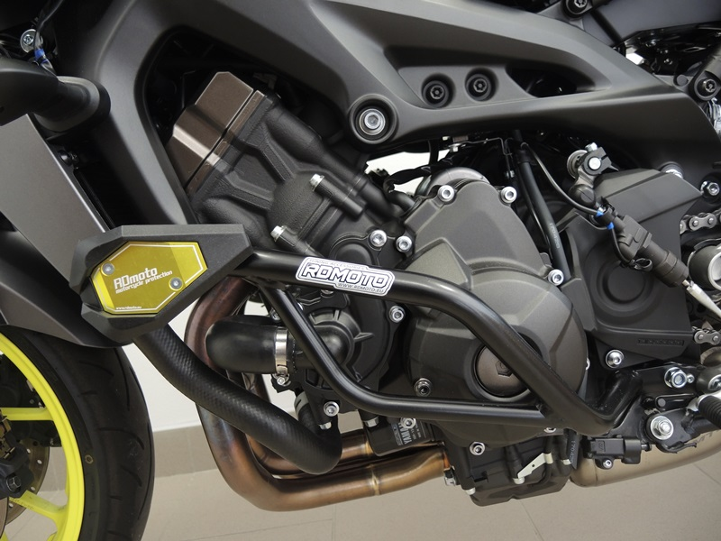
9
13,11,12
10
Origin.bolt
Original bolt. Rear place.

