CF109
Honda CB 1000 R Neo Sport Café

Kit for left side |  |  |  |  | Kit for right side
ID | Description | Cat. No. | Pcs. |  | ID | Description | Cat. No. | Pcs.
1 | AL insertion for protector | X122 | 1 |  | 1 | AL insertion for protector | X122 | 1
2 | Bolt M12x125x1.25 | 952 | 1 |  | 2 | Bolt M12x125x1.25 | 952 | 1
3 | Protector | PVPKN-0/16 | 1 |  | 3 | Protector | PVPKN-0/16 | 1
4 | Washer M10 flat | 804 | 1 |  | 4 | Washer M10 flat | 804 | 1
5 | Safety nut M10 | 810 | 1 |  | 5 | Safety nut M10 | 810 | 1
6 | Plastic cover M12 | X60 | 1 |  | 6 | Plastic cover M12 | X60 | 1
7 | RDmoto sticker |  | 1 |  | 7 | RDmoto sticker |  | 1
8 | Nut cap M10 | X35 | 1 |  | 8 | Nut cap M10 | X35 | 1
 |  |  |  |  | 9 | Rod 400x10x30x30 |  | 1

We recommend using medium strenght thread glue during assembly.

Mounting instructions (same for both sides):

- Unscrew the original bolt from upper part of the frame.
- Prepare the protector with its bolt.
- Attach the upper part of ID.1 Frame using the ID.2 M12 bolt, but do not tighten yet.
- In the rear part, take the ID.8 Rod and push it through. Now attach the crash frame onto the rod with ID.4 washer and Id.5 M10 nut.
- Use the same instructions for installing the left side.
- Finally, tighten all bolts and fit the caps (ID.6).
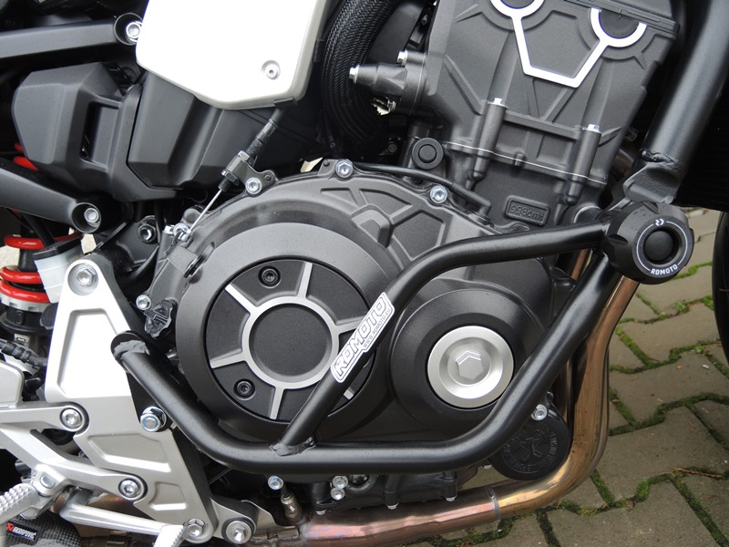

ID2 + ID3 + ID6

9
13,11,12
10
ID9 + ID4 + ID5 + ID8
Origin.bolt
Original bolt. Rear place.

