CF10
Suzuki DR650SE
Mounting kit
Note | Description | Cat.No | Quan.
1 | Bolt M8x110 | 844 | 1
2 | Washer M8 | 802 | 4
3 | Bolt M8x45mm | 820 | 1
4 | Bolt M8x25mm | 831 | 2
5 | Washer M8 (spring) | 800 | 2
6 | aluminium. cylinder d=13mm | 130 | 1
7 | dural. cylinder d=60mm | 434 | 1
8 | dural. cylinder d=21mm | 1158 | 1
9 | Washer M10 | 805 | 1
10 | Stickers RDmoto |  | 2
11 | Adapter | X72 | 1

Mounting instruction:

During installation it is necessary to adjust the cutting off cooler holder..

Warning - the threads of the screws is recommended to use glue (blue color).

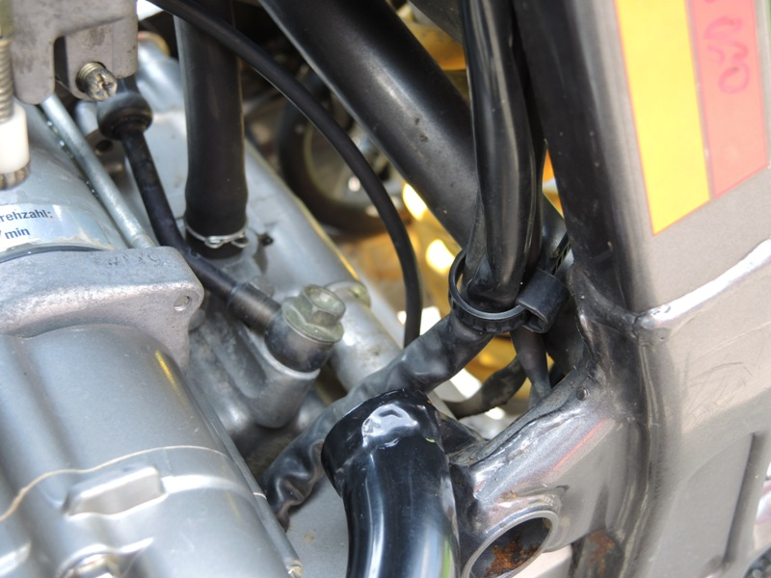
- Dismantle original bolt from frame.
- On the left side insert duralumin cylinder (note 7) and right side insert duralumin cylinder (note 8) and insert crash frames, this set fixed by original bolt.

- Remove bolt from coolant.
- Insert aluminum cylinder (note 6). Used bolt (no. 3 ) and washer (no. 9 and 2 ).
- Trought the frame insert bolt (no. 1) used washer (no. 2) and original nut.
- It is important to cut holder.
- Connect frames, used steel bar, bolts (no. 4) and washer (5 and 2).
