CF111KD
BMW F850GS 2018-

Kit for left side |  |  |  |  | Kit for right side
ID | Description | Cat. No. | Pcs. |  | ID | Description | Cat. No. | Pcs.
1 | Frame |  | 1 |  | 1 | Rám |  | 1
2 | Bolt M12x100 | 986 | 2 |  | 2 | Bolt M12x110 | 946 | 2
3 | Washer flat M12 | 803 | 2 |  | 3 | Washer flat M12 | 803 | 2
4 | Dural. roller d=52,4mm | 1273 | 1 |  | 4 | Dural. roller d=11mm | 1272 | 2
5 | Dural. roller d=51mm | 1274 | 1 |  | 5 | Sticker RD moto |  | 2
6 | Bolt M10x35 | 847 | 1 |  | 6 | Bolt M10x35 | 847 | 1
7 | Washer flat M10 | 804 | 2 |  | 7 | Washer flat M10 | 804 | 1
8 | Plastic cover M12 | X60 | 2 |  | 8 | Plastic cover M12 | X60 | 2
9 | Plastic cover M10 | X4 | 1 |  | 9 | Plastic cover M10 | X4 | 1
10 | Nut M10 | 810 | 1 |  | 10 | Bolt M8x30 | 834 | 1
11 | Washer M10 spring | 801 | 1

We recommend using medium strenght thread glue during assembly.

Mounting Instructions:

- On left of the motorcycle, take off the original bolts from top part of the motorcycle frame (as shown on attached picture).
- Now take the M12 ID.2 bolts and M12 ID.3 washers and push them through the ID.1 crash frame. Then, fit them with ID.4 (front) and ID.5 (rear) rollers and mount the assembly into the motorcylce frame.
- Then, affix it in the rear bottom part with M10 ID.6 bolt, ID.11 spring washer and ID.7 flat washer.
- Now take the right side and unscrew the original bolts from upper part of motorcycle frame (as shown on attached picture).
- Push the M12 ID.2 bolts and M12 ID.3 washers and push them through the ID.1 frame. On them, put the ID.4 dural rollers and mounth the assembly into the motorcycle frame.
- Affix the frame at the bottom rear part with M10 ID.6 bolt and ID.7 washer.
- Finally, tighten the frames together in the fron part using M8 ID.10 bolt.
- Now tighten all screws and place the plastic covers on top of the bolts.

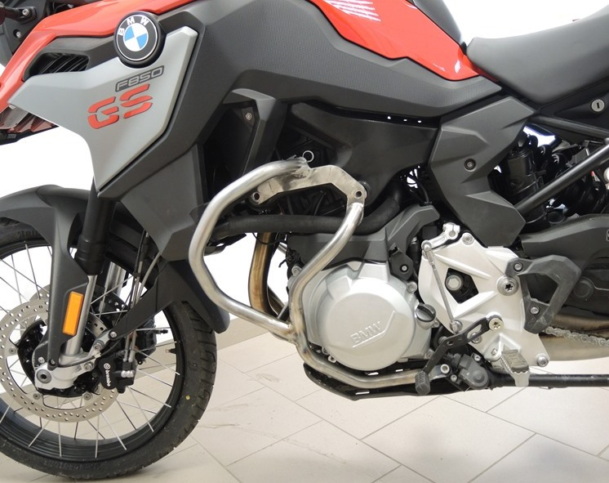
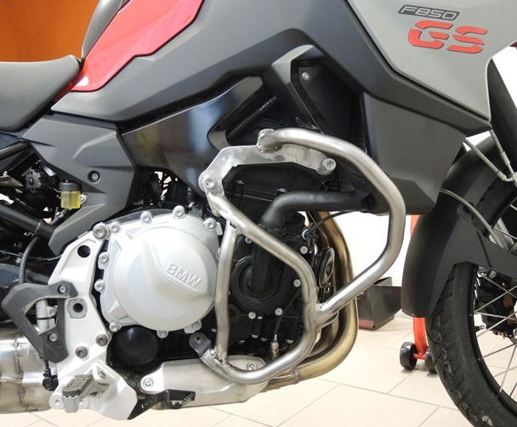
ID.5
Bolt M12 ID.2 + Washer - flat M10 ID.3 + Dural. roller ID.5

Bolt M12 ID.2 + Washer M12 ID.3+ dural roller ID.4
Bolt M10 ID.6 + Washer M10 ID.7
Bolt M10 ID.6 + Washer M10 flat ID.7
Bolt M12 ID.2 + Washer flat M10 ID.3 + Dural. roller ID.4
9
13,11,12
10
Origin.bolt
Original bolt. Rear place.

