CF113
Lower
Honda CRF 1000 Africa Twin Sport Adventure(manual) ´18-

Mounting Kit:
ID | Description | Cat. No. | Pc
1 | Roller d=25, hole diam 8,5 | 1257 | 2
2 | Bolt M8x70 | 841 | 2
3 | Washer M8 flat | 802 | 2
4 | Silentblock | X34 | 1
5 | Nut M8 | 813 | 1
6 | RD Sticker |  | 2

Follow the instructions on pictures below.
Note: We recommend using thread glue during installation (blue color).

First, take off the lower engine guard. Then, unscrew original bolt M8 from the frame. Use the ID.2 bolt and equip it with washer and frame from the right side of the motorcycle.
Now, place the ID.1=25mm roller and ID.4 silentblock underneath the frame on its right side, loosen the bolt in rear part, mount the frame and tighten both bolts. Now do the same on the left side, unscrew the original bolt from frame, place the ID.1 roller, crash frame and ID.3 washer onto the ID.2 bolt, unscrew the original bolt in rear part, mount the crash frame and tighten. Finally, you can place back the engine guards.

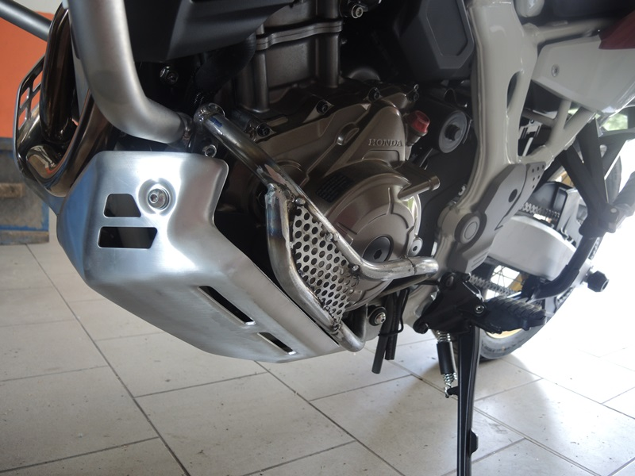

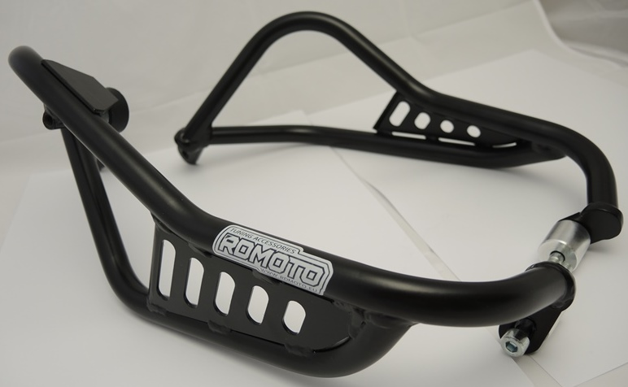

origináll
original

Bolt M8 ID.2 + roller ID.1
Silentblok ID.4 + washer M8 ID.5

ID.2 + ID.1
ID.2 + ID.1

4,5
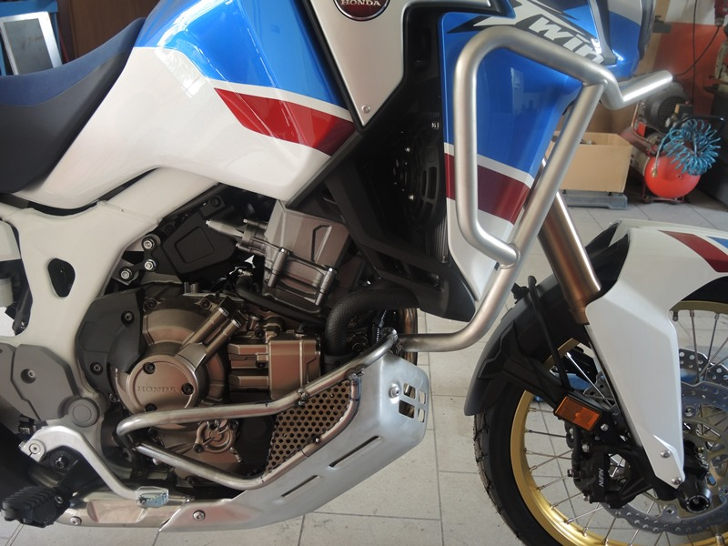
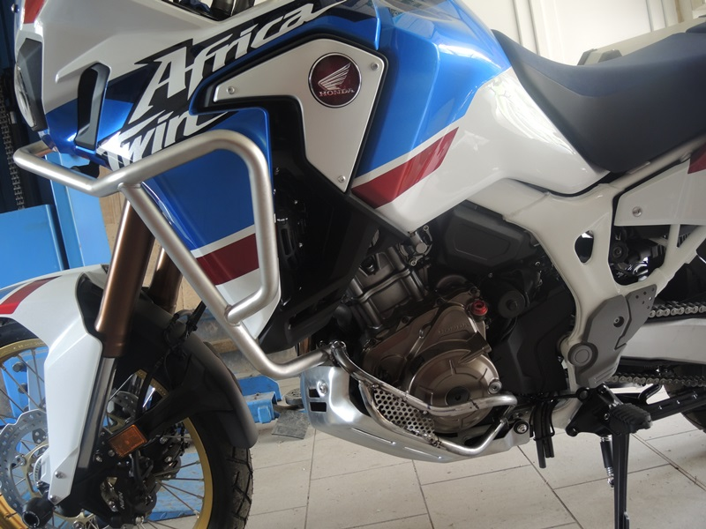
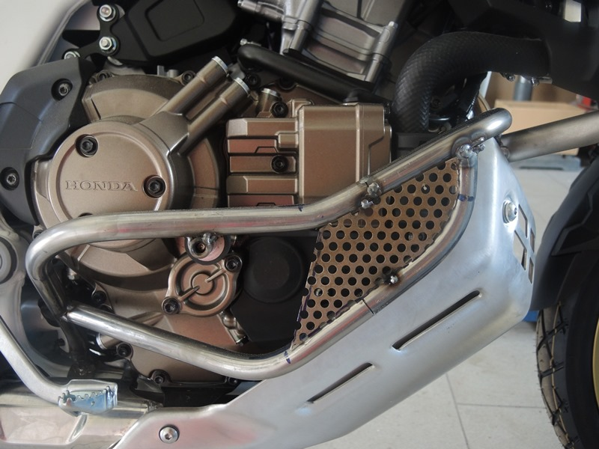
Original šrouby
Original bolts

