CF114
Honda CB 500 F_2018-

Kit for Left Side |  |  |  |  | Kit for Right Side
ID | Description | Cat. No. | Pcs. |  | ID | Description | Cat. No. | Pcs.
1 | Frame | CF114 | 1 |  | 1 | Frame | CF114 | 1
2 | Bolt M10xx80x1,25 | 920 | 1 |  | 2 | Bolt M10x70x1,25 | 898 | 1
3 | Insert for Allen Bolt M10 | X115 | 1 |  | 3 | Insert for Allen Bolt M10 | X115 | 1
4 | Plastic Cover M10 | X4 | 1 |  | 4 | Plastic Cover M10 | X4 | 1
5 | Bolt M10x55x1,25 | 915 | 1 |  | 5 | Bolt M10x55x1,25 | 915 | 1
6 | Pipe Cover | X19 | 1 |  | 6 | Pipe Cover | X19 | 1
7 | RDmoto Sticker |  | 1 |  | 7 | RDmoto Sticker |  | 1

We recommend using medium strenght thread glue during installation.

Mounting Instructions:

- First, unscrew the original M10 bolts on left side and mount the crash frame, as shown on attached pictures.
- Follow the same procedure on the right side.

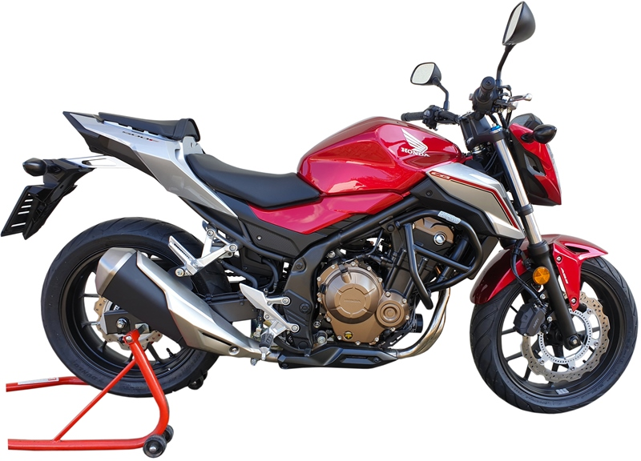

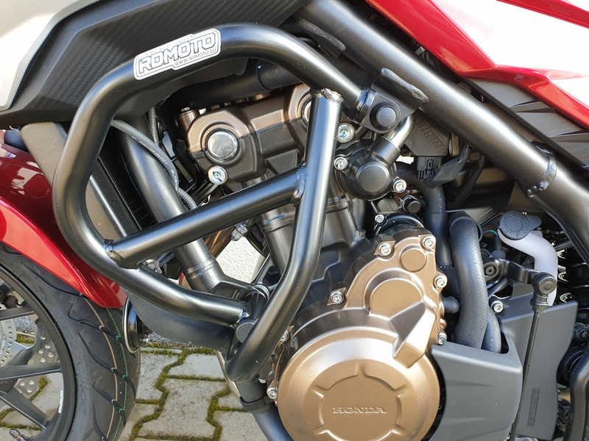
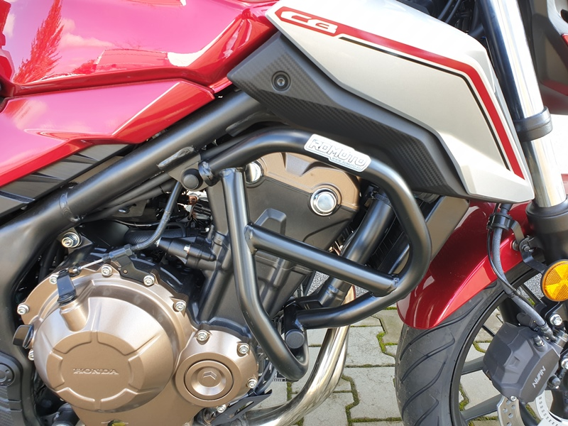
Bolt M10 ID.5 + Cover M10 ID.6
Bolt M10 ID.2 + Insert M10 ID.3 + Cover M10 ID.4

Bolt M10 ID.5 + Cover M10 ID.6

Bolt M10 ID.2 + Insert M10 ID.3 + Cover M10 ID.4
9
13,11,12
10
Origin.bolt
Original bolt. Rear place.

