CF115
BMW R Nine T 2014-

Kit for Left Side |  |  |  |  | Kit for Right Side
ID | Description | Cat. No. | Pcs. |  | ID | Description | Cat. No. | Pcs.
1 | Frame |  | 1 |  | 1 | Frame |  | 1
2 | Bolt M10x65 | 943 | 1 |  | 2 | Bolt M10x75 | 1007 | 1
3 | Washer Flat M10 | 804 | 2 |  | 3 | Washer Flat M10 | 804 | 2
4 | Dural. roller d=19mm | 1285 | 1 |  | 4 | Dural. roller d=30mm | 1287 | 1
5 | Dural. roller d=55mm | 1283 | 1 |  | 5 | Dural. roller d=46mm | 1288 | 1
6 | Dural. roller d=48mm | 1284 | 1 |  | 6 | Dural. roller d=29mm | 1286 | 1
7 | Bolt M10x80 | 852 | 1 |  | 7 | Bolt M10x75 | 1007 | 1
8 | Bolt M12x110 | 946 | 1 |  | 8 | Bolt M12x85 | 1009 | 1
9 | Washer Flat M12 | 803 | 1 |  | 9 | Washer Flat M12 | 803 | 1
10 | Plastic cover M12 | X60 | 2 |  | 10 | Plastic Cover M12 | X60 | 2
11 | Plastic cover M10 | X4 | 2 |  | 11 | Plastic Cover M10 | X4 | 2

We recommend using medium strenght thread glue during installation.

Mounting Instructions:

- First, unplug the cables shown on attached photos.
- Unscrew the original M10 bolt on left upper side and the M12 bolt under the cylinder.
- Use the M10 and M12 bolts and rollers (see photos) to fix the frame guard.
- Follow the same procedure on the other side (except unplugging the cables).
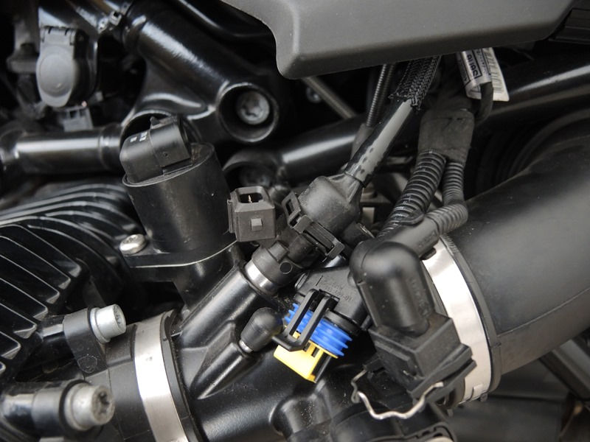

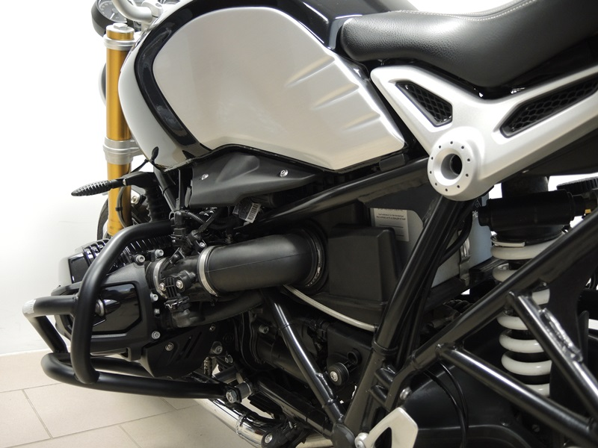
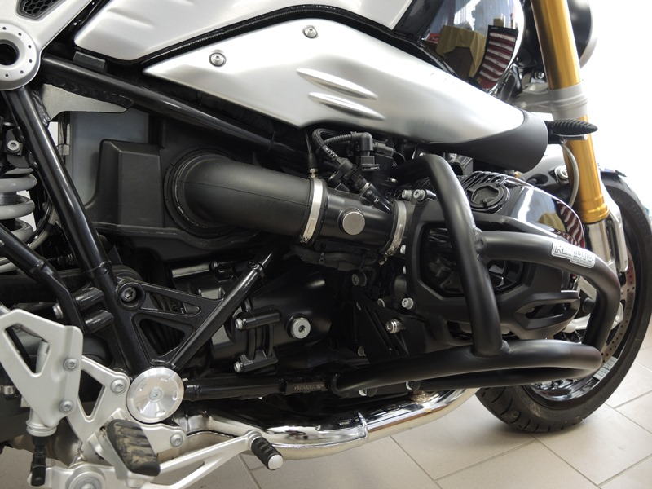
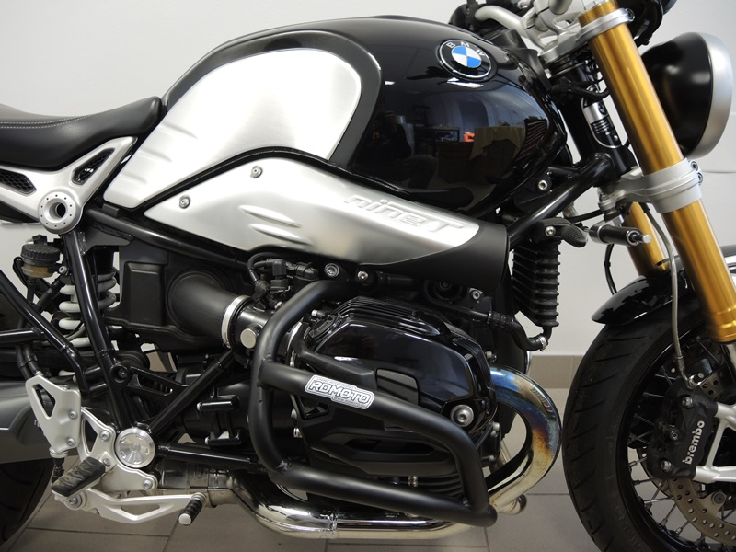
Šroub M12 ID.2 + podložka plochá M10 ID.3 + Dural. váleček ID.5

Bolt M10 ID.2 + Washer M10 ID.3 + Dural. roller ID.4 + Cover M10 ID.11
Bolt M10 ID.2 + Washer M10 ID.3 + Dural. roller ID.4 + Cover M10 ID.11

Bolt M12 ID.8 + Roller ID.6 + Washer M12 ID.9 + Cover M12 ID.10 .
Bolt M10 ID.7 + Washer M10 ID.3 + Cover M10 ID.11
Bolt M12 ID.8 + Roller ID.6 + Washer M12 ID.9 + Cover M12 ID.10.
Bolt M10 ID.7 + Washer M10 ID.3 + Cover M10 ID11.

9
13,11,12
10
Origin.bolt
Original bolt. Rear place.

