CF116
Yamaha V-Max 2009-
Kit for Left Side |  |  |  |  | Kit for Right Side
ID | Description | Cat. No. | Pcs. |  | ID | Description | Cat. No. | Pcs.
1 | Frame | CF116 | 1 |  | 1 | Frame CF116 |  | 1
2 | Bolt M12x105x1,25 | 912 | 1 |  | 2 | Bolt M12x130x1,25 | 1027 | 1
3 | Insert for Allen Bolt M12 | X116 | 1 |  | 3 | Insert for Allen Bolt M12 | X116 | 1
4 | Dural. roller d=30mm | 1298 | 1 |  | 4 | Dural. roller d=54mm | 1297 | 1
5 | Plastic cover M12 | X60 | 1 |  | 5 | Plastic cover M12 | X60 | 1
6 | Bolt M10x55x1,25 | 915 | 2 |  | 6 | Bolt M10x55x1,25 | 915 | 2
7 | Dural. roller d=14mm | 1296 | 2 |  | 7 | Dural. roller d=14mm | 1296 | 2
8 | Insert for Allen Bolt M10 | X115 | 2 |  | 8 | Insert for Allen Bolt M10 | X115 | 2
9 | Plastic cover M10 | X4 | 2 |  | 9 | Plastic cover M10 | X4 | 2
10 | Bolt M8x30 | 834 | 1

We recommend using medium strenght thread glue.

Mounting Instructions:

- On the left side, unscrew the bottom original M12 bolt and two M10 bolts in the middle section.
- Put the ID. 3 M12 insert for allen bolt and the ID.4 roller onto the ID.2 M12 bolt and mount the ID.1 crash frame (do not tighten the bolts yet)
- Now put the ID. 8 M10 insert for allen bolt onto ID.6 M10 bolt and push it through rear hole on the frame (see photos), fit it with the ID.7 roller and mount into the engine bracket.
- Finally, tighten all bolts.
- Use the same procedure to install the other side!

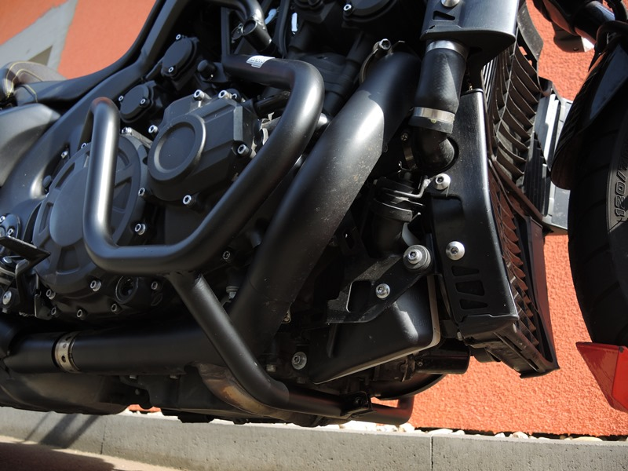
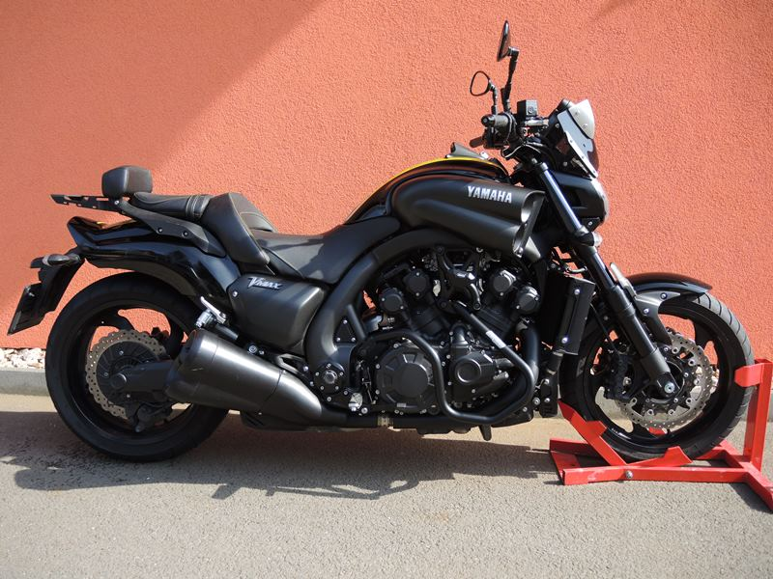
Šroub M10 ID.10 + váleček (mezi padací rámy)ID.11 + váleček ID.7 + krytka M10 ID.9
Bolt M8
ID.10.
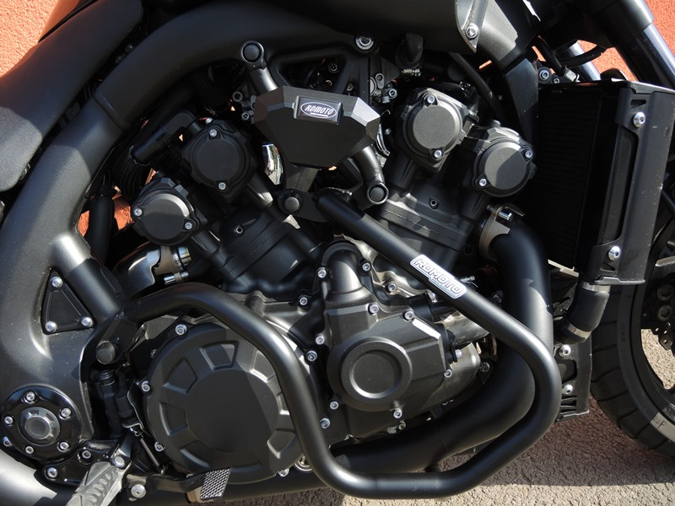
Bolt M10 ID.6 + Roller ID.7 + Insert M10 ID.8 + Cover M10 ID.9

Bolt M10 ID.6 + Roller ID7 + Insert M10 ID.8 + Cover M10 ID.9
Bolt M12 ID.2 + Insert M12 ID.3 + plus cover M12 ID5

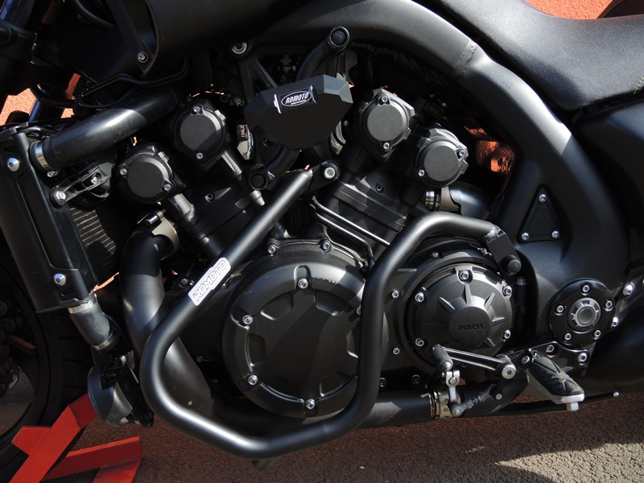

9
13,11,12
10
Bolt M10 ID.6 + Roller ID7 + Insert M10 ID.8 + Cover M10 ID.9

Bolt M12 ID.2 + Insert M12 ID.3 + plus Cover M12 ID5
Bolt M10 ID.6 + Roller ID.7 + Insert M10 ID.8 + Cover M10 ID.9

Origin.bolt
Original bolt. Rear place.

