CF119KD
Ducati Multistrada 1260S 2018-

Kit for Left Side |  |  |  |  | Kit for Right Side
ID | Description | Cat. No. | Pcs |  | ID | Description | Cat. No. | Pcs.
1 | Frame |  | 1 |  | 1 | Frame |  | 1
2 | Screw M10x30 | 882 | 1 |  | 2 | Screw M10x30 | 882 | 1
3 | Washer Flat M10 | 804 | 2 |  | 3 | Washer Flat M10 | 804 | 2
4 | Dural. roller d=69mm | 1313 | 1 |  | 4 | Dural. váleček d=61mm | 1314 | 1
5 | Dural. roller d=7mm | 1312 | 1 |  | 5 | Dural. roller d=7mm | 1312 | 1
6 | Rod M10x385x30x30 |  | 1 |  | 6 | RDmoto Sticker |  | 2
7 | Self-lock nut M10 | 810 | 1 |  | 7 | Self-lock nut M10 | 810 | 1
8 | Screw M5x35 | 1056 | 1 |  | 8 | Screw M5x35 | 1056 | 1
9 | Washer M5 | 1057 | 1 |  | 9 | Washer M5 | 1057 | 1
10 | Plastic cover M10 | X35 | 1 |  | 10 | Plastic cover M10 | X35 | 1
11 | Screw M8x35 | 861 | 1 |  | 11 | Steel Strut | X119 | 1

We recommend using medium strenght thread glue during assembly.

Installation Instructions:

- On left side, take off original screws from the middle part of frame, as shown on photographs.
- In place of the original screw, push through the M10 ID.6 Rod and equip it with ID.4 roller, ID.1 frame, M10 ID.3 washer and M10 ID.7 nut. Do not tighten yet.
- In bottom part, dismount screw from the engine metal wedge and put M5 ID.9 washer onto the M5 ID.8 screw. Then push it through the bottom part of frame. Now Insert ID.5 roller between frame and the wedge and fix it there.
- Use the same procedure during installation of the right side. Remmember to connect both sides together in the bottom part with M8 ID.11 screw and in the upper part with steel strut ID.11, then attach it with M10 ID.2 screws and ID.3 washers.
- Finally, tighten all screws and nuts and put on the plastic covers for nuts. As a last step, you may put on RDmoto sticker.
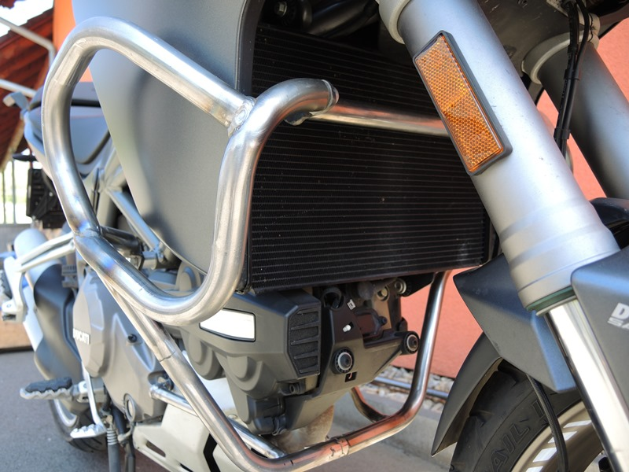

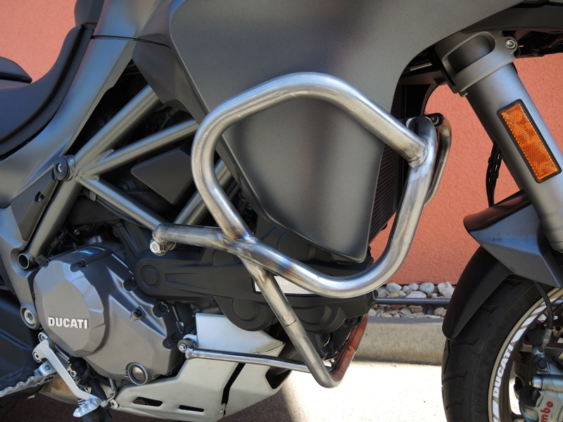
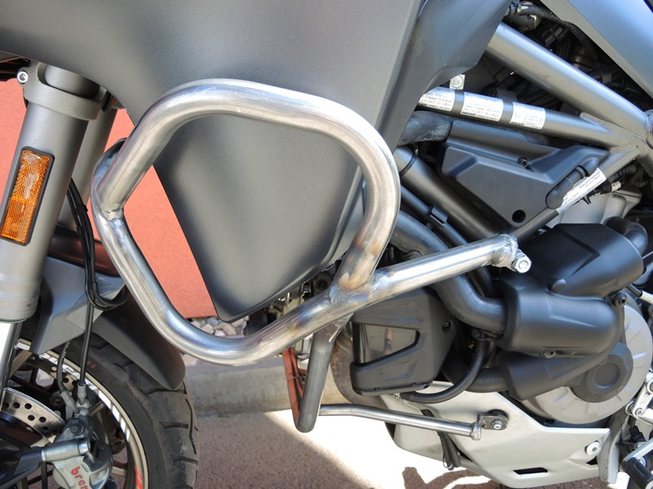
Rod M10 ID.6 + Washer M10 ID.3+ dural. roller ID.4 + Nut M10 ID.7 + Cover M10 ID.10
Screw M10 ID.2 + Washer M10 ID.3
Screw M8 ID.11
Screw M10 ID.2 + Washer M10 ID.3 + Strut ID.11
Dural. roller ID.4 + Washer M10 ID.3+ Nut M10 ID.7 + Cover M10 ID.10
Screw M5 ID.8 + Washer M5 ID.9
Screw M5 ID.8 + Washer M5 ID.9
9
13,11,12
10
Origin.bolt
Original bolt. Rear place.

