CF11
Aprilia Pegaso 650

Fitting kit:
ID | Description | Cat.No | Qty
1 | Crash bars | CF11 | 2
2 | Steel adapter upper | X67 | 1
3 | Steel adapter lower | X66 | 1
4 | Dural.cylinder d=18mm | 1108 | 2
5 | Dural.cylinder d=13mm | 1109 | 2
6 | Bolt M10x70 | 851 | 2
7 | Bolt M6x40 | 865 | 2
8 | Bolt M8x25 | 831 | 2
9 | Washer spring M10 | 801 | 2
10 | Washer spring M6 | 985 | 2
11 | Washer spring M8 | 800 | 2
12 | Washer M10 | 804 | 2
13 | Nut M10 | 810 | 1
14 | Bolt M10x80 | 852 | 1
14 | Plastic cap | X4 | 2
15 | 3M tape | - | 2
16 | Stickers RDmoto | - | 2

Fitting instruction:
- Remove the original screw on the motorcycle frame under the cooler.
- Take a steel stirrup with welded pipe and by the screw together with the nut mount to the place under the cooler, this stirrup tighten only slightly.
- Now remove the original M6 screws on the engine, take the steel holder and insert screws together with washers into this holder.
- To this screws mount on the other hand duralumin cylinders length 13mm.
- These ready holder mount to the point where it joins the engine cover to the frame of the motorcycle , tighten only slightly.
- Remove the original M10 screws in the frame of the motorcycle (it's in the rear mounting).
- Take the crash frame for the left side , pass in the back of this frame screw M10x70mm together with a washer, from the rear of the crash frame put it on the screw duralumin cylinder length 18mm.
- In point of contact the crash frame with the motorcycle frame you can stick 3M tape.
- Insert the crash frame to the upper steel stirrup under the cooler and mount in the rear of your motorcycle frame.
- Take the screw M8x25mm and connect the crash frame with the lower steel holder.
- Now should be easily attached crash frame on the left side.
- The same procedure mount crash frame for the right side, then fix it.

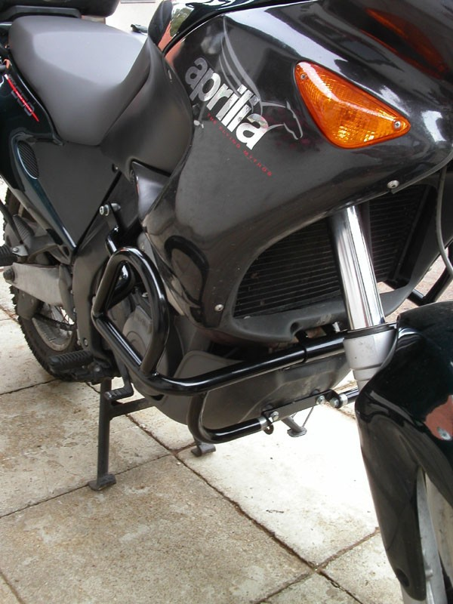
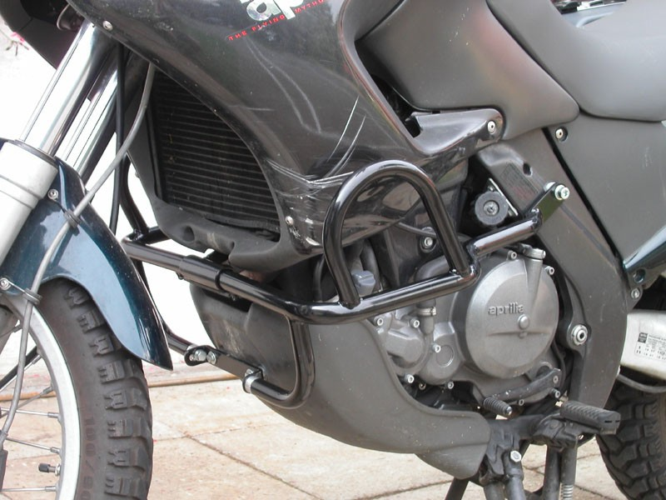
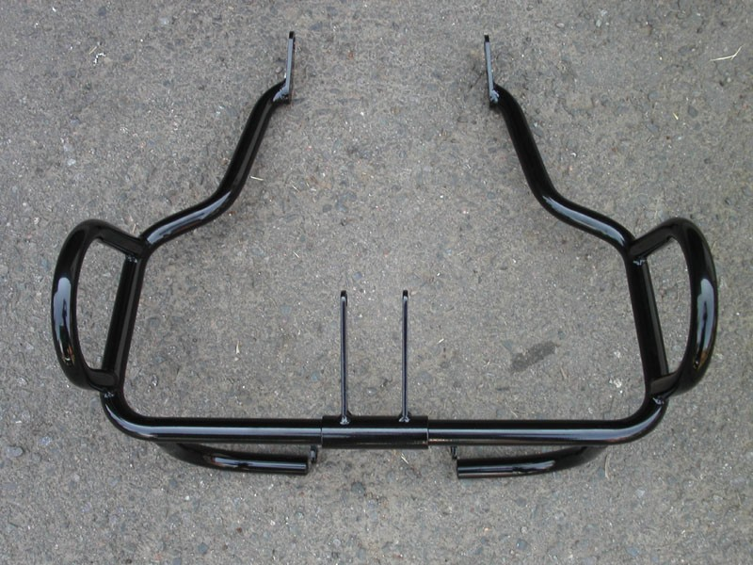

Warning: We recommend use the glue of all threads. Medium strong.

