CF120
BMW R1200GS 2013-

Kit for Left Side |  |  |  |  | Kit for Right Side
ID | Description | Cat.No. | Pcs. |  | ID | Description | Cat. No. | Pcs.
1 | Frame | BMW-2-L+CF121 | 1+1 |  | 1 | Frame | BMW-2-P+CF121 | 1+1
2 | Screw M10x50mm | 849 | 1 |  | 2 | Screw M10x50mm | 849 | 1
3 | Washer-Flat M10 | 804 | 1 |  | 3 | Washer-Flat M10 | 804 | 1
4 | Plastic Cover M10 | X4 | 1 |  | 4 | Plastic Cover M10 | X4 | 1
5 | Dural. roller d=15mm | 465 | 1 |  | 5 | Dural. roller d=15mm | 465 | 2
6 | Screw M8x35mm | 861 | 1 |  | 6 | Screw M8x35mm | 861 | 2
7 | Washer-Flat M8 | 802 | 5 |  | 7 | Washer-Flat M8 | 802 | 5
8 | Screw M8x30mm | 834 | 1 |  | 8 | Screw M8x30mm | 834 | 1
9 | Dural. roller d=4mm | 1305 | 1 |  | 9 | Self-Lock nut M8 | 809 | 2
10 | Self-Lock nut M8 | 809 | 2 |  | 10 | Plastic cover M8 | X5 | 2
11 | Plastic cover M8 | X5 | 2 |  | 11 | Dural. roller d=50mm | 209 | 1
12 | Dural. roller d=50mm | 209 | 1 |  | 12 | Washer M12 | 803 | 1
13 | Washer M12 | 803 | 1 |  | 13 | Nut M12 | 811 | 1
14 | Nut M12 | 811 | 1 |  | 14 | RDmoto Sticker |  | 2
15 | Rod M12x340x30x30 |  | 1 |  | 15 | Screw M8x25mm | 831 | 1
16 | Screw M6x60mm | 872 | 2 |  | 16 | Screw M6x20mm | 875 | 2
17 | Washer M6 | 947 | 6 |  | 17 | Self-lock nut M6 | 948 | 2
18 | Screw M8x25mm | 831 | 1 |  | 18 | Strut | X120 | 1

We recommend using medium strenght thread glue during assembly.
Mounting Instructions:

- On left side, unscrew the original M10 front bolt where stand meets the frame and M12 bolt in the middle of bike (see pictures). Replace it with M12 ID.15 Rod.
- Fit the M12 ID.15 rod with ID.12 dural. roller, crash frame, washer M12 ID.13 and M12 ID.14 nut (dont tighten anything yet).
- Attach bottom part at the place of stand with M10 ID.2 bolt and ID.3 washer.
- In front part, use M8 ID.6 bolt and M8 ID.7 washer and insert the ID.5 roller in between frame and engine.
- Then, attach upper front part with M8 ID.8 bolt and M8 ID.7 washer, slide the frame from the back and insert ID.9 roller in between. Then, put on the washer and fix in place with M8 ID.10 nut (see pictures).
- Use the same procedure on the right side, following pictures attached.
- Finally, tighten all screws and put on the plastic covers.
- Upper frame is secured in place with M8 bolt on both sides. Use ID.18 screw, ID.7 washer and M8 ID.10 nut on left side. On right side, use the ID.15 screw, ID.7 washer and ID.9 M8 nut.
- Now, use M6 ID.16 screws (right side), M16 ID.17 washers (left side) and M6 nuts (right side) to fix ID.18 strut (right side) to the frame and other side to indicators.
You can replace original screws in the indicator brackets with M6 ID.16 screws (left side) and ID.17 washers.
Rod M12 ID.15 + dural. roller ID.11 + washer M12 ID.12 + nut M12 ID.13

Screw M8 ID.6 + dural roller ID.5 + 2x washer M8 ID.7 + cover M8 ID.10 + nut M8 ID.9
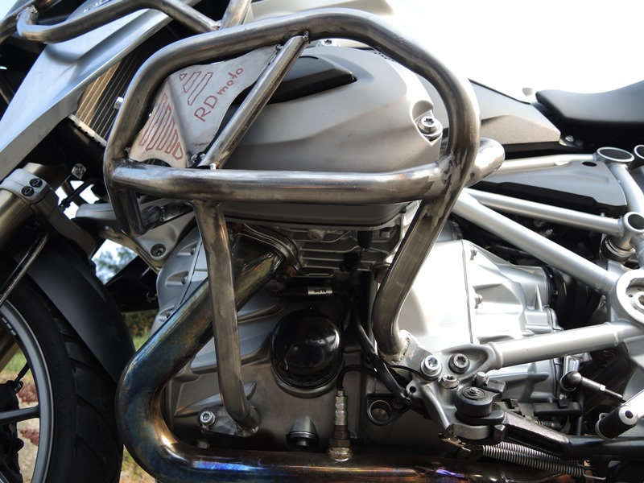
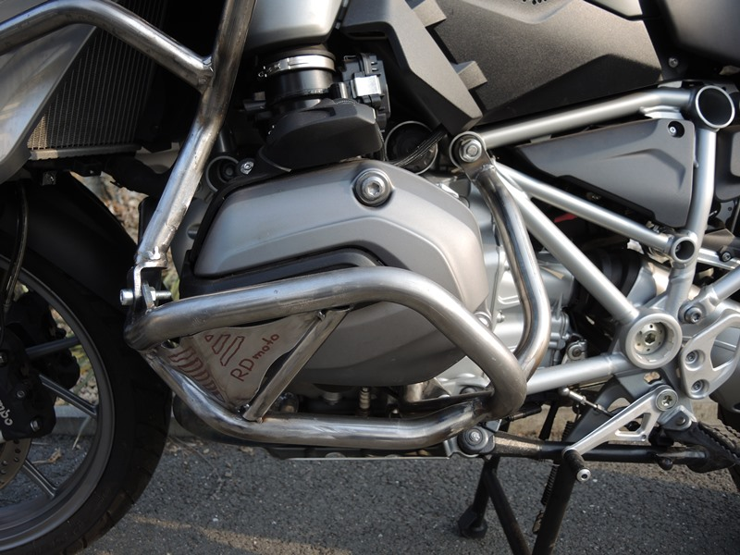
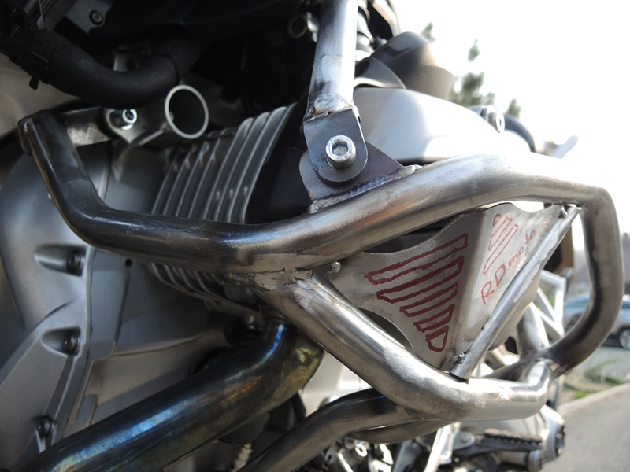
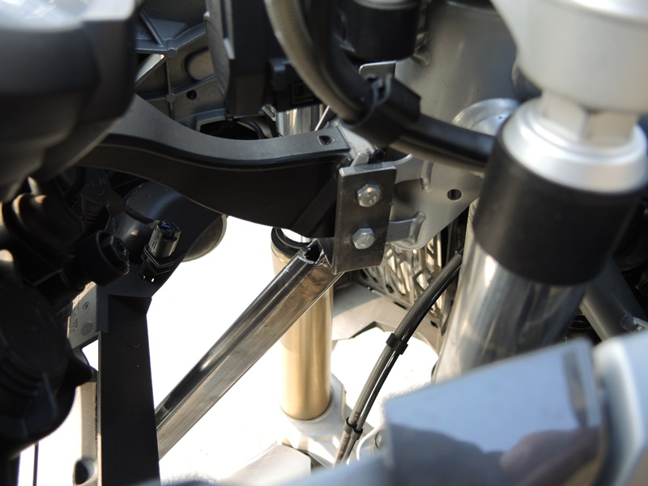
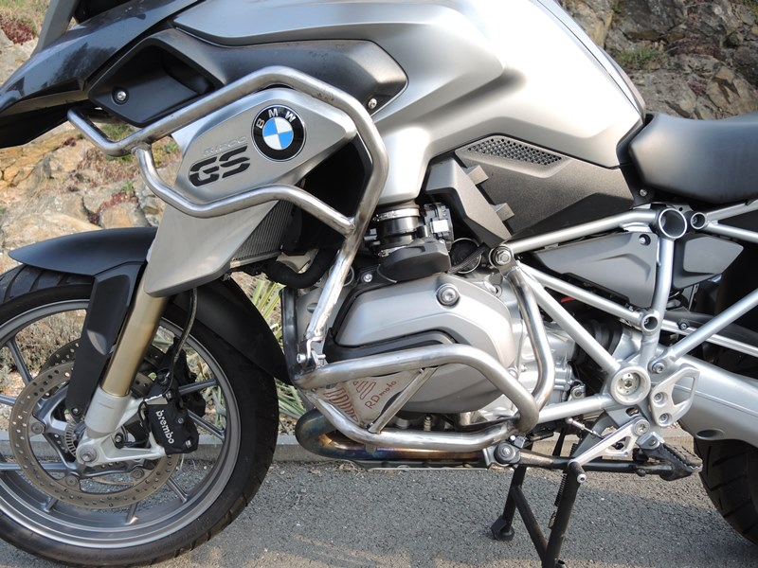
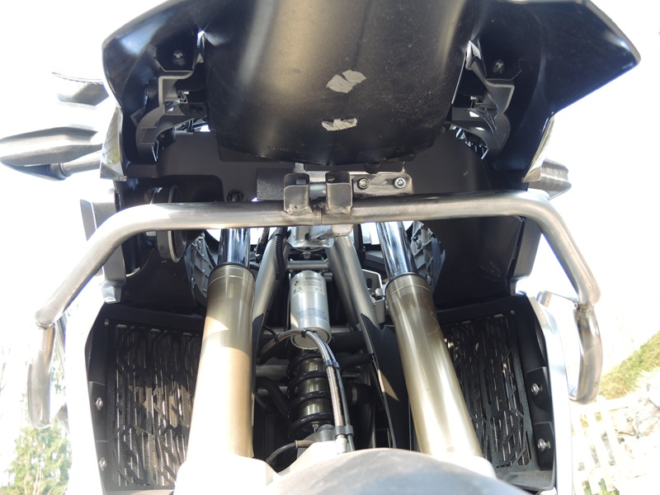
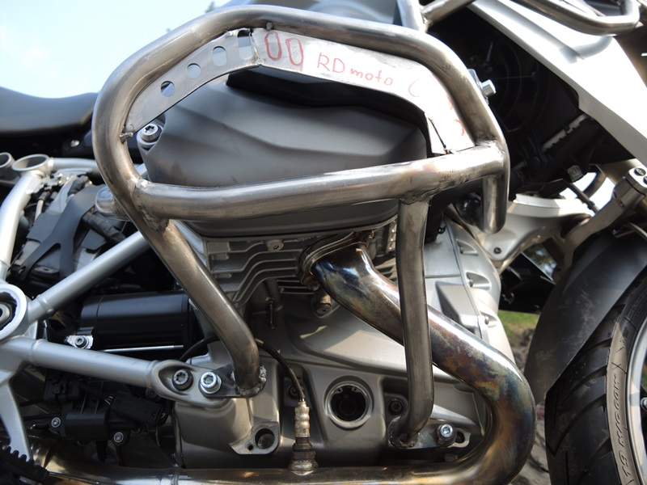
Dural. roller ID.12 + washer M12 ID.803 + nut M12 ID.14

Bolt M10 ID.2 + washer M10 ID.3 + plastic cover M10 ID.4

Screw M8 ID.6 + roller ID.5 + washer M8 ID.7 + cover M8 ID.10

Screw M10 ID.2 + washer M10 ID.3 + plastic cover M10 ID.4
Screw M8 ID.8 + dural roller ID.9 + 2x washer M8 ID.7 + cover M8 ID.11 + nut M8 ID.10.
Screw M8 ID.6 + roller ID.5 + washer M8 ID.7 + cover M8 ID.11

Screw M8 ID.18 + 2x Washer M8 ID.7 + Nut M8 ID.10

Screw M8 ID.8
9
13,11,12
10
Origin.bolt
Original bolt. Rear place.

