CF121
BMW R1200GS 2013-

Kit for Left Side |  |  |  |  | Kit for Right Side
ID | Description | Cat. No. | Pcs. |  | ID | Description | Cat. No. | Pcs.
1 | Frame | CF121 | 1 |  | 1 | Frame | CF121 | 1
2 | Bolt M10x50 | 849 | 1 |  | 2 | Bolt M10x50 | 849 | 1
3 | Washer-flat M10 | 804 | 1 |  | 3 | Washer M10 flat | 804 | 1
4 | Plastic cover M10 | X4 | 1 |  | 4 | Plastic cover M10 | X4 | 1
5 | Dural. roller d=15mm | 465 | 1 |  | 5 | Dural. roller d=15mm | 465 | 2
6 | Bolt M8x35 | 861 | 1 |  | 6 | Bolt M8x35 | 861 | 2
7 | Washer M8 flat | 802 | 3 |  | 7 | Washer M8 flat | 802 | 3
8 | Bolt M8x30 | 834 | 1 |  | 8 | Bolt M8x30 | 834 | 1
9 | Dural. roller d=4mm | 1305 | 1 |  | 9 | Safety nut M8 | 809 | 1
10 | Safety nut M8 | 809 | 1 |  | 10 | Plastic cover M8 | X5 | 2
11 | Plastic cover M8 | X5 | 2 |  | 11 | Dural. roller d=50mm | 209 | 1
12 | Dural.roller d=50mm | 209 | 1 |  | 12 | Washer M12 | 803 | 1
13 | Washer M12 | 803 | 1 |  | 13 | Nut M12 | 811 | 1
14 | Nut M12 | 811 | 1 |  | 14 | RDmoto sticker |  | 2
15 | Rod M12x340x30x30 |  | 1 |  | 15

We recommend using medium strenght thread glue.

Instructions:

- Unscrew the original front M10 bolt on the left side where stand is attached to the frame and M12 bolt in the middle of the bike (see pictures), which you will replace with M12 ID.15 Rod.
- Equip the M12 ID.15 rod with ID.12 dural. roller and then mount the crash frame, M12 ID.13 washer and M12 ID.14 nut onto it as well. (Don’t tighten anything yet).
- Now attach the bottom part (where the stand is) with M10 ID.2 bolt and ID.3 washer.
- In the front part, use M8 ID.6 bolt, M8 ID.7 washer and insert the ID.5 roller between the frame and the engine.
- Front upper part is attached with M8 ID.8 bolt and M8 ID.7 washer. The frame is slipped on from rear to front. Dont forget to put ID.9 roller in between, as well as washer and M8 ID.10 nut (see photos).
- Use the same steps on the other (right) side.
- Finally, tighten all bolts and put up the plastic covers.

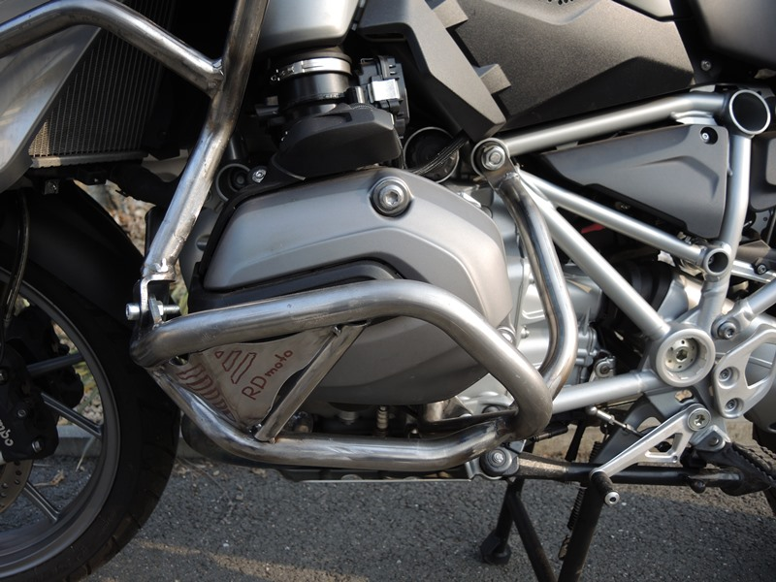
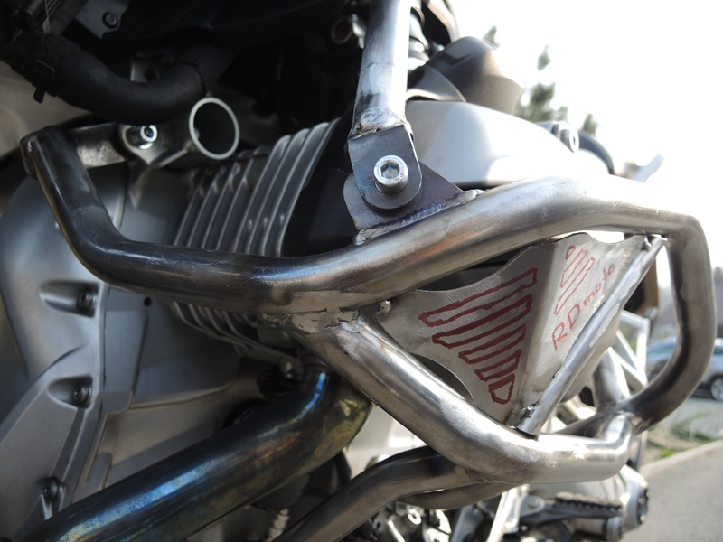
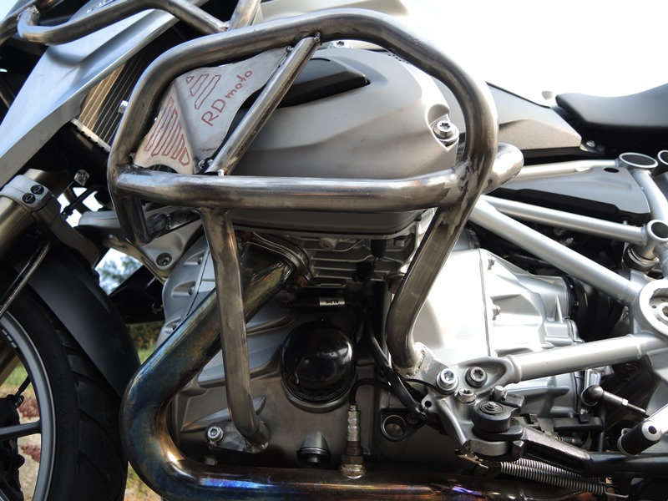
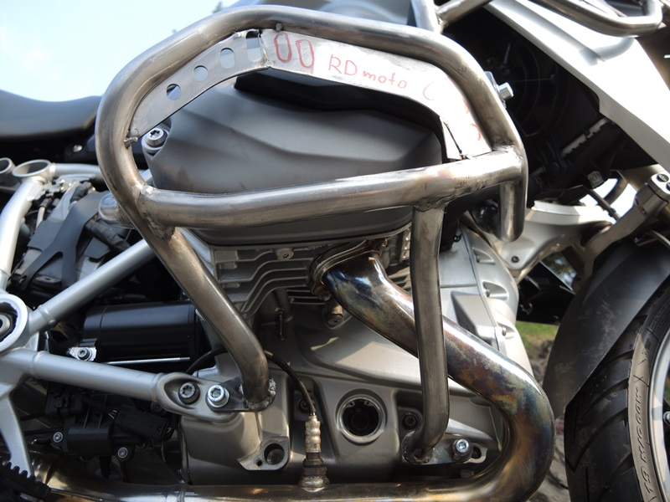
Dural. roller ID.12 + Washer M12 ID.803 + Nut M12 ID.14

Bolt M10 ID.2 + Washer M10 ID.3 + Plastic cover M10 ID.4

Bolt M8 ID.6 + roller ID.5 + Washer M8 ID.7 + Cover M8 ID.10

Bolt M10 ID.2 + Washer M10 ID.3 + Plastic cover M10 ID.4
Bolt M8 ID.8 + dural. roller ID.9 + 2x Washer M8 ID.7 + M8 ID.11 + Nut M8 ID.10.
Bolt M8 ID.6 + Roller ID.5 + Washer M8 ID.7 + Cover M8 ID.11

Rod M8 ID.8 + dural roller ID.5 + 2x Washer M8 ID.7 +Cover M8 ID.10 + Nut M8 ID.9
Rod M12 ID.15 + dural. roller ID.11 + Washer M12 ID.12 + Nut M12 ID.13

9
13,11,12
10
Origin.bolt
Original bolt. Rear place.

