CF122
KTM 690 Enduro R 2019-
Husqvarna 701 Enduro/Supermoto 2016-2020
Kit for Left Side |  |  |  |  | Kit for Right Side
ID | Description | Cat. No. | Pcs |  |  | ID | Description | Cat. No. | Pcs
1 | Upper Crash Frame | CF122-L | 1 |  |  | 1 | Upper Crash Frame | CF122-P | 1
2 | Screw M10x60mm | 850 | 2 |  |  | 2 | Screw M10x60mm | 850 | 2
3 | Frame insertion (d=16mm) | 499 | 1 |  |  | 3 | Frame insertion (d=16mm) | 499 | 1
4 | Frame insertion (d=13mm) | 1143 | 1 |  |  | 4 | Frame insertion (d=13mm) | 1143 | 1
5 | Washer-Spring M10 | 804 | 2 |  |  | 5 | Washer-Spring M10 | 804 | 2
6 | Plastic cover for frame | X19 | 2 |  |  | 6 | Plastic cover for frame | X19 | 2
7 | Strut | X125 | 1 |  |  | 7 | Screw M10x180mm | 978 | 1
8 | Washer-Flat M10 | 804 | 1 |  |  | 8 | Washer-Flat M10 | 804 | 1
9 | Self-lock nut M10 | 810 | 1 |  |  | 9 | ------------------------------- | ---
10 | Dural. roller d=22mm | 1337 | 1 |  |  | 10 | Dural. roller d=22mm | 1337 | 1
11 | Screw M10x50mm | 849 | 1 |  |  | 11 | Screw M10x50mm | 849 | 1
12 | AL Screw Cover | X115 | 1 |  |  | 12 | AL Screw Cover | X115 | 1
13 | Plastic Allen Bolt Cover | X4 | 1 |  |  | 13 | Plastic Allen Bolt Cover | X4 | 1
14 | Dural. roller d=25mm-black | 1291 | 1 |  |  | 14 | Dural. roller d=25mm-black | 1291 | 1
Mounting Instructions:

Install crash frames following instructions on the attached photographs.

Mount X125 strut into the frame, but don’t tighten it yet.

Now take off screws in the upper left part of motorcycle frame and insert the housings (upper hole requires wider housing).

Take the left crash frame and M10x60mm screws with spring washers. Mount them into the frame, but dont tighten yet.

Do the same with the right upper frame.

Now both frames should meet in the area of X125m strut. Take the M10x50mm screws, equip them with the AL screw covers and mount into thread inside the X125 strut. To hide the screw heads, use plastic covers of allen bolts. Use black aluminum alloy rollers (25mm long) to define the gap between the top frame and X125 struts.

Finally, you can tighten everything and use plastic covers for upper frame.

If you experienced any discrepancy during installation, please do let us know.

Thank you for purchasing RDmoto products.

Note: We recommend using medium strenght thread glue for all bolts (blue color).
Bolt M10x60mm + washer M10 – spring + frame insertion (16mm) + frame cover
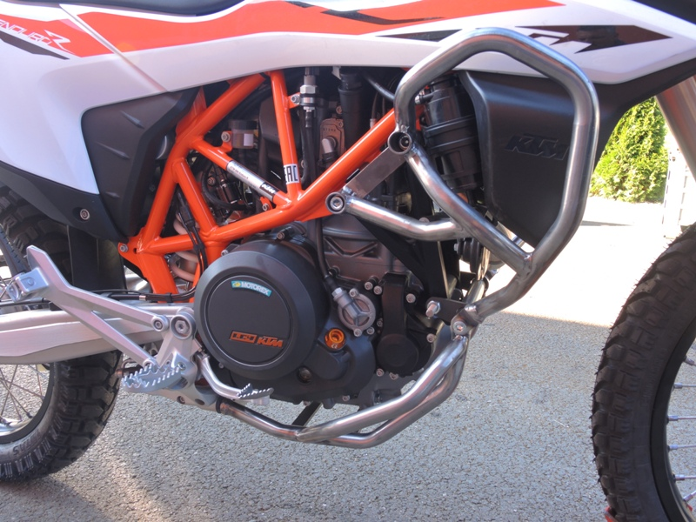
Strut X125 + Screw M10x175mm + Washer M10 –flat 2x + Self-lock nut M10+dural. roller ID.10 2x
Bolt M10x60mm + washer M10 – spring + frame insertion (13mm) + frame cover
Bolt M10x50mm + Al screw cover + plastic cover for allen bolt + dural. roller ID 14 (black)

