CF123
KTM 690 Enduro R 2019-
Husqvarna 701 Enduro/Supermoto 2016-2020
Kit for Left Side |  |  |  |  | Kit for Right Side
ID | Description | Cat. No. | Pcs |  |  | ID | Description | Cat. No. | Pcs
1 | Lower Frame | CF123 | 1 |  |  | 1 | Lower Aluminium plate | X124 | 1
2 | Strut | X125 | 1 |  |  | 2 | Screw M10x180mm | 978 | 1
3 | Washer M10-flat | 804 | 1 |  |  | 3 | Washer M10-flat | 804 | 1
4 | Self-lock nut M10 | 810 | 1 |  |  | 4 | ------------------------- | ---
5 | Dural. roller d=22mm | 1337 | 1 |  |  | 5 | Dural. roller d=22mm | 1337 | 1
6 | Screw M10x50mm | 849 | 1 |  |  | 6 | Screw M10x50mm | 849 | 1
7 | AL screw cover | X115 | 1 |  |  | 7 | AL screw cover | X115 | 1
8 | Plastic allen bolt cover | X4 | 1 |  |  | 8 | Plastic allen bolt cover | X4 | 1
9 | Screw M6x20mm | 1022 | 3 |  |  | 9 | Screw M6x20mm | 1022 | 3
10 | Washer M6 – flat | 947 | 3 |  |  | 10 | Washer M6 – flat | 947 | 3
11 | Washer M6 – large | 987 | 3 |  |  | 11 | Washer M6 – large | 987 | 3
12 | Self-lock nut M6 | 948 | 3 |  |  | 12 | Self-lock nut M6 | 948 | 3
Mounting Instructions:

Follow mounting procedure as shown on attached photographs.

Take off the original lower plastic casing.

Then install X125 strut into the frame, but don’t tighten it yet.

Put on the lower frame in rear part into rubber housings and lean it towards the X125 strut.

Take M10x50mm screws, equip them with Al covers and mount into thread on the X125 strut. To cover the bolt heads, use plastic covers for allen bolts.

Finally, you can tighten everything.

If you encounter any issues during assembly, please do let us know.

Thank you for purchasing RDmoto products.

Note – We recommend using medium glue for threads of all screws (blue color).

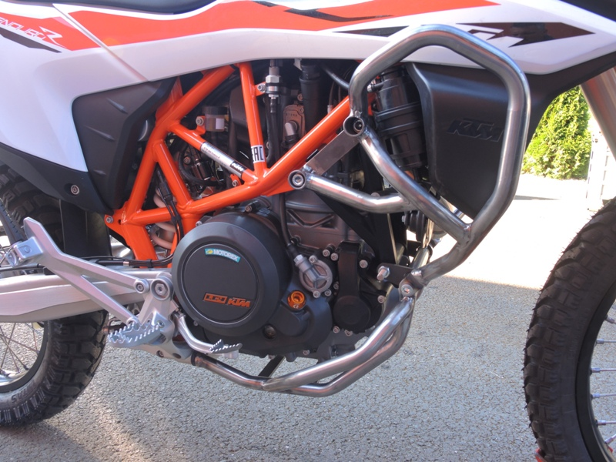
Strut X125 + Screw M10x175mm + Washer M10 –flat 2x + Self-lock nut M10-+dural. roller ID.10 2x
Screw M10x50mm + Al screw cover + plastic allen bolt cover
Screw M6x20mm 6x + Washer M6-flat 6x + Washer M6-large 6x + Self-lock nut M6 6x + Al plate X124

