CF124
KTM 690 Enduro R 2019-
Husqvarna 701 Enduro/Supermoto 2016-2020
Kit for Left Side |  |  |  |  | Kit for Right Side
ID. | Description | Cat. No. | Pcs |  |  | ID | Description | Cat. No. | Pcs
1 | Top Crash Frame | CF122 | 1 |  |  | 1 | Top Crash Frame | CF122 | 1
2 | Screw M10x60mm | 850 | 2 |  |  | 2 | Screw M10x60mm | 850 | 2
3 | Frame insertion (d=16mm) | 499 | 1 |  |  | 3 | Frame insertion (d=16mm) | 499 | 1
4 | Frame insertion (d=13mm) | 1143 | 1 |  |  | 4 | Frame insertion (d=13mm) | 1143 | 1
5 | Washer M10-spring | 804 | 2 |  |  | 5 | Washer M10-spring | 804 | 2
6 | Plastic cap for frame | X19 | 2 |  |  | 6 | Plastic cap for frame | X19 | 2
7 | Strut | X125 | 1 |  |  | 7 | Screw M10x180mm | 978 | 1
8 | Washer M10-flat | 804 | 1 |  |  | 8 | Washer M10-flat | 804 | 1
9 | Safety nut M10 | 810 | 1 |  |  | 9 | ------------------------------- | ---
10 | Dural. roller d=22mm | 1337 | 1 |  |  | 10 | Dural. roller d=22mm | 1337 | 1
11 | Screw M10x50mm | 849 | 1 |  |  | 11 | Screw M10x50mm | 849 | 1
12 | AL screw cap | X115 | 1 |  |  | 12 | AL screw cap | X115 | 1
13 | Plastic cap for Allen bolt | X4 | 1 |  |  | 13 | Plastic cap for Allen bolt | X4 | 1
14 | Lower frame | CF123 | 1 |  |  | 14 | Lower AL cover | X124 | 1
15 | Screw M6x20mm | 1022 | 3 |  |  | 15 | Screw M6x20mm | 1022 | 3
16 | Washer M6 – flat | 947 | 3 |  |  | 16 | Washer M6 – flat | 947 | 3
17 | Washer M6 – large | 987 | 3 |  |  | 17 | Washer M6 – large | 987 | 3
18 | Safety nut M6 | 948 | 3 |  |  | 18 | Safety nut M6 | 948 | 3
Mounting Instructions:

Follow steps and instructions on the attached photographs.
First, uninstall the lower original plastic cover.
Then, mount strut X125 into the frame, but dont tighten it yet.
Mount the lower frame in rear part into rubber brackets and lean it towards the X125 strut. Attach it slightly by M10x50mm screw on one side.
Now take off screws in the left top frame part and insert brackets (wider bracket for the top hole).
Take the left crash frame and screws M10x60mm, mount it into motorcycle frame with spring washers (dont tighten yet).
Do the same with the top right crash frame.
Now, the top frame should meet lower frame in the area of X125 strut, take screws M10x50mm, equip them with the AL screw covers and mount into thread on the X125 strut. Use the plastic allen bolt covers to hide screw heads.
Now you may tighten all screws and use plastic covers on the top frame.
If you encounter any problem during assembly, please do let us know!

Thank you for purchasing RDmoto products.

Note: We recommend using medium strenght glue for threads of all screws.

Screw M10x60mm + Washer M10 – spring + Frame insertion (16mm) + Plastic cap
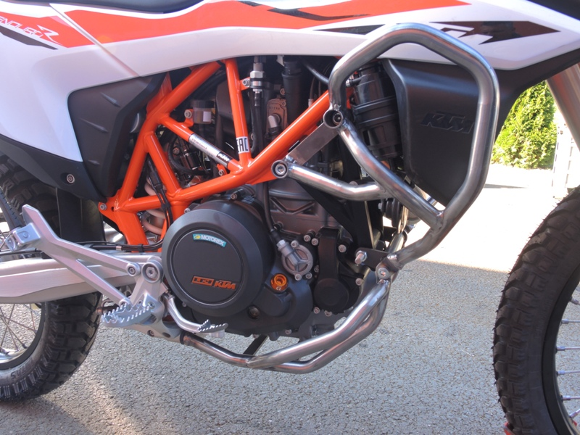
Strut X125 + Screw M10x175mm + Washer M10 – flat 2x + Safety nut M10 +dural.roller ID.10 2x
Screw M10x60mm + Washer M10 – spring + Frame insertion (13mm) + Plastic cap
Screw M10x50mm + Al bolt cover + Plastic allen bolt cover
Screw M6x20mm 6x + Washer M6-flat 6x + Washer M6- flat 6x + Safety nut M6- 6x + Al metal sheet X124

