CF125
Triumph Tiger Explorer 2011-2015
Triumph Tiger Explorer XC 2011-2015

Kit for Left Side |  |  |  |  | Kit for Right Side
ID | Description | Cat.No | Pcs |  | ID | Description | Cat.No | Pcs
1 | Frame | CF125-L | 1 |  | 1 | Frame | CF125-P | 1
2 | Bolt M12x160x1,25mm | 949 | 1 |  | 2 | Bolt M12x70x1,25mm | 937 | 1
3 | Bolt M12x100x1,25mm | 911 | 1 |  | 3 | Bolt M12x150x1,25mm | 984 | 1
4 | Dural. sleeve length=59mm | 1321 | 1 |  | 4 | Dural. sleeve l=14,5mm | 1323 | 1
5 | Dural. sleeve length=22mm | 1322 | 1 |  | 5 | Dural. sleeve l=40mm | 1324 | 1
6 |  |  |  |  | 6 | Plastic cap M12 | X60 | 1

We recommend using medium strenght thread glue during assembly.

Instructions:

- Remove the original M12 bolts on the left side of the motorcycle.
- Take the left crash frame and insert the bolts ID 2 (front mounting) + ID 3 (rear mounting)
- Slide the dural. sleeves ID 4 (front mounting) + ID 5 (rear mounting) onto the bolts from the rear and mount the whole assembly to the motorcycle frame. For safety reasons, you can use medium strength thread glue.
- Remove the original M12 bolts on the right side of the motorcycle.
- Take the right crash frame and insert the bolts ID 3 (front mounting) + ID 2 (rear mounting.
- Slide the dural. sleeves ID 5 (front mounting) + ID 4 (rear mounting) onto the bolts from the rear and mount the whole assembly to the motorcycle frame. For safety reasons, you can use medium strength thread glue
- Finally, tighten all the bolts and put on the plastic cap ID.6.

Šroub M10 ID.2 + podložka M10 ID.3 + plastová krytka M10 ID.4

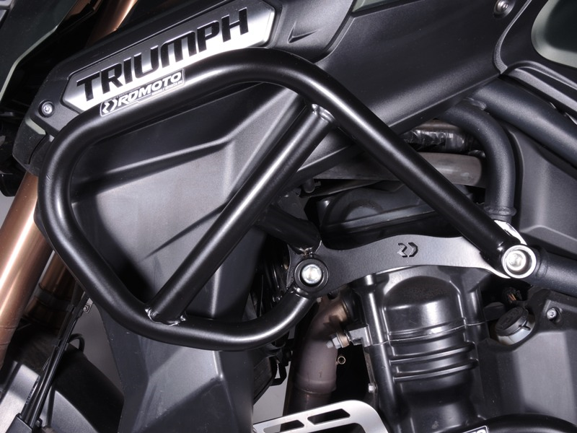
Bolt ID.3 + dural. sleeve ID.5
Bolt ID.2 + dural. sleeve ID.4

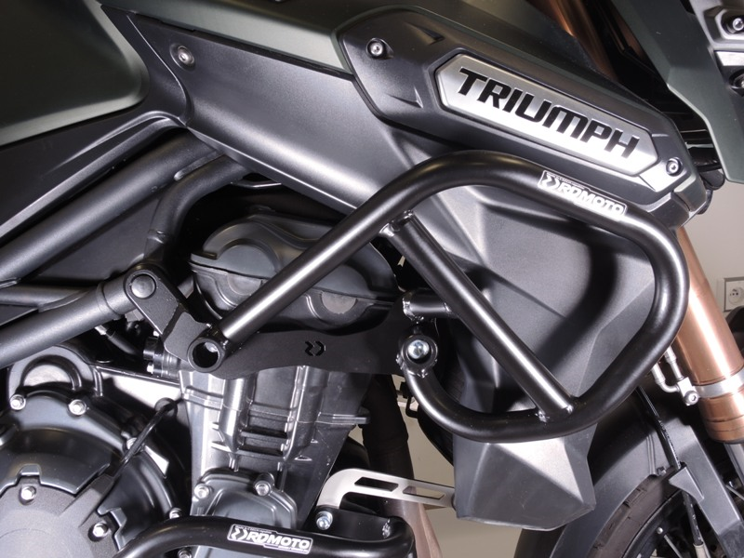
Bolt ID.3 + dural. sleeve ID.5

Bolt ID.2 + dural. sleeve ID.4 + plastic cap ID.6

9
13,11,12
10
Origin.bolt
Original bolt. Rear place.

