CF126
Triumph Tiger Explorer 2011-2015
Triumph Tiger Explorer XC 2011-2015

Kit for Left Side |  |  |  |  | Kit for Right Side
ID | Description | Cat.No | Pcs |  | ID | Description | Cat.No | Pcs
1 | Frame | CF126-L | 1 |  | 1 | Frame | CF126-P | 1
2 | Bolt M8x30mm | 834 | 2 |  | 2 | Bolt M8x30mm | 834 | 1
3 | Dural. sleeve length=6mm | 453 | 1 |  | 3 | Bolt M8x35mm | 861 | 1
4 | Flat washer M8 | 802 | 2 |  | 4 | Flat washer M8 | 802 | 2
5 |  |  |  |  | 5 | Dural. sleeve l=13mm | 1100 | 1
6 |  |  |  |  | 6 | Dural. sleeve l=13mm | 464 | 1

We recommend using medium strenght thread glue during assembly.

Instructions:

- Remove 3 original bolts on the left side of the motorcycle.
- Take the bolt ID 2 and washer ID 4, slide it into the front upper part of the frame. Then také another bolt ID 2 and washer ID 4 and slide it into the middle bottom part of the frame.
- Attach to the motor and mount. Also thread the dural. sleeve ID 3 on the bolt in the middle lower part of the frame. Use the original bolt to attach the crash frame to the rear. For safety reasons, you can use medium strength thread glue.
- Remove 2 original bolts on the right side of the motorcycle and the original rear long bolt, which slide out of the motorcycle frame.
- Take the bolt ID 2 and washer ID 4, slide it into the front upper part of the frame. Then take the bolt ID 3 and washer ID 4 and slide it into the middle bottom part of the frame.
- Attach to the motor and mount. Also thread the dural. sleeve ID 6 on the bolt in the middle lower part of the frame. To attach the crash frame to the rear, use the original bolt and dural. sleeve ID 5. For safety reasons, you can use medium strength thread glue.
- Finally, tighten all the bolts.
Šroub M10 ID.2 + podložka M10 ID.3 + plastová krytka M10 ID.4

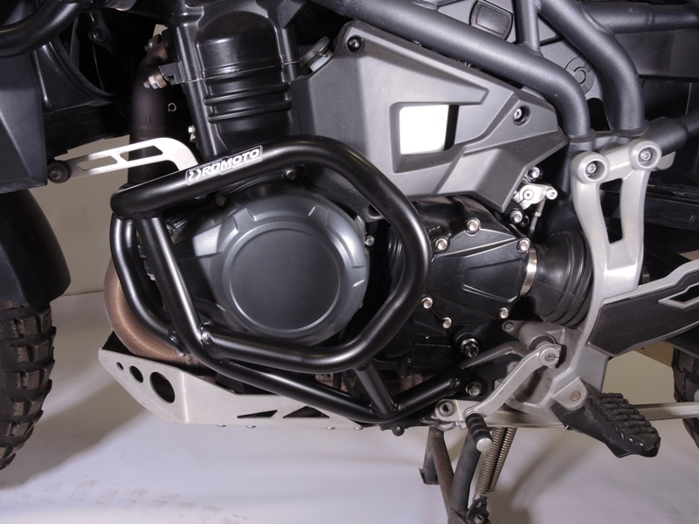
Original bolt
Bolt ID.2 + washer ID.4

Bolt ID.2 + washer ID.4 + dural. sleeve ID.3

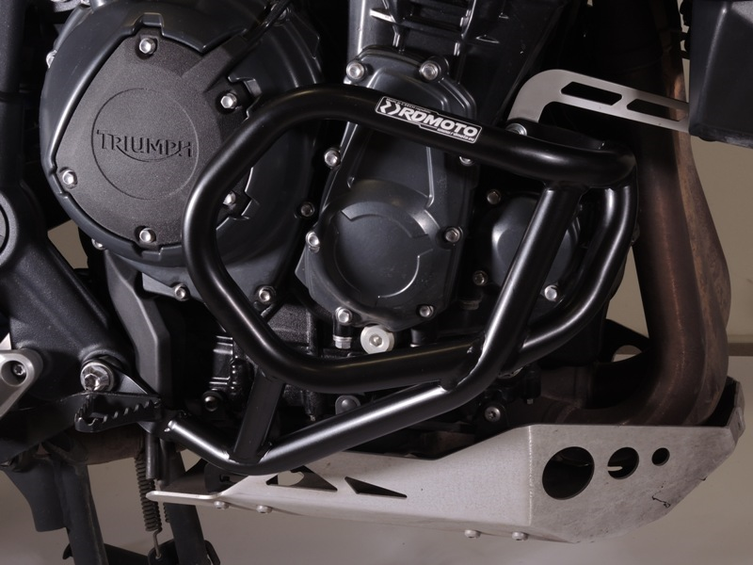
Bolt ID.2 + washer ID.4

Original bolt + dural. sleeve ID.5

Bolt ID.3 + washer ID.4 + dural. sleeve ID.6

9
13,11,12
10
Origin.bolt
Original bolt. Rear place.

