CF127
Triumph Tiger Explorer 2011-2015
Triumph Tiger Explorer XC 2011-2015

Kit for Left Side |  |  |  |  | Kit for Right Side
ID | Description | Cat.No | Pcs |  | ID | Description | Cat.No | Pcs
1 | Frame | CF125-L | 1 |  | 1 | Frame | CF125-P | 1
2 | Bolt M12x160x1,25mm | 949 | 1 |  | 2 | Bolt M12x70x1,25mm | 937 | 1
3 | Bolt M12x100x1,25mm | 911 | 1 |  | 3 | Bolt M12x150x1,25mm | 984 | 1
4 | Dural. sleeve d=59mm | 1321 | 1 |  | 4 | Dural. sleeve l=14,5mm | 1323 | 1
5 | Dural. sleeve d=22mm | 1322 | 1 |  | 5 | Dural. sleeve l=40mm | 1324 | 1
6 | ------------------------------ | -------- |  |  | 6 | Plastic cap M12 | X60 | 1
7 | Frame | CF126-L | 1 |  | 7 | Frame | CF126-P | 1
8 | Bolt M8x30mm | 834 | 2 |  | 8 | Bolt M8x30mm | 834 | 1
9 | Dural. sleeve length d=6mm | 453 | 1 |  | 9 | Bolt M8x35mm | 861 | 1
10 | Flat washer M8 | 802 | 2 |  | 10 | Flat washer M8 | 802 | 2
 |  |  |  |  | 11 | Dural. sleeve l=13mm | 1100 | 1
 |  |  |  |  | 12 | Dural. sleeve l=13mm | 464 | 1

We recommend using medium strenght thread glue during assembly.

Instructions for mounting the upper frame:

- Remove original bolts M12 on the left side of the motorcycle.
- Insert the bolts ID 2 (front mounting) + ID 3 (rear mounting) into left crash frame.
- Slide the dural. sleeves ID 4 (front mounting) + ID 5 (rear mounting) onto the bolts from the rear and mount tho whole assembly to the motorcycle frame. For safety reasons, you can use medium strength thread glue.
- Remove original bolts M12 on the right side of the motorcycle.
- Insert the bolts ID 3 (front mounting) + ID 2 (rear mounting) into the right crash frame.
- Slide the dural. sleeves ID 5 (front mounting) + ID 4 (rear mounting) onto the bolts from the rear and mount the whole assembly to the motorcycle frame. For safety reasons, you can use medium strength thread glue.
- Finally, tighten all the bolts and put on the plastic cap ID
Šroub M10 ID.2 + podložka M10 ID.3 + plastová krytka M10 ID.4

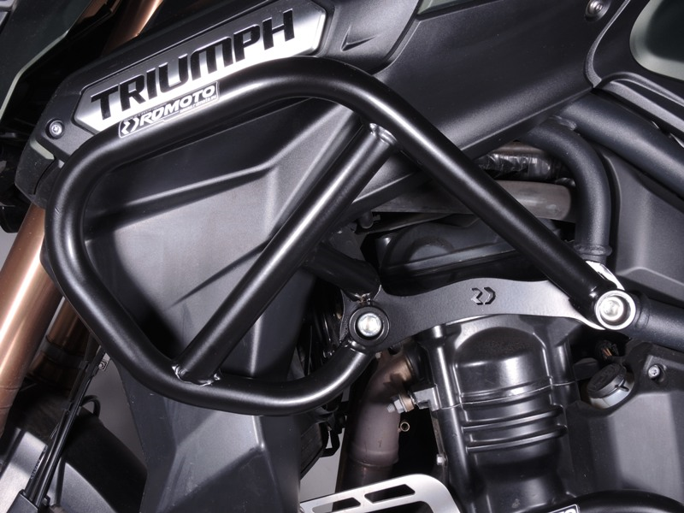
Bolt ID.3 + dural. sleeve ID.5
Bolt ID.2 + dural. sleeve ID.4

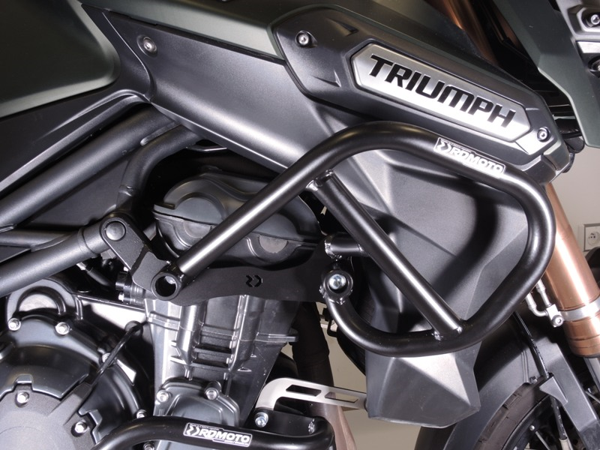
Bolt ID.3 + dural. sleeve ID.5

Bolt ID.2 + dural. sleeve ID.4 + plastic cap ID.6

Instructions for mounting the lower frame:

- Remove 3 original on the left side of the motorcycle.
- Slide the bolt ID 8 and the washer ID 10 into the front upper part of the frame. Then slide the bolt ID 8 and the washer ID 10 into middle bottom part of the frame.
- Attach to the motor and mount. Also thread the dural. sleeve ID 9 on the bolt in the middle lower part of the frame. To attach the crash frame to the rear, use the original bolt. For safety reasons, you can use medium strength thread glue.
- Remove 2 original bolts on the right side of the motorcycle and the original rear long bolt, which slide out of the motorcycle frame.
- Slide the bolt ID 8 and the washer ID 10 into the front upper part of the frame. Then slide the bolt ID 9 and the washer ID 10 into middle bottom part of the frame.
- Attach to the motor and mount. Also thread the dural. sleeve ID 12 on the bolt in the middle lower part of the frame. To attach the crash frame to the rear, use the original bolt and dural. sleeve ID 11. For safety reasons, you can use medium strength thread glue.
- Finally, tighten all the bolts.

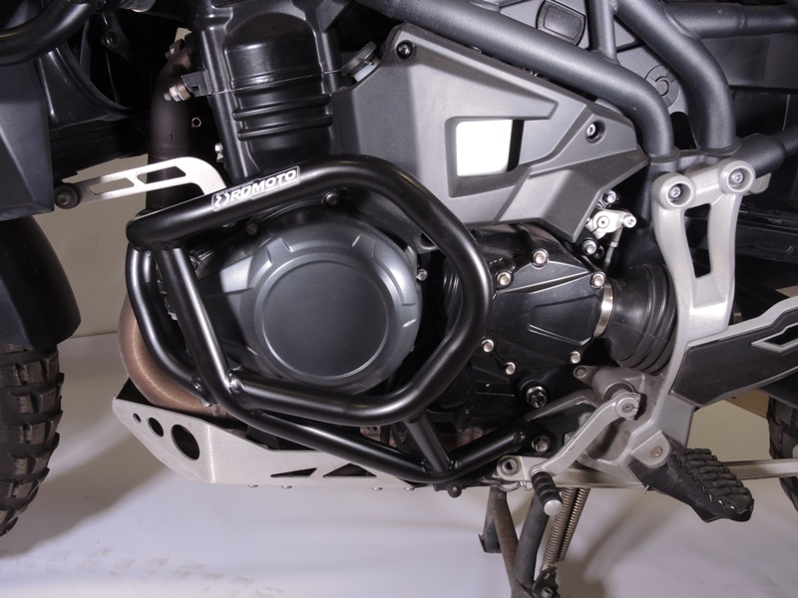
Original bolt
Bolt ID.8 + washer ID.10 + dural. sleeve ID.9

Bolt ID.8 + washer ID.10

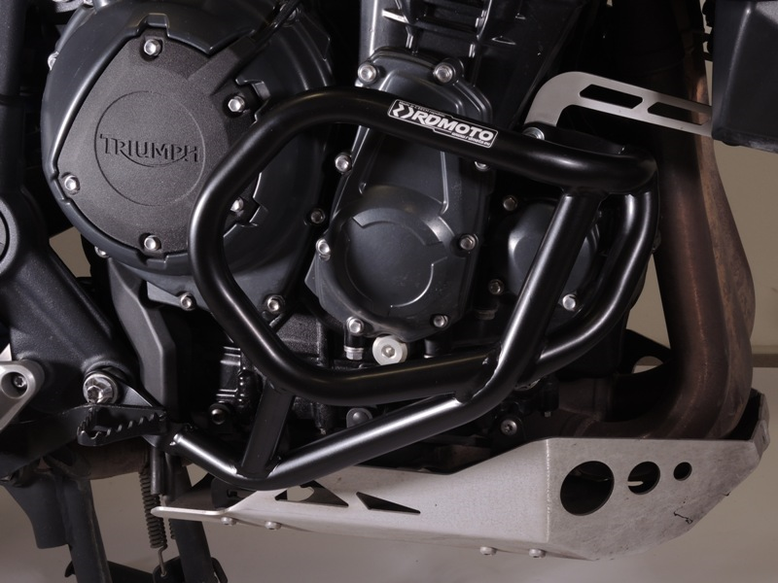
Original bolt + dural. sleeve ID.11

Bolt ID.9 + washer ID.10 + dural. sleeve ID.12

Bolt ID.8 + washer ID.10

9
13,11,12
10
Origin.bolt
Original bolt. Rear place.

