CF128
Kawasaki KLV 1000 2004-2006

Kit for Left Side |  |  |  |  | Kit for Right Side
ID | Description | Cat.No | Pcs |  | ID | Description | Cat.No | Pcs
1 | Frame | CF128-L | 1 |  | 1 | Frame | CF128-P | 1
2 | Bolt M10xx100x1,25mm | 892 | 1 |  | 2 | Bolt M10x100x1,25mm | 892 | 1
3 | Bolt M10x50mm | 996 | 1 |  | 3 | Lock nut M10 | 810 | 1
4 | Dural. sleeve | 1315 | 1 |  | 4 | Dural. sleeve | 1315 | 1
5 | Flat washer M10 | 804 | 2 |  | 5 | Flat washer M10 | 804 | 2
6 | Bolt M8x25mm | 831 | 2 |  | 6 | Flat washer M8 | 802 | 8
7 | Lock nut M8 | 809 | 2 |  | 7 | Bolt M8x25mm | 833 | 2
8 | Dural. sleeve | 109 | 1 |  | 8 | Dural. sleeve | 109 | 1
9 | Bolt M8x50mm | 837 | 2 |  | 9 | Bolt M8x50mm | 837 | 2
10 | Dural. sleeve | 252 | 2 |  | 10 | Dural. sleeve | 252 | 2
11 | Plastic cap M8 | X5 | 2 |  | 11 | Plastic cap M8 | X5 | 2
12 | Plastic cap M10 | X4 | 2 |  | 12 | Plastic cap M10 | X4 | 2
13 | Ocelová vzpěra pod světlo | X129 | 1

We recommend using medium strenght thread glue during assembly.

Instructions:

- Mount the crash frame from the left side, see the picture
- Mount the crash frame from the right side, see the picture
- Tighten the bolt only after mounting both sides.
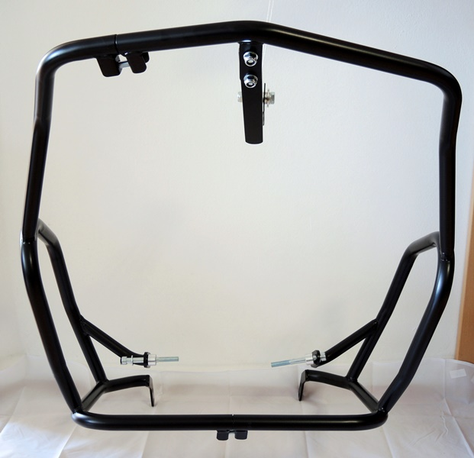

2x bolt M10 ID.2 + 2x dural. sleeve ID.8 + 2x washer M10 + 2x plastic cap 45

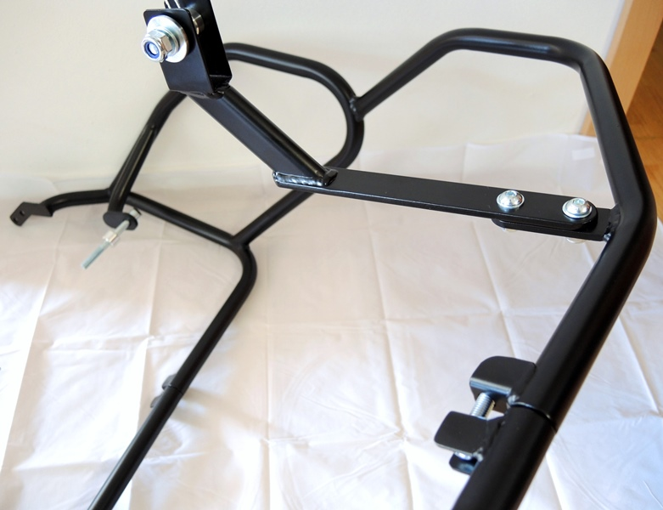
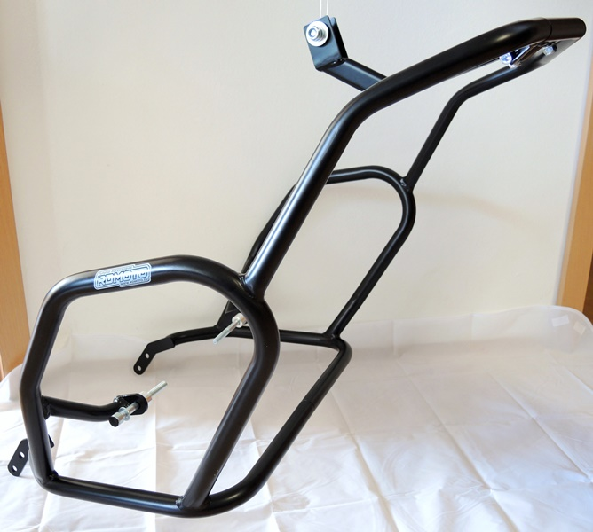
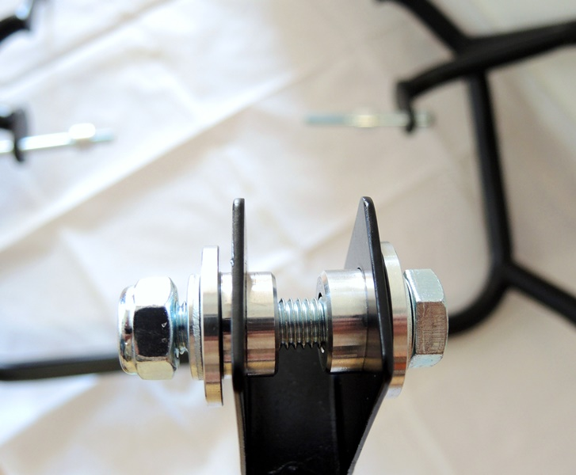
Bolt M10 ID.3 + sleeve ID.4 + washer M10 ID.5
2 x bolt M8 ID.6 + 4x washer M8 ID.6 + 2x nut M8 ID.7

Nut M10 ID.3 + sleeve ID.4 + washer M10 ID.5
Šroub M8 ID.7

Bolt M8 ID.7

4x olt M8 ID.9 + 4x sleeve ID.10 + 4x washer M8 + 4x cap X5

4x šroub M8 ID.9 + 4x váleček ID.10 + 4x podložka M8 + 4x krytka X5

2x bolt M10 ID.2 + 2x sleeve ID.8 + 2x washer M10 + 2x palstic cap 45

9
13,11,12
10
Origin.bolt
Original bolt. Rear place.

