CF129
KTM 790 / 890 Adventure /R_2019-

Kit for Left Side |  |  |  |  | Kit for Right Side
ID | Description | Cat. No | Pcs |  | ID | Description | Cat.No | Pcs
1 | Frame | CF129-L | 1 |  | 1 | Frame | CF129-P | 1
2 | Steel adapter | X132 | 1 |  | 2 | Steel adapter | X133 | 1
3 | Dural. sleeve, lenght=78mm | 1325 | 1 |  | 3 | Dural. sleeve, lenght =60mm | 1326 | 1
4 | Dural. sleeve, lenght=24mm | 1329 | 1 |  | 4 | Dural. sleeve, lenght =24mm | 1329 | 1
5 | Dural. sleeve, lenght =27mm | 1330 | 1 |  | 5 | Dural. sleeve, lenght =27mm | 1330 | 1
6 | Screw M8x50mm | 1065 | 2 |  | 6 | Screw M8x50mm | 1065 | 2
7 | Screw M8x100mm | 1000 | 1 |  | 7 | Screw M8x80mm | 843 | 1
8 | Screw M10x25mm | 1066 | 1 |  | 8 | Screw M8x25mm | 831 | 2
9 | Washer - Flat M8 | 802 | 3 |  | 9 | Washer - Flat M8 | 802 | 5
10 | Washer - Flat M10 | 804 | 1 |  | 10 | Screw M8x25mm | 833 | 1

We recommend medium strenght thread glue.

Instructions:

- Take off the original bottom plastic casing

- Mount the steel adapters following instructions below

- Put back on the original plastic casing

- Mount the crash frames following instructions below

Left bottom part:

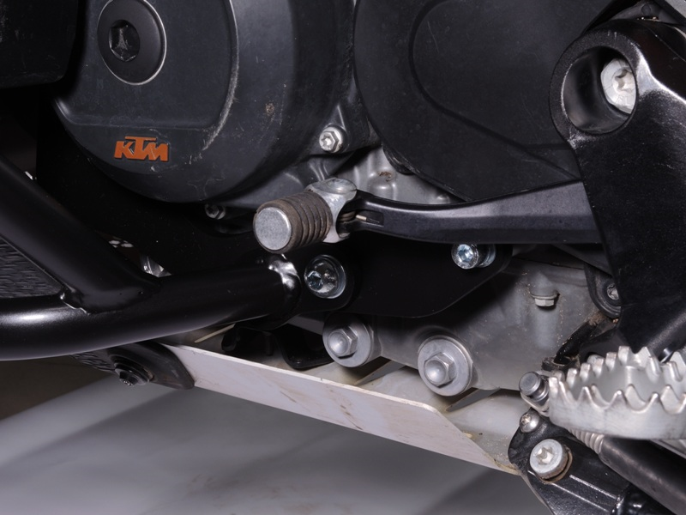
Dural. sleeve ID.5 (lenght 27mm) + Screw ID.6 + Washer ID.9

Šroub M10 ID.8 + podložka ID.10
Steel adapter ID.2 + dural. sleeve ID.4 (lenght 24mm) + Screw ID.6 + Washer ID.9
Screw M10 ID.8 + Washer ID.10

Right bottom part:
Steel adapter ID.2 + dural. sleeve ID.4 (lenght 24mm) + Screw ID.6 + Washer ID.9
Dural. sleeve ID.5 (lenght 27mm) + Screw ID.6 + Washer ID.9

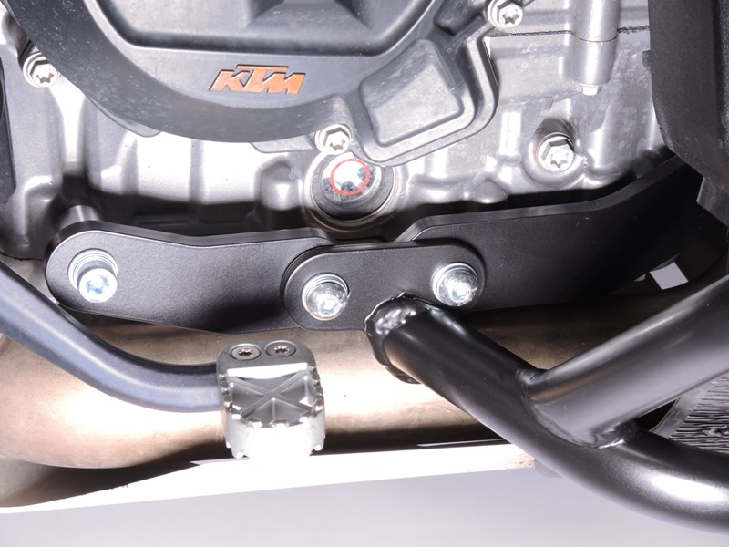
2x Screw ID.8 + 2x Washer ID.9

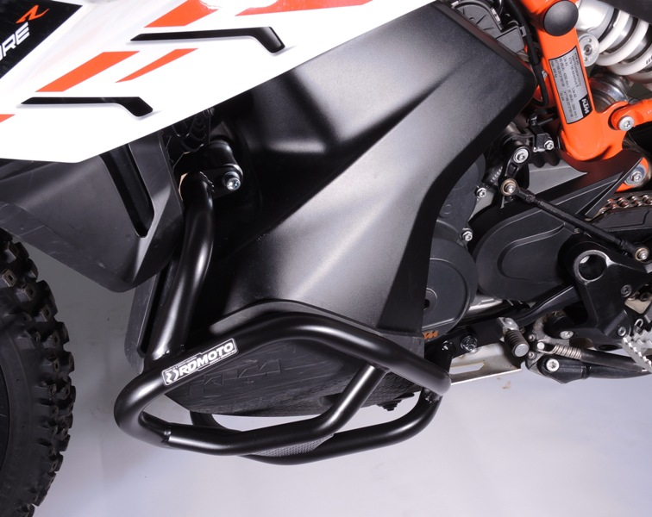
Screw ID.7 + dural. sleeve ID.3 (lenght 78mm) + Washer ID.9

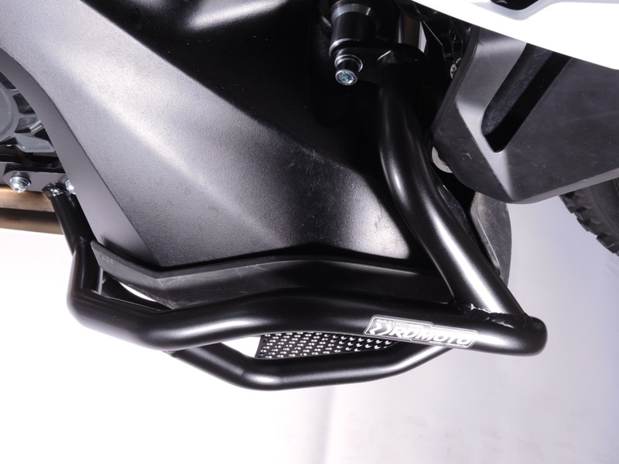
Screw ID.7 + dural. sleeve ID.3 (lenght 60mm) + Washer ID.9

9
13,11,12
10
Origin.bolt
Original bolt. Rear place.

