CF12
Suzuki DR650RS

ID. | Description | Cat.N | Qt.
1 | Bolt M8x25 rear gripping | 833 | 2
2 | Washer M8 big surface | 988 | 2
3 | Steel lower bracket- smaller | X37 | 1
4 | U clamp with thread M10 | X38 | 1
5 | Washers M10 | 804 | 6
6 | Nut M10 | 810 | 2
7 | Steel bracket upper | X50 | 1
8 | Crash frames L+R | CF12 | 1+1
9 | Bolt M10x20mm lower head for gripping frame+bracket | 819 | 4
10 | Plastic cover | X35 | 2
11 | 3M Tape | 3M | 2
12 | Stickers RDMOTO |  | 2

Fitting instruction:
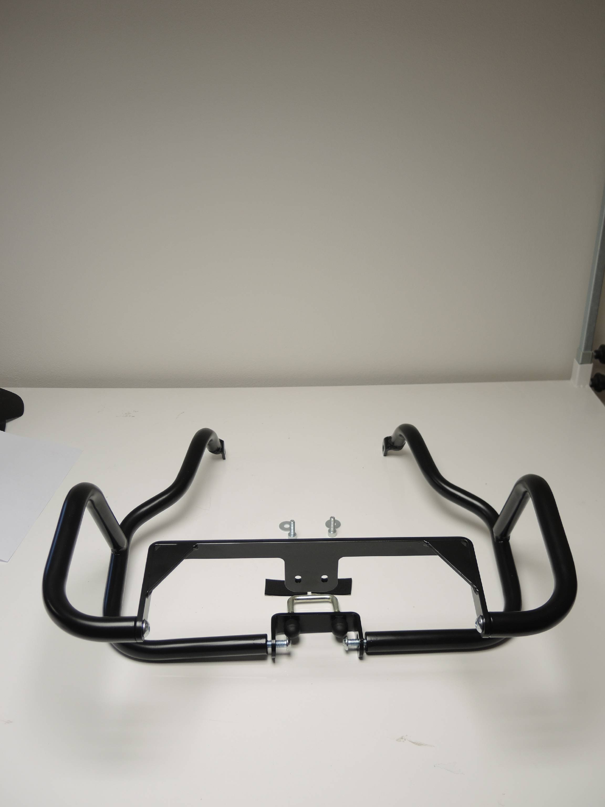
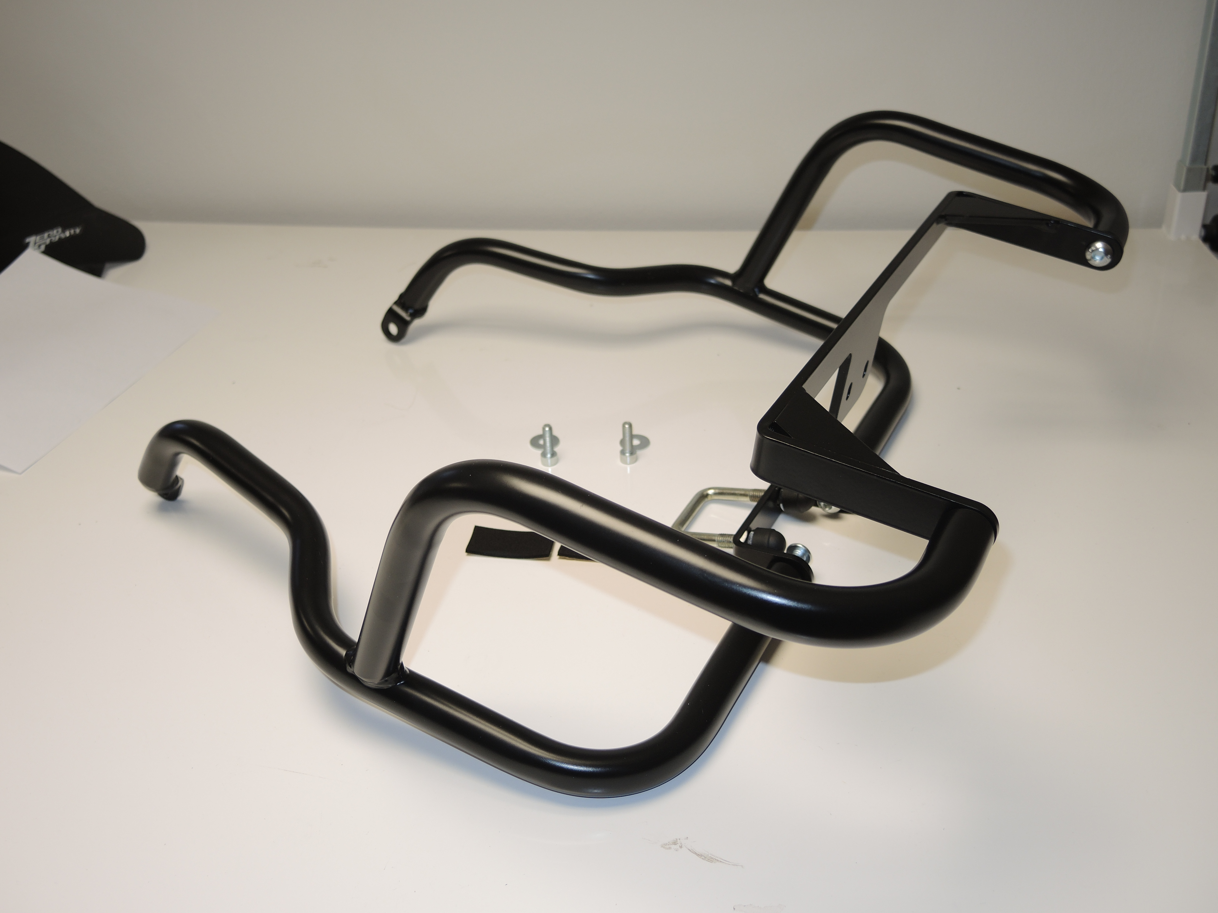
Place original bolts.
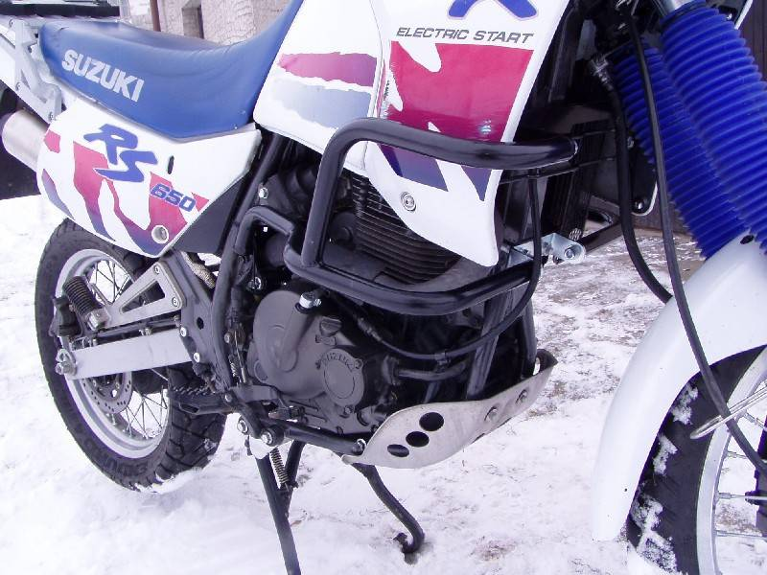
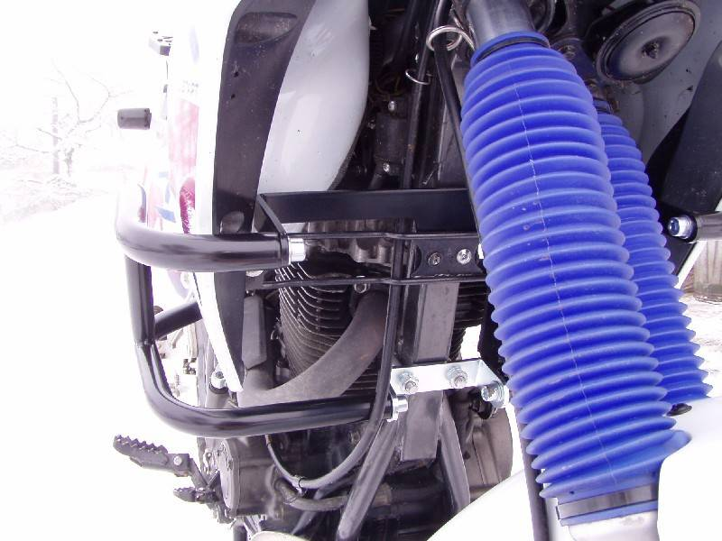
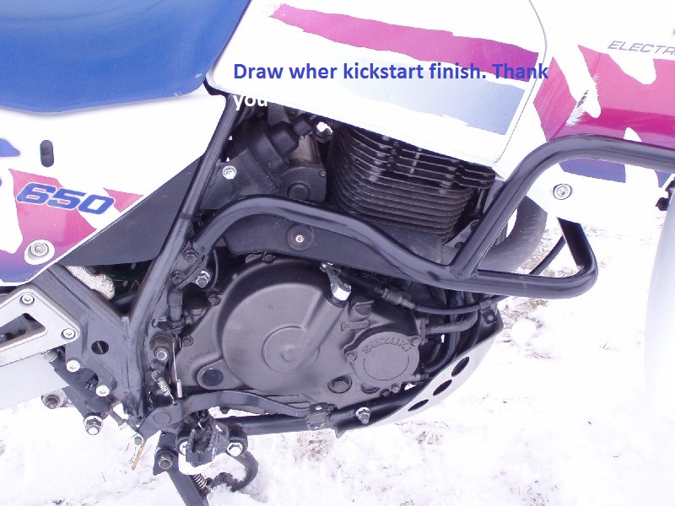
Dismantle original bolt M8. For mounting use bolt ID.1 with washer ID.2 for both sides.
Use bolts ID.9 and washer ID.5 for both sides. With vlack steel digger adapter ID.7
Tighten nuts and washers M10 ID.6 and ID.5
Use smaller steel bracket ID.3
Place plastic caps on the nuts.
Use clamp shape U with threads M10. ID.4

