CF130
KTM 790 / 890 Adventure /R_2019-

Kit for Left Side |  |  |  |  | Kit for Right Side
ID | Description | Cat.No. | Pcs |  | ID | Description | Cat. No | Pcs
1 | Frame | CF129-L | 1 |  | 1 | Frame | CF129-P | 1
2 | Steel adapter | X132 | 1 |  | 2 | Steel adapter | X133 | 1
3 | Dural. sleeve, lenght =78mm | 1325 | 1 |  | 3 | Dural. sleeve, lenght =60mm | 1326 | 1
4 | Dural. sleeve, lenght =24mm | 1329 | 1 |  | 4 | Dural. sleeve, lenght =24mm | 1329 | 1
5 | Dural. sleeve, lenght =27mm | 1330 | 1 |  | 5 | Dural. sleeve, lenght =27mm | 1330 | 1
6 | Screw M8x50mm | 1065 | 2 |  | 6 | Screw M8x50mm | 1065 | 2
7 | ------------------------------------------ | ------- | --- |  | 7 | ------------------------------------------ | ------- | ---
8 | Screw M10x25mm | 1066 | 1 |  | 8 | Screw M8x25mm | 831 | 2
9 | Washer - Flat M8 | 802 | 4 |  | 9 | Washer - Flat M8 | 802 | 6
10 | Washer - Flat M10 | 804 | 1 |  | 10 | Screw M8x25mm | 833 | 1
11 | Frame | CF134-L | 1 |  | 11 | Frame | CF134-P | 1
12 | Stirrup 22mm | 680 | 1 |  | 12 | Stirrup 22mm | 680 | 1
13 | Stirrup with threads 22mm | 682 | 1 |  | 13 | Stirrup with threads 22mm | 682 | 1
14 | Screw M6x40mm | 865 | 2 |  | 14 | Screw M6x40mm | 865 | 2
15 | Dural. sleeve, lenght =10mm | 124 | 1 |  | 15 | Dural. sleeve, lenght =10mm | 124 | 1
16 | Screw M8x120mm | 845 | 1 |  | 16 | Screw M8x100mm | 1000 | 1
17 | Washer – Flat M6 | 947 | 2 |  | 17 | Washer – Flat M6 | 947 | 2
18 | Stirrup plastic insertion | 1331 | 2 |  | 18 | Stirrup plastic insertion | 1331 | 2
19 | Strut (to put between the frames) | X134 | 1

We recommend using medium strenght thread glue.

Instructions:

- Take off the original plastic casing

- Mount the steel adapters following instructions below

- Put the original casing back

- Mount the bottom crash frames following instructions below, do not tighten the screw on top

- When you finish mounting bottom frame, you may proceed with upper part
Bottom Left Part:

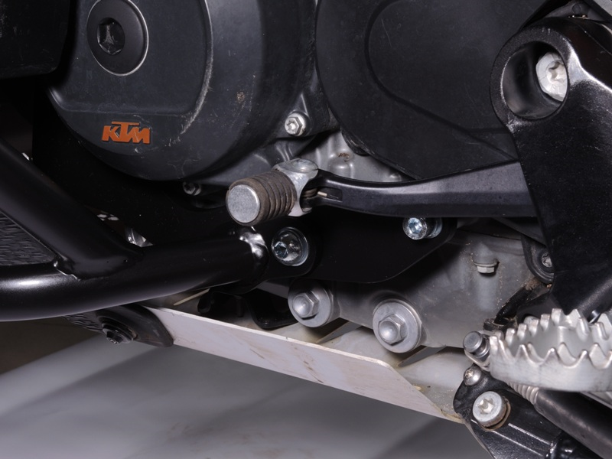
Dural. roller ID.5 (lenght 27mm) + Screw ID.6 + Washer ID.9

Šroub M10 ID.8 + podložka ID.10
Steel adapter ID.2 + Dural. sleeve ID.4 (lenght 24mm) + Screw ID.6 + Washer ID.9
Screw M10 ID.8 + Washer ID.10

Bottom Right Part:
Steel adapter ID.2 + Dural. sleeve ID.4 (lenght 24mm) + Screw ID.6 + Washer ID.9
Dural. sleeve ID.5 (lenght 27mm) + Screw ID.6 + Washer ID.9

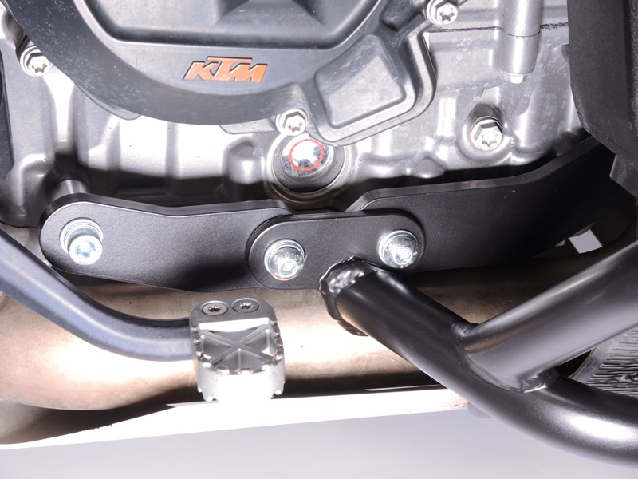
2x Screw ID.8 + 2x Washer ID.9

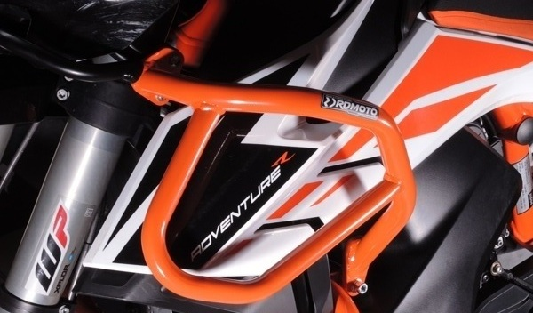
Left Side : Screw ID.16 (lenght 120mm) + Washer ID.9 + dural. sleeve ID.15 (lenght 10mm) + dural. sleeve (put inside the frame) ID.3 (lenght 78mm)
Pravá strana : Screw ID.16 (lenght 100mm) + Washer ID.9 + dural. roller ID.15 (lenght 10mm) + dural. sleeve (to put inside the frame) ID.3 (lenght 60mm)

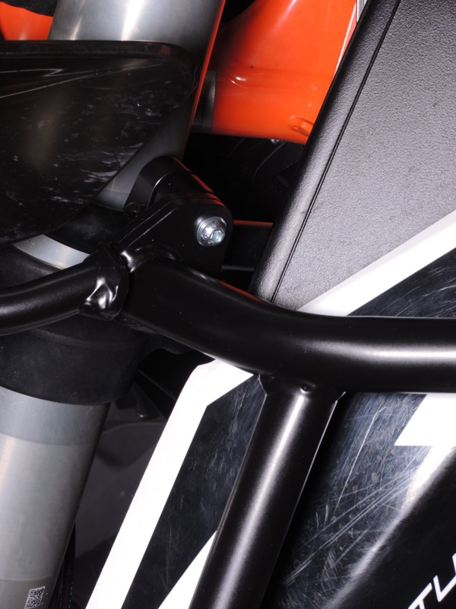
Steel strut ID.19 + Dural. stirrups ID.12 and ID.13 + 2x plastic insertions ID.18 + 2x Screws ID.14 + 2x Washers ID.17
Mounting procedure is identical for both sides.
9
13,11,12
10
Origin.bolt
Original bolt. Rear place.

