CF131
KTM 790 Adventure

Kit for the left side |  |  |  |  | Kit for the right side
ID | Description | Cat.No | Pcs |  | ID | Description | Cat.No | Pcs
1 | Dural.sleeve l=13mm | 86 | 2 |  | 1 | Dural.sleeve l=13mm | 86 | 2
2 | Dural.sleeve l=6mm | 1338 | 2 |  | 2 | Dural.sleeve l=6mm | 1338 | 2
3 | Bolt M8x60mm | 839 | 2 |  | 3 | Bolt M8x60mm | 839 | 2
4 | Bolt M8x70mm | 840 | 1 |  | 4 | Bolt M8x70mm | 840 | 1
5 | Sticker RDmoto |  | 1 |  | 5 | Sticker RDmoto |  | 1

We recommend using medium strength thread glue during assembly.

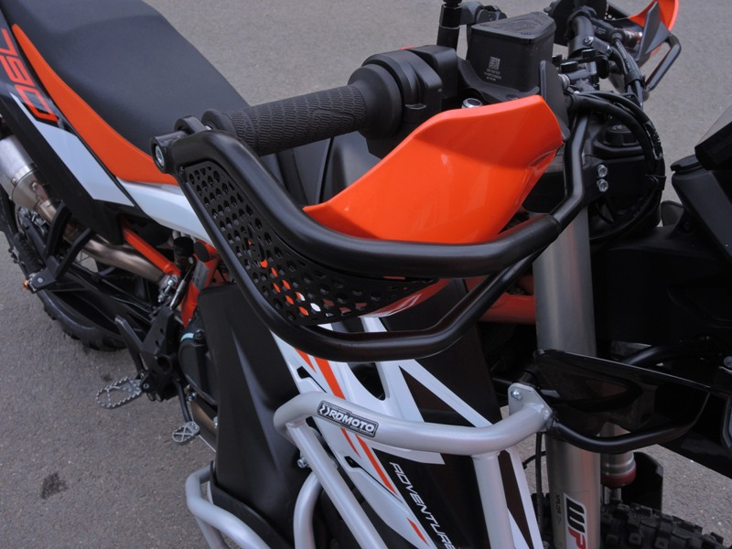
2x dural. sleeve ID. 1 + 2x dural. sleeve ID.2 + 2x bolt M8x60mm ID.3
Bolt M8x70mm ID.4
Protektor ID.3 + vložka ID.1 + šroub ID.2
The assembly of the left and right side is identical.

