CF132
Honda CRF1100L Africa Twin 2020-

Kit for Left Side |  |  |  |  | Kit for Right Side
ID | Description | Cat.No | Pcs |  | ID | Description | Cat.No | Pcs
1 | Upper Crash Frame | CF132-L | 1 |  | 1 | Upper Crash Frame | CF132-P | 1
2 | Steel Adapter | X138 | 1 |  | 2 | Steel adapter – with nut | X137 | 1
3 | Bolt M10x110mm | 879 | 1 |  | 3 | Steel adapter – under light | X139 | 1
4 | Washer Flat M10 | 804 | 1 |  | 4 | Washer M8- Flat | 802 | 3
5 | Bolt M8x35mm – under light | 861 | 2 |  | 5 | Safety nut M8 | 809 | 2
6 | Washer M8- Flat | 802 | 7 |  | 6 | Bolt M8x25mm | 831 | 1
7 | Safety nut M8 | 809 | 2
8 | Bolt M6x20mm – under light | 1024 | 2
9 | Washer M6 – under light | 1023 | 4
10 | Nut M6 – under light | 948 | 2
11 | Bolt M8x25mm | 831 | 1
12 | Dural. Sleeve lenght = 8mm | DV1334 | 1
13 | Bolt M8x110mm | 844 | 1

We recommend using medium strenght thread glue during assembly.

Mounting Instructions:

- Deinstall the original motorcycle hood.
- Mount the steel adapters X137, X138 following below described instructions.
- Install the original motorcycle hood back on.
- Mount the steel adapter X139 under the light, but dont tighten any nuts yet, you will need to lean the adapter during assembly of upper frames to correctly fit the M6 bolts connecting upper frames together.
- Now you may install the upper crash frames which connect under the light. If they differ on each side leaning away from the plastics, you may adjust it by the M6 bolts.
- Mount the crash frames and finally tighten all bolts.

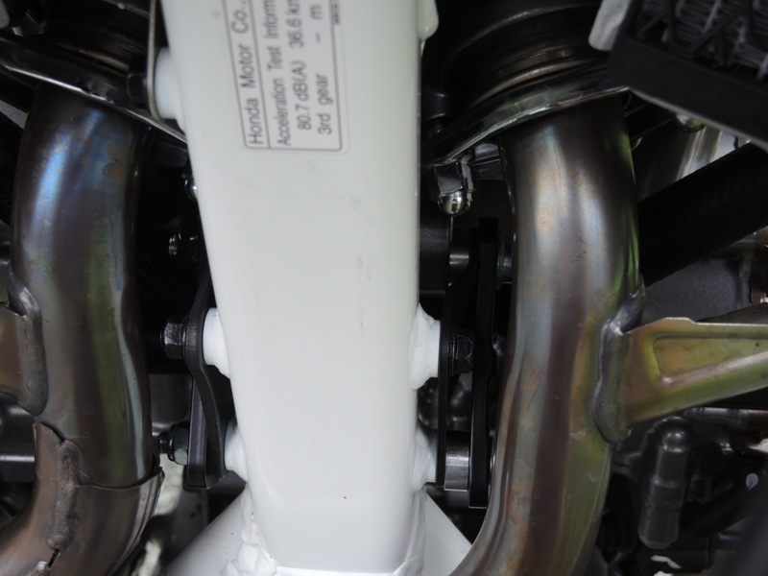
Adapter X138 ID.2 + dural. roller ID.12+ bolt M10 ID.3 + washer M10 ID.4 + bolt M8 ID.13 + washer M8 ID.6
Adapter X137 ID.2 with pre-welded nut + washer M8 ID.4 + nut M8 ID.5

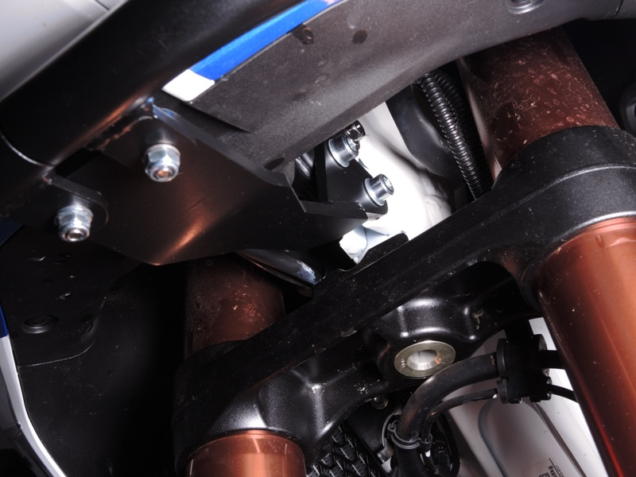
Steel adapter X139 + 2x bolt M8x35mm ID.5 + 4x washer M8 ID.6 + 2x nut M8 ID.7., Mount the adapter, but dont tighten anything yet
2x bolts M6x20mm ID.8 + 4x washers M6 ID.9 + 2x nuts M6 ID.10

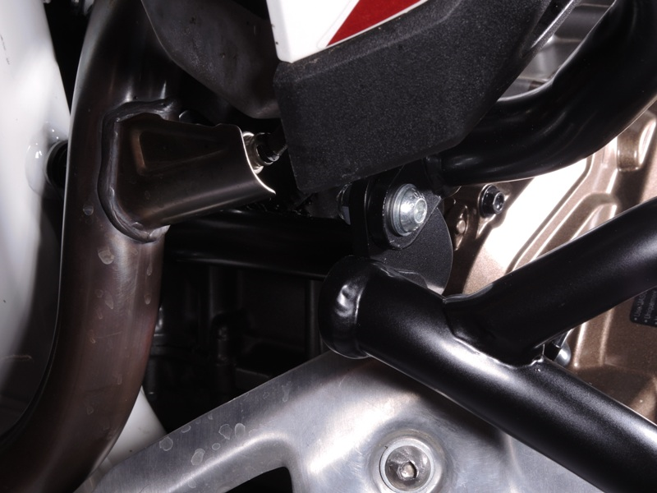
bolt M8x25mm ID.11 + 2x washer M8 ID.6 + nut M8 ID.7

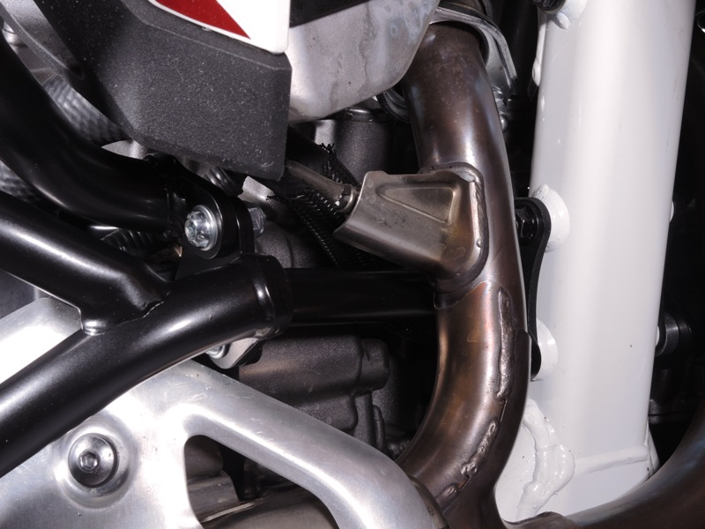
bolt M8x25mm ID.6 + 2x washer M8 ID.4 + nut M8 ID.5
9
13,11,12
10
Origin.bolt
Original bolt. Rear place.

