CF133
Honda CRF1100L Africa Twin 2020-

Kit for left side |  |  |  |  | Kit for right side
ID | Description | Cat.No | Pcs |  | ID | Description | Cat.No. | Pcs
1 | Lower crash frame | CF133-L | 1 |  | 1 | Lower crash frame | CF133-P | 1
2 | Steel adapter | X138 | 1 |  | 2 | Steel adapter – with nut | X137 | 1
3 | Steel adapter – bottom | X143 | 1 |  | 3 | Washer flat M8 | 802 | 7
4 | Bolt M10x110mm | 879 | 1 |  | 4 | Safety nut M8 | 809 | 4
5 | Washer flat M10 | 804 | 1 |  | 5 | Bolt M8x25mm | 831 | 2
6 | Washer flat M8- | 802 | 7 |  | 6 | Bolt M8x50mm | 837 | 1
7 | Safety Nut M8 | 809 | 3
8 | Bolt M8x25mm | 831 | 3
9 | Dural. sleeve lenght = 8mm | DV1334 | 1
10 | Bolt M8x110mm | 844 | 1

We recommend using medium strenght thread glue during assembly.

Installation Instructions:

- Deinstall the original engine cover from motorcycle.
- Now install the X137, X138 and X143 steel adapters following instructions below.
- Put back the engine cover which you took off in Step 1).
- Mount the lower crash frames and tighten all bolts.

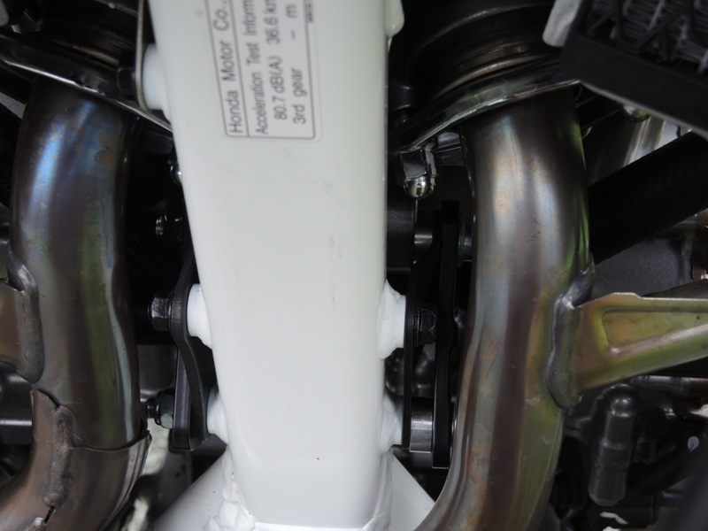
Adapter X138 ID.2 + Dural. sleeve ID.9+ Bolt M10 ID.4 + Washer M10 ID.5 + Bolt M8 ID.10 + Washer M8 ID.6
Adapter X137 ID.2 with pre-forged nut + Washer M8 ID.3 + Nut M8 ID.4

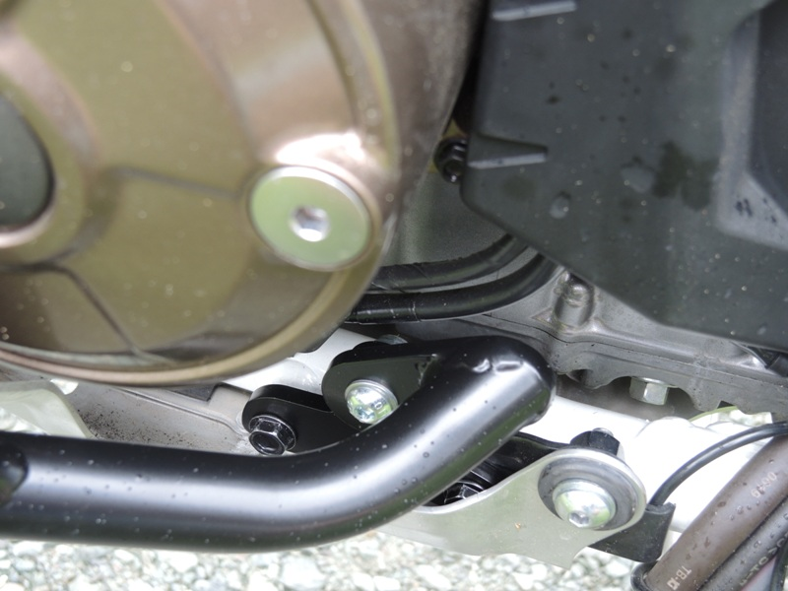
On left side, mount the steel adapter X143 ID.3 under the original bolt and check correct position/angle of the adapter.
Bolt M8x25mm ID.8 + Washer M8 ID.6 + Nut M8 ID.7

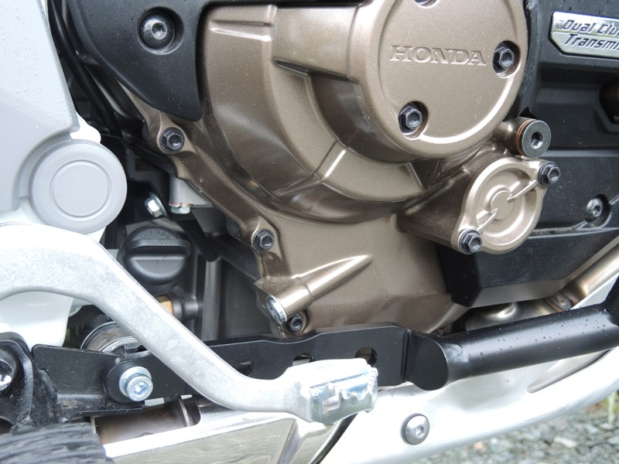
Bolt M8x50mm ID.6 + Washer M8 ID.3 + Nut M8 ID.4

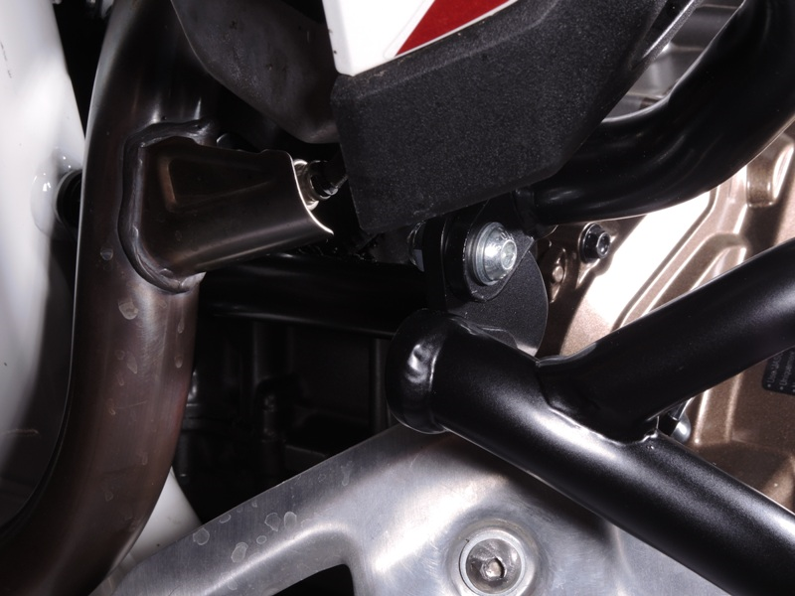
Use bolts to mount the lower crash frames; 2x Bolt M8x25mm ID.8 + 4x Washer M8 ID.6 + 2x Nut M8 ID.7
Use bolts to mount the lower crash frames; 2x Bolt M8x25mm ID.5 + 4x Washer M8 ID.3 + 2x Nut M8 ID.4
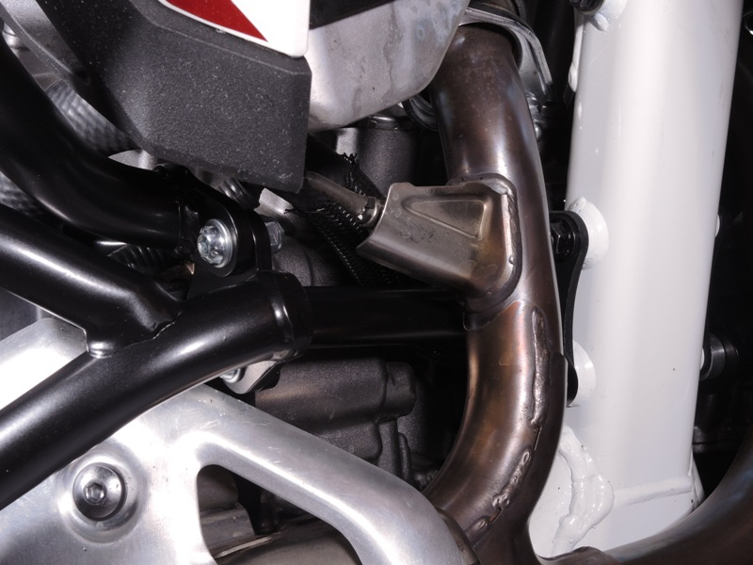
9
13,11,12
10
Origin.bolt
Original bolt. Rear place.

