CF134
KTM 790 / 890 Adventure /R_2019-

Kit for Left Side |  |  |  |  | Kit for Right Side
ID | Description | Cat. No | Pcs |  | ID | Description | Cat. No. | Pcs
1 | Frame | CF134-L | 1 |  | 1 | Frame | CF134-P | 1
2 | Stirrup 22mm | 680 | 1 |  | 2 | Stirrup 22mm | 680 | 1
3 | Stirrup with threads 22mm | 682 | 1 |  | 3 | Stirrup with threads 22mm | 682 | 1
4 | Screw M6x40mm | 865 | 2 |  | 4 | Screw M6x40mm | 865 | 2
5 | Dural. sleeve, lenght=75mm | 1340 | 1 |  | 5 | Dural. sleeve, lenght =93mm | 1339 | 1
6 | Screw M8x120mm | 845 | 1 |  | 6 | Screw M8x100mm | 1000 | 1
7 | Washer - Flat M8 | 802 | 1 |  | 7 | Washer - Flat M8 | 802 | 1
8 | Washer - Flat M6 | 947 | 2 |  | 8 | Washer - Flat M6 | 947 | 2
9 | Plastic stirrup insertion | 1331 | 2 |  | 9 | Plastic stirrup insertion | 1331 | 2
10 | Strut (put between the frames) | X134 | 1

We recommend using medium strenght thread glue.

Instructions:

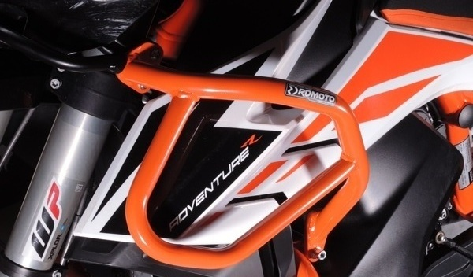
Left side : Screw ID.6 (lenght 120mm) + Washer ID.7 + dural. sleeve ID.5 (lenght 75mm)
Right side : Screw ID.6 (lenght 100mm) + Washer ID.7 + dural. sleeve ID.5 (lenght 93mm)

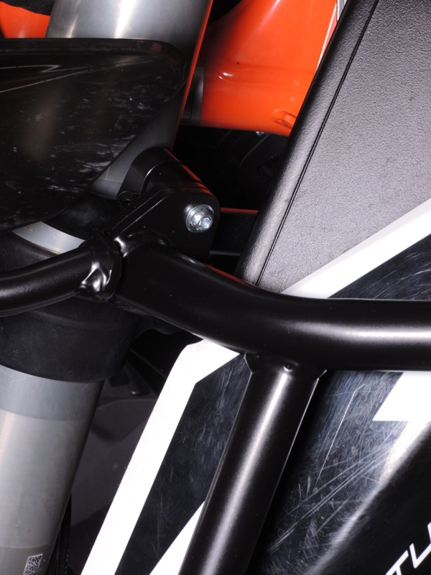
Steel strut ID.10 + dural. stirrups ID.2 and ID.3 + 2x plastic insertions ID.9 + 2x Screws ID.4 + 2x Washers ID.8
Mounting procedure is identical for both sides.

9
13,11,12
10
Origin.bolt
Original bolt. Rear place.

