CF138-SL01

**CFMOTO NK650**

|  |  |  |  |  |  |  |  |  |
| --- | --- | --- | --- | --- | --- | --- | --- | --- |
| **Kit for Left Side** | | | |  | **Kit for Right Side** | | | |
| **ID** | **Description** | **Cat.No** | **Pcs** |  | **ID** | **Description** | **Cat.No** | **Pcs** |
| 1 | Dural. adapter under the slider | 292 | 1 |  | 1 | Dural. adapter under the slider | 292 | 1 |
| 2 | Bolt M10x85mm | 981 | 1 |  | 2 | Bolt M10x65mm | 943 | 1 |
| 3 | Slider SL01 | SL01K | 1 |  | 3 | Slider SL01 | SL01K | 1 |
| 4 | Slider cap | capSL01-K | 1 |  | 4 | Slider cap | capSL01-K | 1 |
| 5 | Bolt M6x25mm | 877 | 3 |  | 5 | Bolt M6x25mm | 877 | 3 |
| 6 | Bolt M4x12mm | 876 | 2 |  | 6 | Bolt M4x12mm | 876 | 2 |
| 7 | Steel adapter | 762 | 1 |  | 7 | Steel adapter | 763 | 1 |
| 8 | Bolt M8x30mm | 834 | 1 |  | 8 | Bolt M8x30mm | 834 | 1 |
| 9 | Bolt M10x100x1,25mm | 892 | 1 |  | 9 | Bolt M10x105x1,25mm | 893 | 1 |
| 10 | Flat washer M8 | 802 | 1 |  | 10 | Flat washer M8 | 802 | 1 |
| 11 | Flat washer M10 | 804 | 1 |  | 11 | Dural. sleeve l=5mm | 433 | 2 |
| 12 | Dural. sleeve l=5mm | 433 | 2 |  | 12 | RDmoto sticker |  | 1 |
| 13 | Dural. sleeve l=4,5mm | 116 | 1 |  |  |  |  |  |
| 14 | RDmoto sticker |  |  |  |  |  |  |  |

**We recommend using medium strength thread glue during assembly.**

**Mounting the steel adapter:**

Adapter ID.7 + bolt ID.8 + bolt ID.9 + washer M8 ID.10 + washer M10 ID.11 + dural. sleeve ID.13

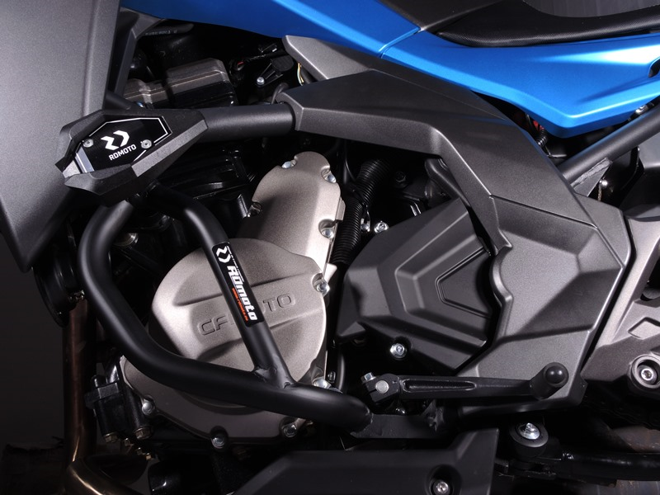

2x dural. sleeve ID.12 under the footrests holder

**Mounting the slider:**

Adapter ID.1 + bolt ID2 M10x85mm ID.2 + slider ID.3 + cap ID.4 + 3x bolt ID.5 + 2x bolt ID.6

Original bolt

**Mounting the steel adapter:**

Adapter ID.7 + bolt ID.8 + bolt ID.9 + washer M8 ID.10

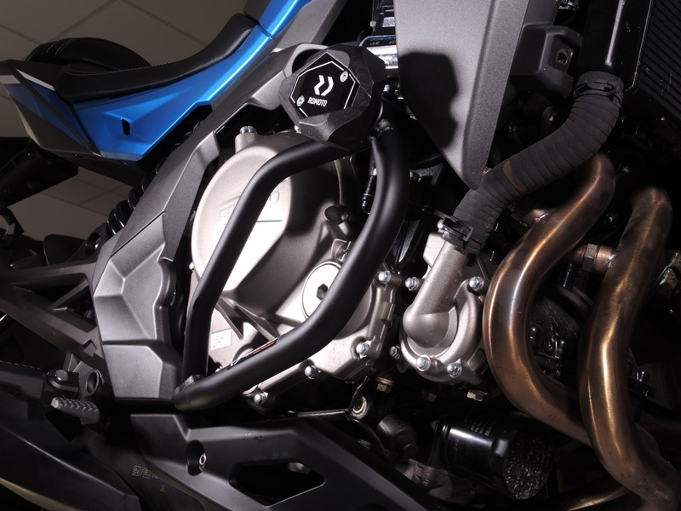

Original bolt

**Mounting the slider:**

Adapter ID.1 + bolt M10x85mm ID.2 + slider ID.3 + cap ID.4 + 3x bolt ID.5 + 2xbBolt ID.6

2x Dural. sleeve ID.11 under the footrests holder

10

13,11,12

9

Original bolt. Rear place.

Origin.bolt