CF139
Yamaha 700 Ténéré 2019-

Kit for Left Side |  |  |  |  | Kit for Right Side
ID | Description | Cat.No | Pcs |  | ID | Description | Cat.No | Pcs
1 | Crash frame | CF139-L | 1 |  | 1 | Crash frame | CF139-P | 1
2 | Aluminum protector insert | X131 | 1 |  | 2 | Aluminum protector insert | X131 | 1
3 | Protector | PVPKN-0/16 | 1 |  | 3 | Protector | PVPKN-0/16 | 1
4 | POM sleeve under the protector | 1345 | 1 |  | 4 | POM sleeve under the protector | 1345 | 1
5 | Bolt M10x65mm | 943 | 1 |  | 5 | Bolt M10x65mm | 943 | 1
6 | Bolt M12x70x1,25mm | 937 | 1 |  | 6 | Bolt M12x75x1,25mm | 914 | 1
7 | Dural. Sleeve length 26mm | 1343 | 1 |  | 7 | Dural. sleeve, length 17mm | 1344 | 1
8 | Hex insert M12 | X116 | 1 |  | 8 | Hex insert M12 | X116 | 1
9 | Plastic bolt cap M12 | X60 | 1 |  | 9 | Plastic bolt cap M12 | X60 | 1
10 | Bolt M8x30mm | 834 | 1 |  | 10 | Bolt M8x30mm | 834 | 1
11 | Flat washer M8 | 802 | 1 |  | 11 | Flat washer M8 | 802 | 1

We recommend using medium strength thread glue during assembly.

Instructions:

- Remove original bolts on the left side of the motorcycle.
- Start with the LEFT crash frame. Fasten it at the bottom with M8x30 bolt with M8 flat washer (do not tighten yet). At the top, insert dural. washer l=26mm (use original steel washer) under the crash frame holder. Insert M12x70x1,25mm bolt into the dural. insert and mount the entire assembly together in the motorcycle frame.
- Tighten bolts and use plastic cap on the M12 bolt head
- Take M10x65mm bolt, aluminum protector insert, protector (ID 3) and POM sleeve (ID4). Mount the entire assembly in the prepared M10 thread in the crash frame
- The assembly of the right side is the same. Just use bolt M12x75x1,25mm and dural. sleeve l=17mm under the crash frame.

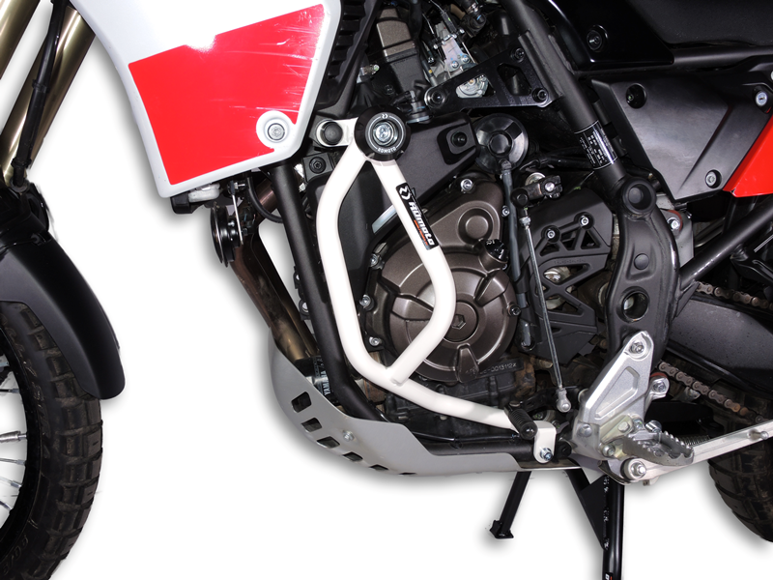
Bolt ID.6 + dural.sleeve ID.7 + insert ID.8 + plastic cap ID.9
Bolt ID.5 + prot. Insert ID.2 + protector ID.3 + POM sleeve ID.4
Bolt ID.10 + washer ID.11
Crash frame ID.1
Bolt ID.5 + prot. insert ID.2 + protector ID.3 + POM sleeve ID.4

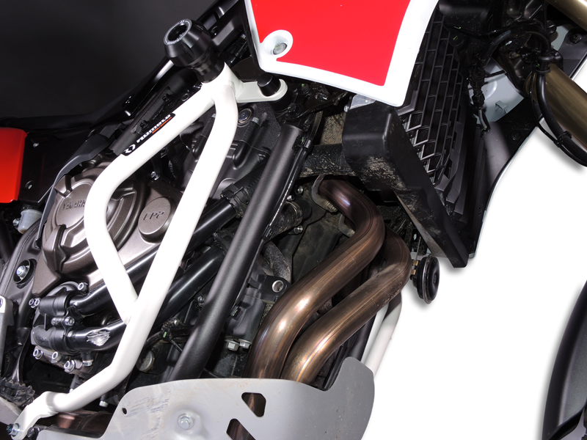
Bolt ID.10 + insert ID.11
Crash frame ID.1
Bolt ID.6 + dural.sleeve ID.7 + insert ID.8 + plastic cap ID.9

9
13,11,12
10
Origin.bolt
Original bolt. Rear place.

