CF13
Aprilia ETV Caponord
Fitting kit

ID | Description | Cat.No | QTY
1 | Crash frames |  | 2
2 | Steel adapter-shape L | X40 | 2
3 | Bolt M8x25 | 831 | 6
4 | Washer M8 | 802 | 10
5 | Nut M8 | 809 | 4
6 | Plastic cover | X32 | 2
7 | Dural. cylinder d=45mm | 1147 | 2
8 | Bolt M10x100 | 885 | 2
9 | Washer- flat M10 | 804 | 2
10 | Steel adapter | X39 | 1
11 | Dural. cylinder d=25mm | 122 | 2
12 | Bolt M5x60 | 873 | 2
13 | Washer-flat | 947 | 2
 | Stickers RDmoto |  | 2

Assembly instruction:
7
8
9
12,13
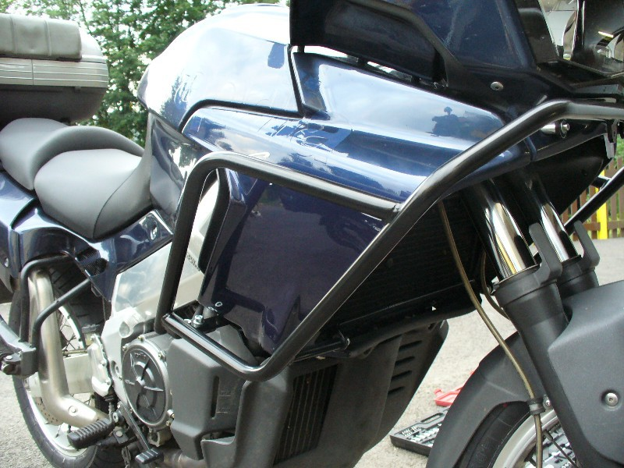
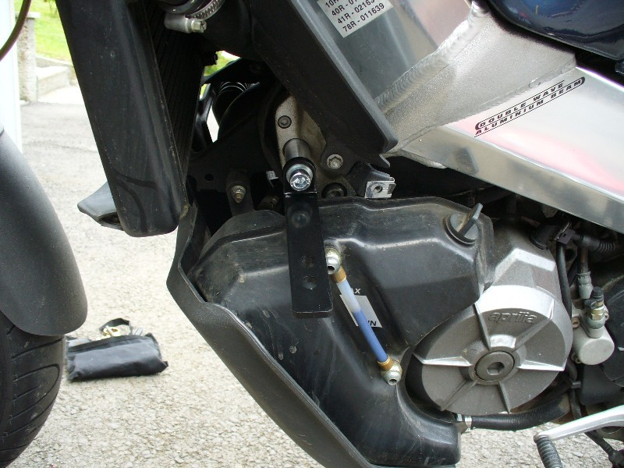
1
11
1

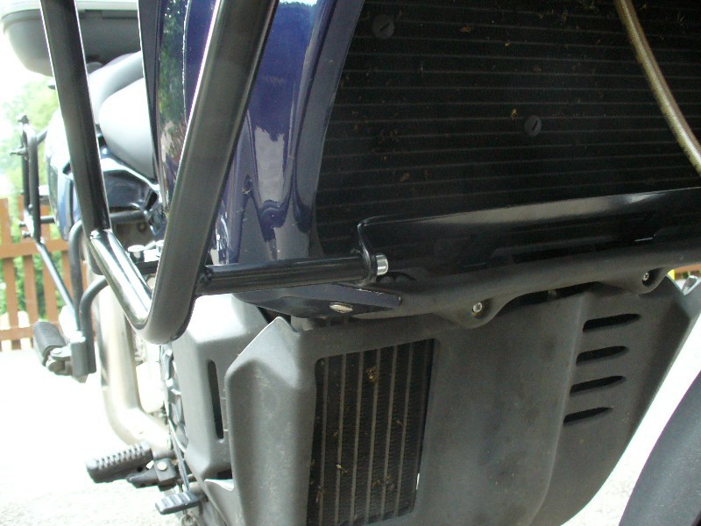
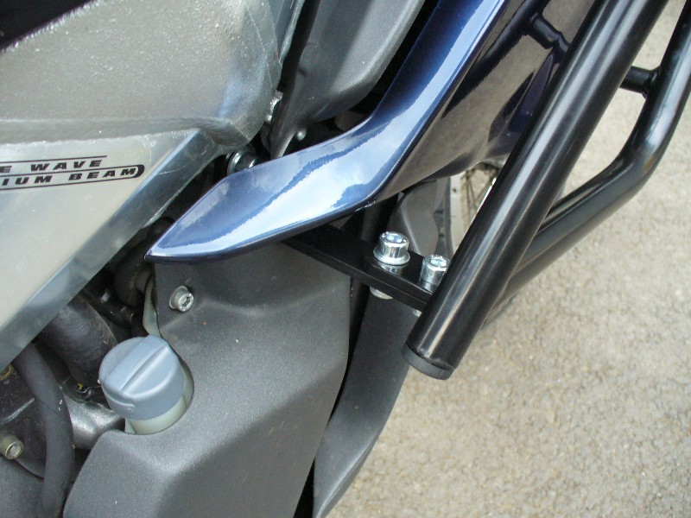
6
3
2
4
5
10
3
4
Dismantle original plastic. Insert steel adapter and use original bolts.

- Take out left and right side fairing.
- Mounting steel adapter, shape L.
- Take out bolts under the light.
- Mounting crash frames-do this according to photos. Left and right side are same.

Use the glue of all threads- medium strong.

