CF142-SL01

**Honda CB650F**

|  |  |  |  |  |  |  |  |  |  |  |
| --- | --- | --- | --- | --- | --- | --- | --- | --- | --- | --- |
| **Kit for Left Side** | | | | | |  | **Kit for Right Side** | | | |
| **ID** | **Description** | | | **Cat.No** | **Pcs** |  | **ID** | **Description** | **Cat.No** | **Pcs** |
| 1 | Dural. adapter under the slider | | | 292 | 1 |  | 1 | Dural. adapter under the slider | 292 | 1 |
| 2 | Bolt M10x35mm | | | 847 | 1 |  | 2 | Bolt M10x35mm | 847 | 1 |
| 3 | Spring washer M10 | | | 801 | 1 |  | 3 | Spring washer M10 | 801 | 1 |
| 4 | Bolt M6x25mm | | | 877 | 3 |  | 4 | Bolt M6x25mm | 877 | 3 |
| 5 | Bolt M4x12mm | | | 876 | 2 |  | 5 | Bolt M4x12mm | 876 | 2 |
| 6 | Slider | | | SL01K | 1 |  | 6 | Slider | SL01K | 1 |
| 7 | Slider cap - black | | | capSL-K | 1 |  | 7 | Slider cap – black | capSL-K | 1 |
| 8 | Bolt M12x70x1,25mm | | | 937 | 1 |  | 8 | Bolt M12x50x1,25mm | 990 | 1 |
| 9 | Flat washer M12 | | | 803 | 2 |  | 9 | Flat washer M12 | 803 | 2 |
| 10 | Steel rod M12x250mm | | | 12x250xZT | 1 |  | 10 | Nut M12 | 1073 | 1 |
| 11 | Lock nut M12 | | | 811 | 1 |  | 11 | Lock nut M12 | 811 | 1 |
| 12 | RDmoto sticker | | |  |  |  | 12 | Dural. sleeve l= 45mm | 1348 | 1 |
|  |  | | |  |  |  | 12 | RDmoto sticker |  | 1 |
|  | |  |

**We recommend using medium strength thread glue during assembly.**

**Mounting Instructions:**

1. **Remove original side plastics.**
2. **Remove original bottom bolt on the engine, see the picture below.**
3. **Remove the shift lever on the left side.**
4. **Take Steel rod M12x250mm with a sealed nut from the mounting kit and insert it from the left side of the motorcycle to the right side. You will have a sealed nut on the left side of the motorcycle.**
5. **Take the classic M12 nut and screw it up to the engine from the right side and tighten it. The lower part of the motorcycle is ready for the assembly of crash frames.**
6. **Remove the original upper bolt on the right side of the motorcycle and take the right crash frame. At the top, lightly tighten the drop frame with an M12x50x1.25mm bolt with an M12 flat washer.**
7. **At the bottom, thread a 45mm long dural. sleeve onto a steel rod. Fit the crash frame and tighten the frame slightly with an M12 lock nut with a flat washer. You can now tighten the upper bolt and lower nut (torque 40Nm). The crash frame on the right side is mounted.**
8. **Install the left crash frame in a similar way, tighten the M12x70x1.25mmbolt in the upper part of the motorcycle and tighten the M12 lock nut with a flat M12 washer in the lower part.**
9. **The last step is the installation of crash sliders, which is the same for the left and right side.**
10. **Take dural. adapters under the sliders and M10x35mm bolts with M10 spring washers, mount the adapters on the prepared threads in the crash frames.**
11. **Install sliders using Bolts M6x25mm and mount the aluminum caps into sliders using Bolts M4x12mm.**

**Thank you for purchasing our product. If you have any problems with the installation, please contact us: info@rdmoto.eu**

Adapter ID.1 + bolt M10x35mm ID.2 + washer M10 ID.3 + slider ID.6 + cap ID.7 + bolt 3x M6x25mm ID.4 + 2x bolt M4x12mm ID.5

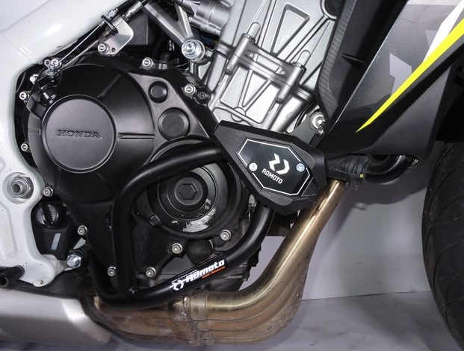

The original bottom bolt.

Nut M12 ID.10 + dural. sleeve ID.12 + lock nut M12 ID.11 + washer M12 ID.9

bolt M12x50x1,25mm ID.8 + washer M12 ID.9

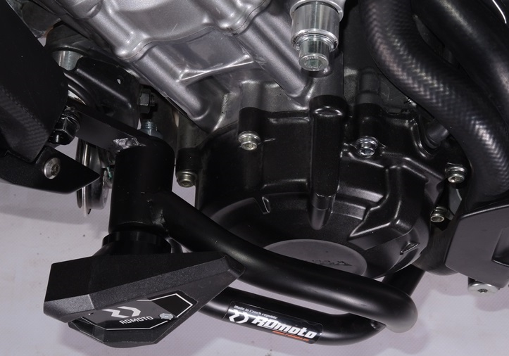

Steel rod M12x250mm ID.10 + lock nut M12 ID.11 + washer M12 ID.9

Adapter ID.1 + bolt M10x35mm ID.2 + washer M10 ID.3 + slider ID.6 + cap ID.7 + bolt 3x M6x25mm ID.4 + 2x bolt M4x12mm ID.5

Bolt M12x70x1,25mm ID.8 with washer M12 ID.9

10

13,11,12

9

Original bolt. Rear place.

Origin.bolt