CF14
Suzuki DL650 V-Strom
2004-2010

Kit for the left side |  |  |  |  | Kit for the right side
No. | Description | Cat.no. | Pcs |  |  | No. | Description | Cat.no. | Pcs
1 | Crash bar |  | 1 |  |  | 1 | Crash bar |  | 1
2 | Bolt M8x30mm | 834 | 1 |  |  | 2 | Bolt M8x50mm | 837 | 3
3 | Bolt M8x50mm | 837 | 3 |  |  | 3 | Pad M8 (spring) | 800 | 3
4 | Pad M8 (spring) | 800 | 3 |  |  | 4 | Cover on head of bolt | X5 | 3
5 | Cover on head of bolt | X5 | 3 |  |  | 5 | Dural. cylinder d=13mm | 86 | 2
6 | Dural. cylinder d=13mm | 86 | 2 |  |  | 6 | Plastic plug into the tube | X19 | 1
7 | Plastic plug into the tube | X19 | 1 |  |  | 7 | Advertising sticker RDmoto |  | 1
8 | Advertising sticker RDmoto |  | 1 |  |  | 9 | Dural. cylinder d=16mm | 252 | 1
9 | Dural. cylinder d=16mm | 252 | 1

Installation:

Make the installation of the crash bar according to the instruction on the below attached photos.

Warning – we recommend to use safety glue on threads of all bolts (moderate strong – blue colour).

The right side:

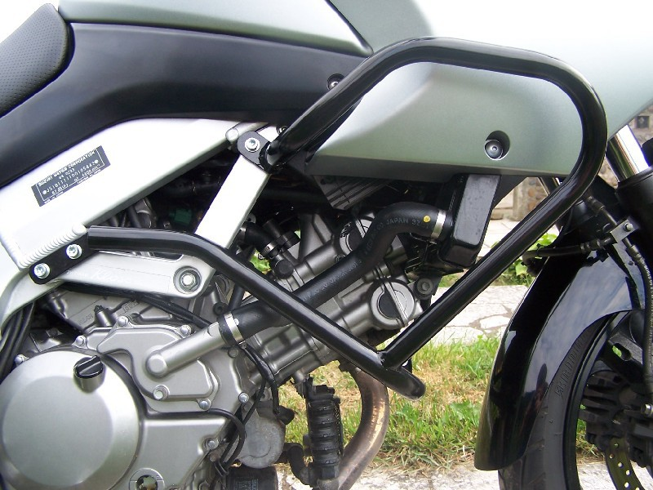

bolt M8x50 mm + cylinder 13mm + pad (spring) + cover on head of bolt
two bolts M8x50mm + two duralumin cylinders 13mm + two pads (spring) + two covers on head of bolt
for connecting of the left and right side of the crash bars; bolt M8x30mm

The left side:

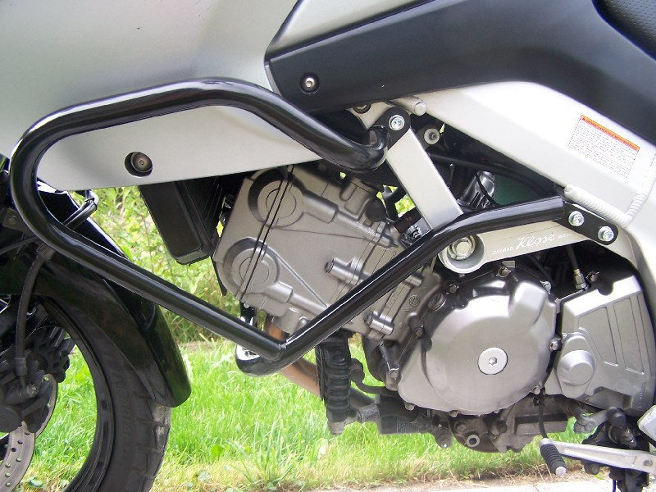

for connecting of the left and right side of the crash bars (viz the right side)
bolt M8x50 mm + cylinder 13mm + pad (spring) + cover on head of bolt

two bolts M8x50mm + two duralumin cylinders 13mm + two pads (spring) + two covers on head of bolt

