CF15
Yamaha BT 1100 Bulldog

Kit for the left side |  |  |  |  | Kit for the right side
No. | Description | Cat.no. | Pcs |  |  | No. | Description | Cat.no. | Pcs
1 | Crash bar |  | 1 |  |  | 1 | Crash bar |  | 1
2 | Nut M10 – safety | 810 | 1 |  |  | 2 | Nut M10 – safety | 810 | 1
3 | Pad M10 – plane | 804 | 1 |  |  | 3 | Pad M10 – plane | 804 | 1
4 | Steel bar 10x230x30x30 |  | 1 |  |  | 4 | Advertising sticker RDmoto |  | 1
5 | Advertising sticker RDmoto |  | 1

Installation:

Make the installation of the crash bar according to the instruction on the below attached photos.

The installation of the crash bar for the left and right side is the same.

Warning – we recommend to use safety glue on threads of all bolts (moderate strong – blue colour).

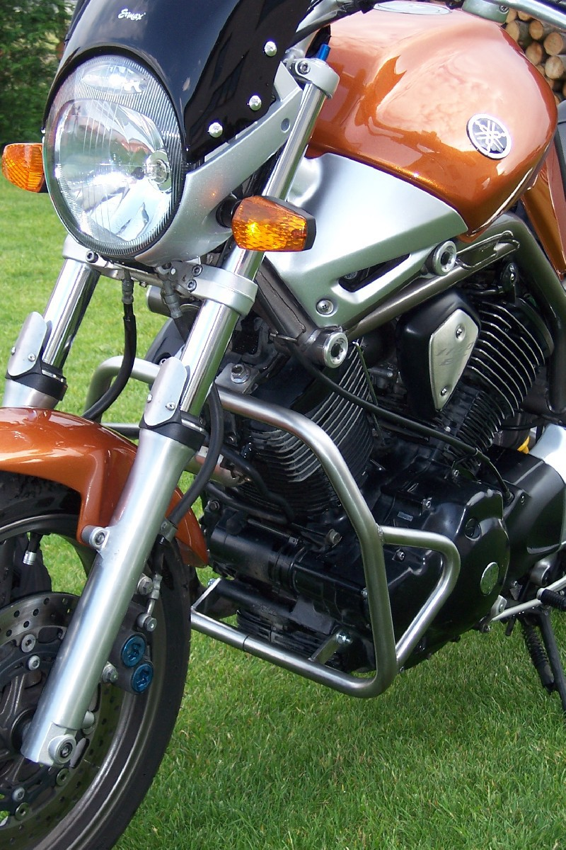
original nut

steel bar d=230mm + two pads M10 (plane) + two nuts M10 (safety)

