CF17
Cagiva Elefant

Kit for left side |  |  |  |  | Kit for right side
ID | Description | Cat.no | Qty |  |  | ID | Description | Cat.no | Qty
1 | Crash frame | - | 1 |  |  | 1 | Crash frame | - | 1
2 | Bolt M10x20 | 819 | 1 |  |  | 2 | Bolt M10x20 | 819 | 1
3 | Washer M10 spring | 801 | 1 |  |  | 3 | Washer M10 spring | 801 | 1
4 | Steel special hoop | X3 | 1 |  |  | 4 | Steel special hoop | X3 | 1
5 | Bolt M8x50 | 837 | 2 |  |  | 5 | Bolt M8x50 | 837 | 2
6 | Washer M8 - spring | 800 | 2 |  |  | 6 | Washer M8 - spring | 800 | 2
7 | Sticker RDmoto |  | 1 |  |  | 7 | Dural.cylinder d=16,5mm | 106 | 1
8 | 3M tape |  | 2 |  |  | 8 | Sticker RDmoto |  | 1
9 | Steel bar | X77 | 1 |  |  | 9 | 3M tape |  | 2

Assembly :
Warning – use the glue of all threads- medium strong (blue colour).

Right side:
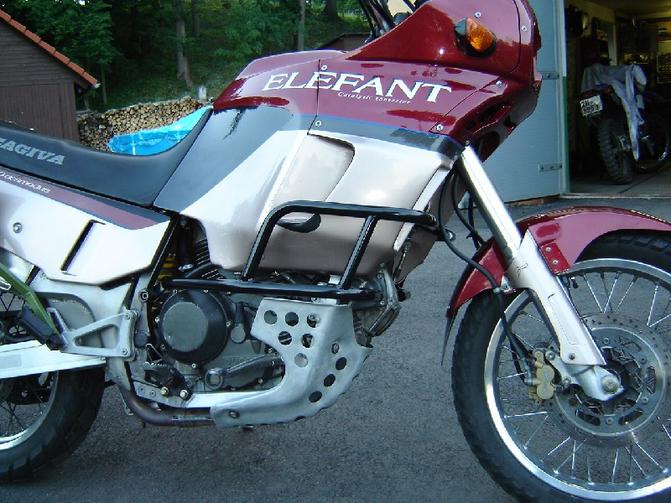
Crash frame Conect, use steel bar ID.11.
Use bolts ID.2 M10X30 and washers M10 spring.

Original cylinderfrom right side insert on the left side.
Use original bolt

Stick 3M tape on the steel hoop ID.4 and on the cash frame.
Bolts M8x50 and washers M8 gripping frames on the bike

Left side:
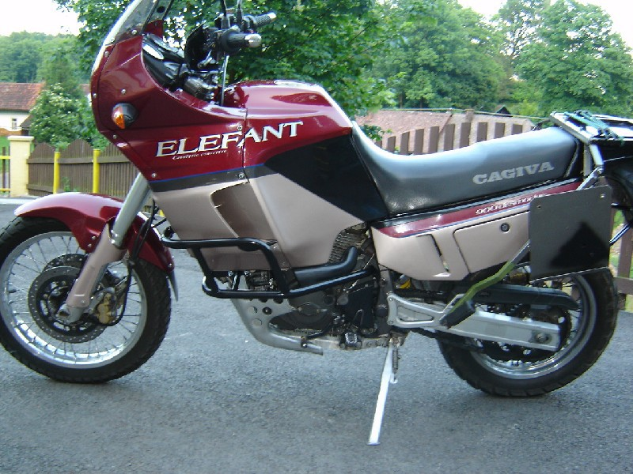
Stick 3M tape on the steel hoop ID.4 and on the cash frame.
Bolts M8x50 and washers M8 gripping frames on the bike.

.

Insert dural.cylinder d=16,5mm ID.7, Insert it between the frame and cash frame.

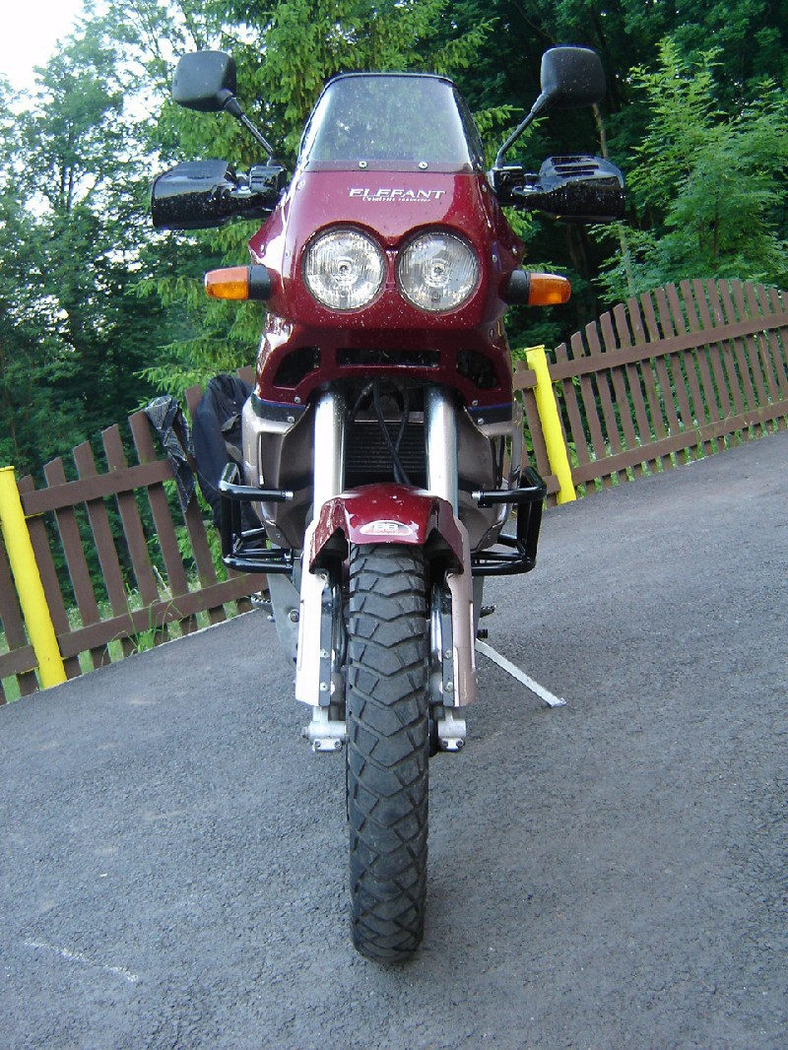
spojovací trubka + šroub M8x25mm + podložka M8 (pérová)
Crash frame Conect, usesteel bar ID.11.
Use bolts ID.2 M10X30 and washers M10 spring.

