CF18
KTM 950 Adventure

Kit for the left side |  |  |  |  | Kit for the rigth side
No. | Description | Cat.no. | Pcs |  |  | No. | Description | Cat.no. | Pcs
1 | Crash frame |  | 1 |  |  | 1 | Crash frame |  | 1
2 | stirrup | X78 | 1 |  |  | 2 | stirrup | X78 | 1
3 | nut M8 | 951 | 2 |  |  | 3 | nut M8 | 951 | 2
4 | washer M8 - flat | 802 | 4 |  |  | 4 | washer M8 - flat | 802 | 4
5 | screw M8x70mm | 841 | 1 |  |  | 5 | screw M8x70mm | 841 | 1
6 | screw M8x40mm | 828 | 1 |  |  | 6 | screw M8x40mm | 828 | 1
7 | dural roller d=12mm | 130 | 1 |  |  | 7 | dural roller d=12mm | 130 | 1
8 | plastic cover 25mm | X19 | 1 |  |  | 8 | plastic cover 25mm | X19 | 1
9 | tape 3M |  | 2 |  |  | 9 | tape 3M |  | 2
10 | sticker RDmoto |  | 1 |  |  | 10 | sticker RDmoto |  | 1
11 | washer M8 - spring | 800 | 2 |  |  | 11 | washer M8 - spring | 800 | 2

Installation:

Make the installation of the crash bar according to the instruction on the below attached photos.

The installation of the crash bar for the left and right side is the same.

Warning – we recommend to use safety glue on threads of all bolts (moderate strong – blue colour).

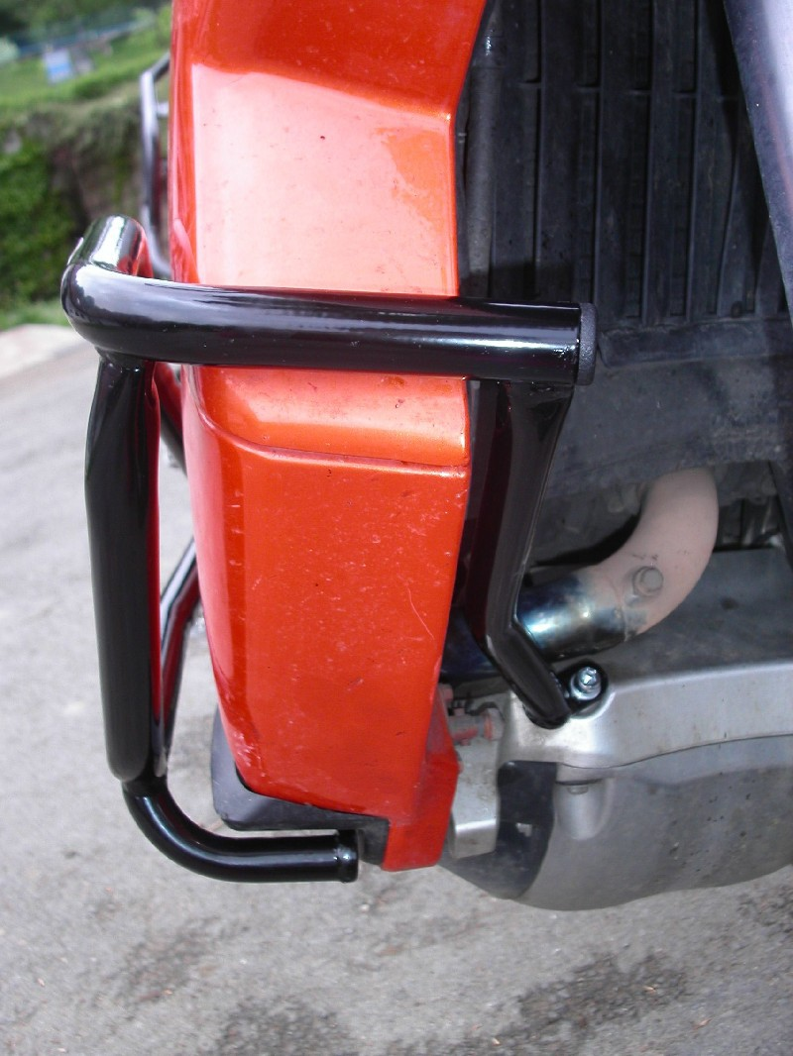
plastic cover

bolt M8x70mm + pad M8 (flat)
bolt M8x40mm + washer M8 (flat) + duralumin cylinder d=12mm
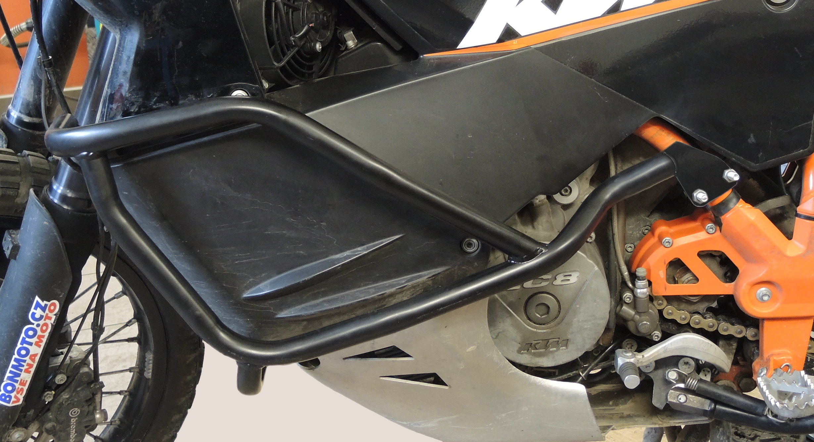

Stirrup + 3M tape + 2x washer M8 (flat) + 2x washer(spring) + 2x nut M8

