CF19
Honda X11
2000-

Kit for the left side |  |  |  |  | Kit for the right side
No. | Description | Cat.no. | Pcs |  |  | No. | Description | Cat.no. | Pcs
1 | Crash bars |  | 1 |  |  | 1 | Crash bars |  | 1
2 | Bolt M10x85x1,25 | 934 | 1 |  |  | 2 | Bolt M10x85x1,25 | 934 | 1
3 | Dural.cylinder d=20mm | 435 | 1 |  |  | 3 | Dural.cylinder d=20mm | 435 | 1
4 | Plastic plug into the tube 22mm | X32 | 1 |  |  | 4 | Plastic plug into the tube 22mm | X32 | 1
5 | Bolt M8x16mm | 829 | 1 |  |  | 5 | Bolt M8x16mm | 829 | 1
6 | Pad M8 - spring | 800 | 1 |  |  | 6 | Pad M8 - spring | 800 | 1
7 | Steel nut M12 | X12 | 1 |  |  | 7 | Steel nut M12 | X12 | 1
8 | Plastic plug into the tube 25mm | X19 | 1 |  |  | 8 | Plastic plug into the tube 25mm | X19 | 1
9 | Advertising sticker RDmoto |  | 1 |  |  | 9 | Advertising sticker RDmoto |  | 1
10 | Steel bar 12(1,25)x395x30x30 |  | 1
11 | Connecting bar d=302mm | X33 | 1

Installation:

Make the installation according to the instruction on the below attached photos. The installation of the left and right side is the same.

Warning – we recommend to use safety glue on threads of all bolts (moderate strong – blue colour).

The right side:

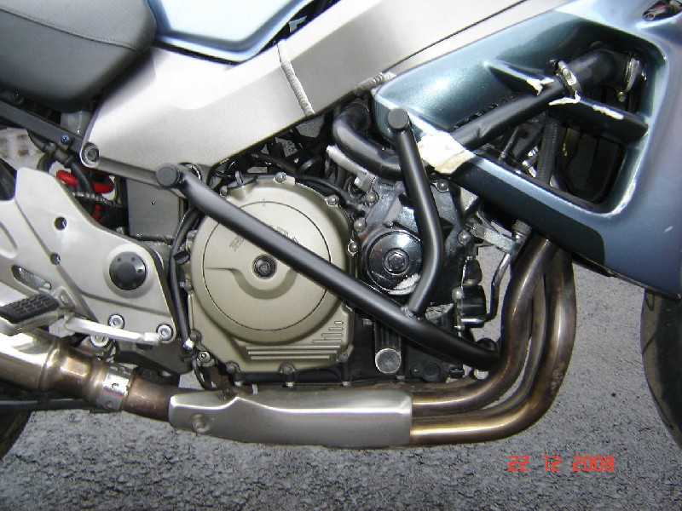
Insert dural.cylinder between the fairing and frame ,use bolt M10x85 + plastic plug into the tube 22mm

steel bar d= 395mm + steel nut M12 + plastic plug into the tube 25mm
connecting bar + bolt M8x16mm + pad M8 (spring)

The left side:

Insert dural.cylinder between the fairing and frame ,use bolt M10x85 + plastic plug into the tube 22mm

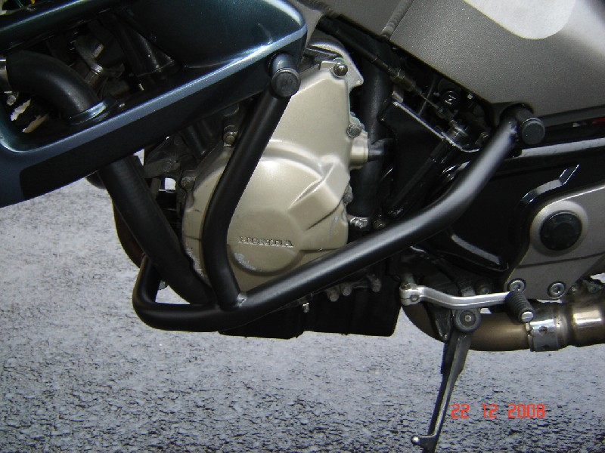
steel bar d=335mm + steel nut M12 + plastic plug into the tube 25mm
connecting bar + bolt M8x16mm + pad M8 (spring)

