CF20
BMW R1100S

Kit for the left side |  |  |  |  | Kit for the right side
No. | Description | Cat.no. | Pcs |  |  | No. | Description | Cat.no. | Pcs
1 | Crash bar |  | 1 |  |  | 1 | Crash bar |  | 1
2 | Bolt M8x25mm | 833 | 1 |  |  | 2 | Bolt M10x100mm | 885 | 1
3 | Bolt M10x100mm | 885 | 1 |  |  | 3 | Pad M10-spring | 801 | 1
4 | Pad M10-spring | 801 | 1 |  |  | 4 | Dural. cylinder d=65mm | 1138 | 1
5 | Dural. cylinder d=65mm | 1138 | 1 |  |  | 5 | Bolt M12x60mm | 960 | 1
6 | Bolt M12x60mm | 960 | 1 |  |  | 6 | Pad M12-plane | 803 | 1
7 | Pad M12-plane | 803 | 1 |  |  | 7 | Dural. cylinder d=14mm | 438 | 1
8 | Dural. cylinder d=14mm | 438 | 1 |  |  | 8 | Silentblok | X21 | 1
9 | Silentblok | X21 | 1 |  |  | 9 | Nut M8 – safety | 809 | 1
10 | Nut M8 – safety | 809 | 1 |  |  | 10 | Pad M8 – plane | 802 | 1
11 | Pad M8 – plane | 802 | 1 |  |  | 11 | Advertising sticker RDmoto |  | 1
12 | Advertising sticker RDmoto |  | 1
Installation:

Make the installation of the crash bar according to the instruction on the below attached photos.

The installation of the crash bar for the left and right side is the same.

Warning – we recommend to use safety glue on threads of all bolts (moderate strong – blue colour).

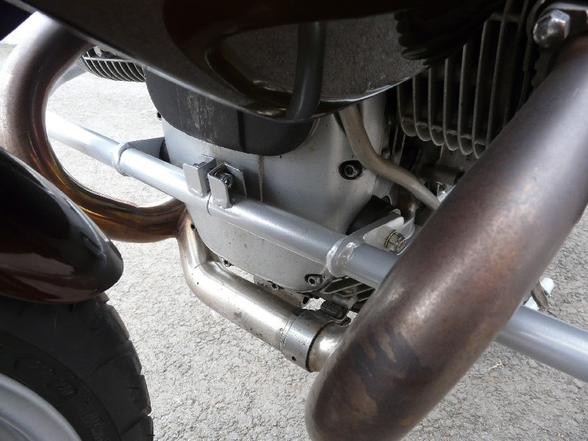
two silentblock + two nuts M8 (safety) + two pad M8 (plane)
bolt M8x25mm

The right side:

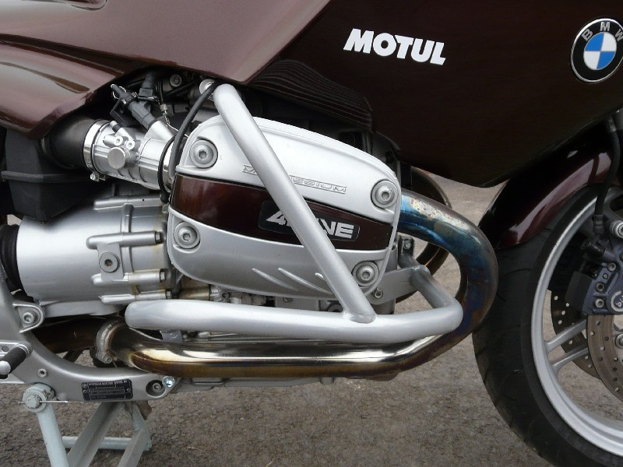
bolt M10x100mm + duralumin cylinder 65mm + pad M10 (spring)
bolt M12x60mm + duralumin cylinder 14mm + pad M12 (plane)

The left side:

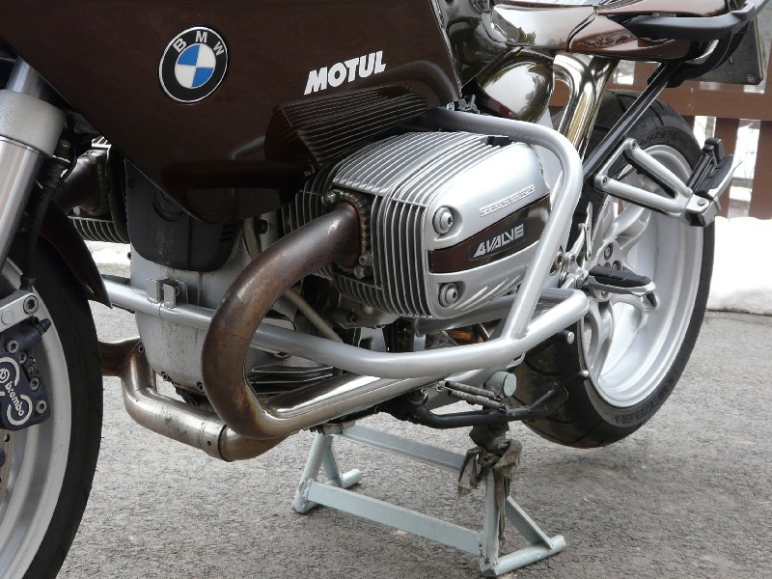
bolt M10x100mm + duralumin cylinder 65mm + pad M10 (spring)

bolt M12x60mm + duralumin cylinder 14mm + pad M12 (plane)

