CF21
Aprilia Pegaso Trail / Strada 650

Fitting kit:

ID | Description | Cat.N | Qt
1 | Welded holder | X74 | 1
2 | Connectio steel bar | X73 | 1
3 | Bolt M10x80 | 852 | 2
4 | Washer M10 | 804 | 4
5 | Nut M10 | 810 | 2
6 | Bolt M8x25 | 831 | 2
7 | Washer spring M8 | 800 | 2
8 | Bolt M6x16 | 962 | 2
9 | Washer M6 spring | 985 | 2

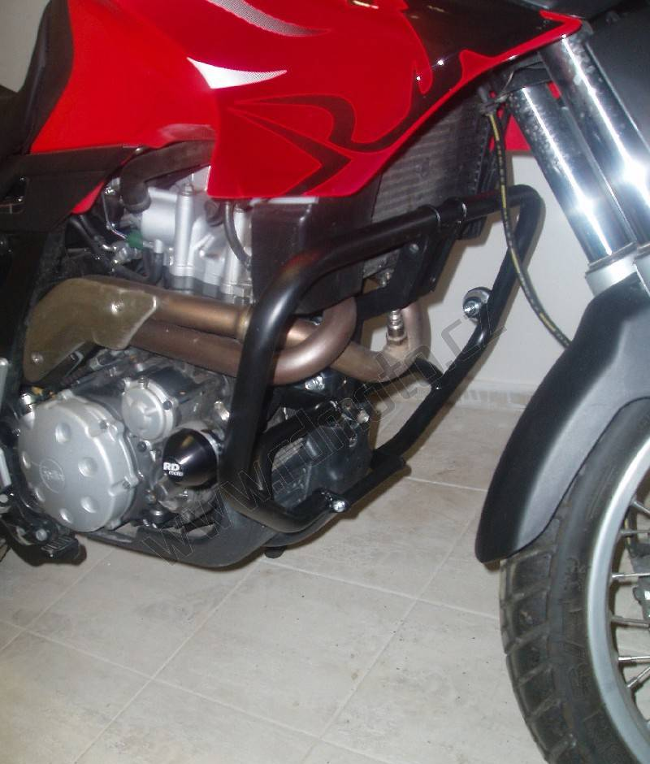

Note: Use glue medium strong during assembly for all bolts and nuts.

Make assembly as you see on the picture.
1
3,4
4,5
8,9
8,9
2
6,7
6,7
3,4
4,5
